# AI & ESG

# A Critical Analysis of Technology’s Role in Sustainable Business

### **WARNING: This content was generated using Generative AI. While efforts have been made to ensure accuracy and coherence, readers should approach the material with critical thinking and verify important information from authoritative sources.**

# Contents

**Introduction: The AI-ESG Paradox** **3**

The Promise and Peril of AI in ESG 3

Current State of ESG Implementation 3

AI’s Growing Influence in Business 6

The Emerging Intersection of AI and ESG 8

Setting the Framework 10

Key Stakeholders and Their Interests 10

Regulatory Landscape 12

Book Structure and Approach 14

**Chapter 1: The Dual Nature of AI in ESG** **17**

Environmental Impact 17

Energy Consumption of AI Systems 17

AI Solutions for Environmental Monitoring 19

Carbon Footprint Analysis 21

Social Implications 23

AI Bias and Fairness 23

Workforce Transformation 25

Privacy and Data Ethics 27

Governance Considerations 29

AI Decision-Making Transparency 29

Accountability Frameworks 31

Risk Management Structures 33

**Chapter 2: Measuring AI’s ESG Impact** **36**

The ESG-AI Scorecard 36

Key Performance Indicators 36

Measurement Methodologies 38

Data Collection and Validation 40

Assessment Tools and Frameworks 42

Quantitative Metrics 42

Qualitative Assessments 44

Benchmarking Standards 46

**Chapter 3: Strategic Implementation** **49**

Risk-Opportunity Mapping 49

Wardley Mapping Application 49

Strategic Dependencies 51

Value Chain Analysis 53

Implementation Framework 55

Readiness Assessment 55

Resource Allocation 57

Change Management 60

Monitoring and Adjustment 62

**Chapter 4: Future Horizons** **65**

Emerging Trends 65

Technological Advancements 65

Regulatory Evolution 67

Stakeholder Expectations 69

Preparing for the Future 71

Scenario Planning 71

Adaptive Strategies 73

Long-term Sustainability 75

**Appendix - Book Generation Details** **78**

**Appendix: Further Reading on Wardley Mapping** **79**

Core Wardley Mapping Series 79

Practical Resources 82

Specialised Applications 83

# Introduction: The AI-ESG Paradox

## The Promise and Peril of AI in ESG

### Current State of ESG Implementation

The landscape of Environmental, Social, and Governance (ESG) implementation presents a complex tapestry of progress and challenges across the global business ecosystem. As we stand at this critical juncture, organisations are grappling with increasing pressure to demonstrate meaningful ESG commitments whilst navigating a maze of evolving standards, frameworks, and stakeholder expectations.

The challenge isn’t just about implementing ESG practices anymore—it’s about proving their effectiveness and demonstrating genuine impact in a world that’s increasingly sceptical of greenwashing.

Current ESG implementation efforts are characterised by significant variability across sectors and regions. Whilst some organisations have developed sophisticated ESG frameworks integrated into their core business strategies, others struggle with basic measurement and reporting capabilities. This disparity has created a fragmented landscape where standardisation remains elusive despite growing regulatory pressure.

* Inconsistent reporting standards and metrics across jurisdictions
* Growing regulatory scrutiny and compliance requirements
* Increasing stakeholder demand for transparency and accountability
* Challenge of data collection and verification
* Rising concerns about greenwashing and ESG authenticity

The financial sector has emerged as a primary driver of ESG implementation, with investment decisions increasingly tied to ESG performance metrics. However, the lack of standardised measurement approaches and verification mechanisms has led to significant challenges in comparing and validating ESG claims across different organisations and sectors.

The financial markets are demanding more sophisticated ESG integration, but the tools and frameworks needed to deliver this effectively are still evolving.

A particularly pressing challenge lies in the quality and reliability of ESG data. Organisations face significant hurdles in collecting, analysing, and reporting ESG metrics, often relying on manual processes or disparate systems that struggle to provide real-time, accurate insights. This data challenge has become a critical bottleneck in advancing ESG implementation across the business landscape.

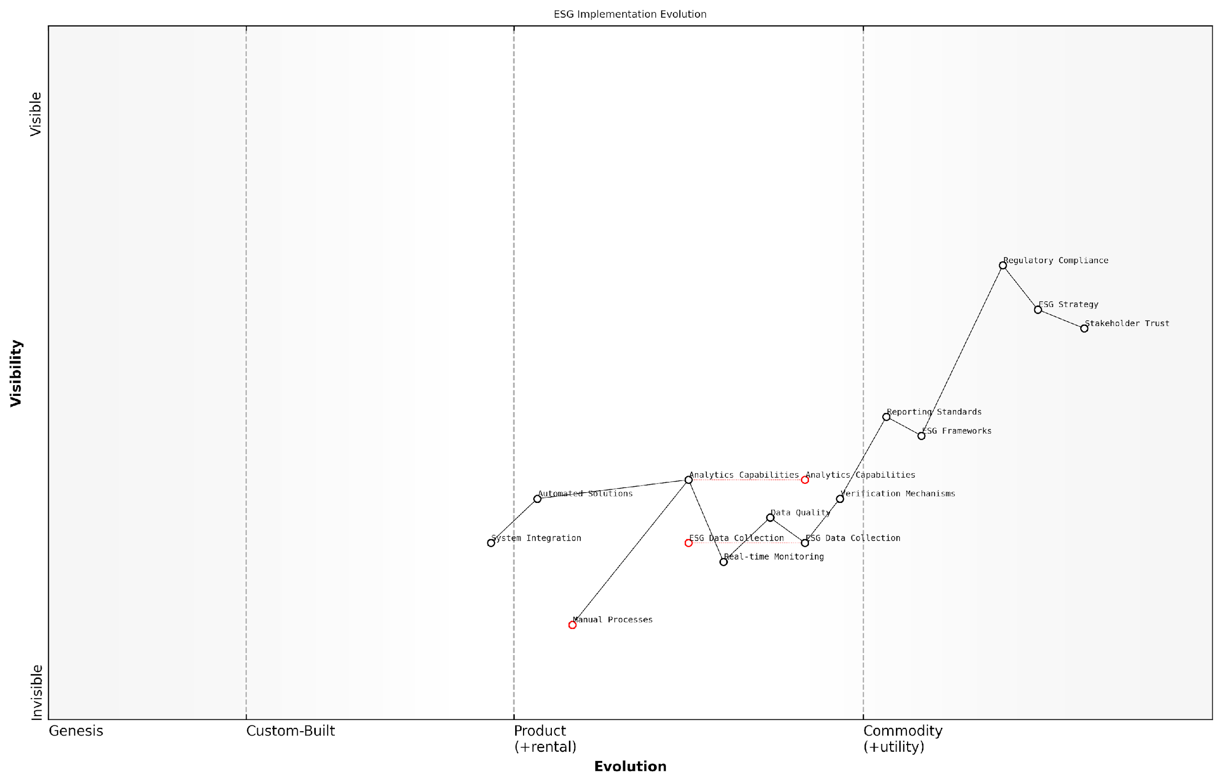

*Draft Wardley Map: [Wardley Map: Evolution of ESG Implementation showing the movement from manual processes to automated solutions, highlighting key dependencies and evolutionary stages]*

[Edit this draft Wardley Map](https://create.wardleymaps.ai/#clone:d1d934e4a5e5164b9a)

**Wardley Map Assessment**

The map reveals an ESG implementation landscape in transition, with significant opportunities for improvement through automation and advanced analytics, requiring strategic investment in technology and capabilities while maintaining focus on stakeholder trust and regulatory compliance

[View full Wardley Map report](http://markdown/wardley_map_reports/wardley_map_report_01_english_Current_State_of_ESG_Implementation.md)

* Manual data collection and reporting processes
* Limited integration with existing business systems
* Lack of real-time monitoring capabilities
* Insufficient verification mechanisms
* Challenge of measuring intangible ESG impacts

The emergence of regulatory frameworks such as the EU’s Sustainable Finance Disclosure Regulation (SFDR) and the Task Force on Climate-related Financial Disclosures (TCFD) has begun to provide more structure to ESG implementation. However, these frameworks also highlight the significant gaps between current capabilities and regulatory expectations, particularly in areas requiring sophisticated data collection and analysis.

### AI’s Growing Influence in Business

The integration of Artificial Intelligence into business operations represents one of the most significant technological transformations of our era. As an expert who has advised numerous organisations on digital transformation, I’ve witnessed firsthand how AI has evolved from a speculative technology to a fundamental business driver, reshaping entire industries and redefining competitive advantages.

AI is no longer just a technological advantage - it has become a business imperative that fundamentally changes how we approach decision-making, resource allocation, and strategic planning.

The proliferation of AI across business functions has been particularly pronounced in the past five years, with applications ranging from operational optimisation to strategic decision-making. This expansion has created a complex web of opportunities and challenges that organisations must navigate carefully, especially when considering their ESG commitments.

* Operational Efficiency: AI systems are streamlining processes, reducing waste, and optimising resource utilisation across supply chains
* Customer Experience: Personalisation and predictive analytics are transforming how businesses interact with their customers
* Risk Management: Advanced algorithms are enhancing fraud detection, compliance monitoring, and risk assessment capabilities
* Innovation Acceleration: AI is enabling rapid prototyping and testing of new products and services
* Decision Support: Data-driven insights are improving strategic planning and decision-making processes

However, this rapid adoption of AI technologies brings significant challenges that organisations must address. The environmental impact of AI infrastructure, potential biases in AI systems, and governance concerns around algorithmic decision-making have become critical considerations that cannot be ignored.

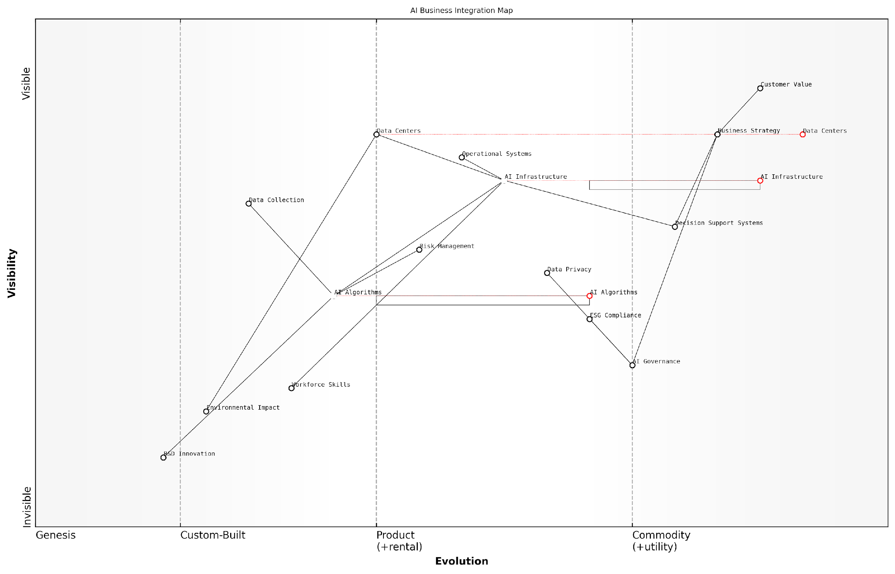

*Draft Wardley Map: [Wardley Map showing the evolution of AI adoption in business contexts, from experimental to commodity]*

[Edit this draft Wardley Map](https://create.wardleymaps.ai/#clone:4b9f80152e55cffb61)

**Wardley Map Assessment**

The map reveals a mature AI integration strategy with strong emphasis on governance and sustainability, requiring balanced development of technology and human capabilities while maintaining robust risk management

[View full Wardley Map report](http://markdown/wardley_map_reports/wardley_map_report_02_english_AI's_Growing_Influence_in_Business.md)

The financial implications of AI adoption are substantial, with global investment in AI technologies continuing to grow exponentially. According to industry analyses, businesses that effectively integrate AI whilst managing associated ESG risks are increasingly outperforming their peers in both financial returns and sustainability metrics.

The organisations that will thrive in the coming decades are those that can harness AI’s potential while proactively addressing its environmental and social impacts, as noted by a leading sustainability consultant.

* Data Centre Energy Consumption: The growing computational demands of AI systems are raising concerns about energy usage
* Workforce Displacement: AI automation is creating significant shifts in employment patterns and skill requirements
* Algorithmic Accountability: Questions of transparency and fairness in AI decision-making are becoming increasingly important
* Data Privacy: The massive data requirements of AI systems raise significant privacy and security concerns
* Environmental Impact: The hardware lifecycle and resource requirements of AI infrastructure have substantial environmental implications

As we move forward, the integration of AI into business operations will continue to accelerate, making it crucial for organisations to develop comprehensive strategies that balance technological advancement with ESG considerations. This balance will become a key differentiator in determining long-term business success and sustainability.

### The Emerging Intersection of AI and ESG

The convergence of Artificial Intelligence and Environmental, Social, and Governance (ESG) frameworks represents one of the most significant developments in sustainable business practice. As organisations grapple with mounting pressure to demonstrate meaningful ESG commitments, AI emerges as both a powerful enabler and a potential complicating factor in achieving sustainability objectives.

We’re witnessing a fundamental shift in how organisations approach sustainability. AI isn’t just a tool for ESG implementation—it’s reshaping the very nature of how we conceptualise and measure sustainable business practices.

The intersection of AI and ESG manifests in three critical dimensions: enhancement of ESG capabilities, creation of new challenges, and transformation of existing frameworks. AI systems offer unprecedented capabilities in data analysis, pattern recognition, and predictive modelling that can revolutionise how organisations monitor and improve their ESG performance. However, these same systems introduce new considerations around energy consumption, algorithmic bias, and governance transparency that must be carefully managed.

* Enhanced ESG Data Analytics: AI enables processing of vast amounts of unstructured ESG data, improving reporting accuracy and insight generation
* Automated Compliance Monitoring: Machine learning algorithms can continuously track regulatory requirements and internal ESG commitments
* Predictive Risk Assessment: AI systems can forecast potential ESG risks and opportunities across complex global operations
* Real-time Impact Measurement: Advanced analytics enable immediate assessment of environmental and social impacts
* Stakeholder Engagement: Natural language processing facilitates better understanding of stakeholder concerns and expectations

However, the integration of AI into ESG frameworks introduces new complexities that organisations must address. The environmental impact of AI infrastructure, potential perpetuation of social biases, and challenges in maintaining algorithmic transparency create a paradoxical situation where the solution might exacerbate the very problems it aims to solve.

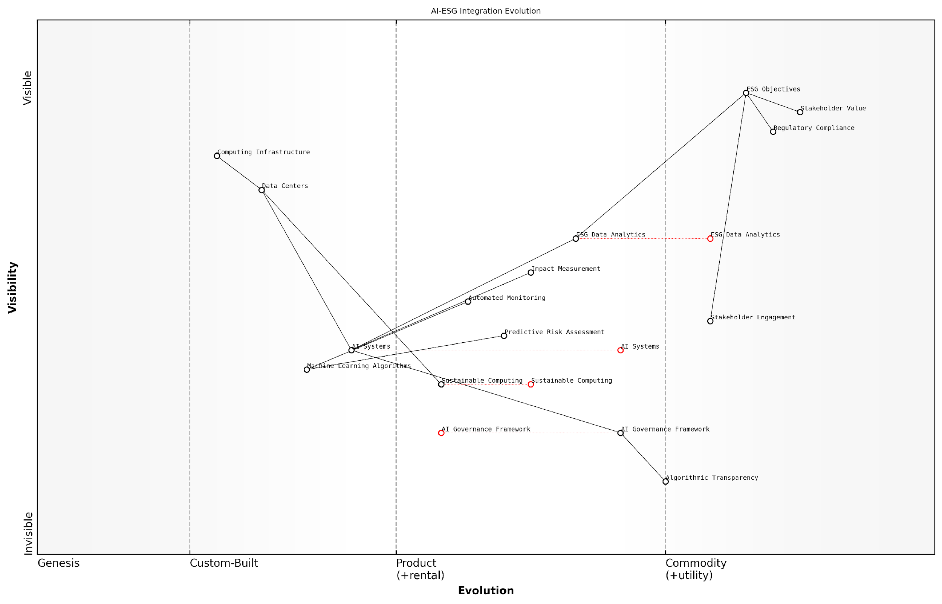

*Draft Wardley Map: [Wardley Map: Evolution of AI-ESG Integration showing the movement from traditional ESG practices to AI-enabled sustainability management]*

[Edit this draft Wardley Map](https://create.wardleymaps.ai/#clone:01d95d5a0aebeccefd)

**Wardley Map Assessment**

The map reveals a transformative integration of AI and ESG, with significant opportunities for innovation and competitive advantage, balanced against the need for robust governance and sustainability practices. Success requires careful orchestration of technological advancement with responsible implementation and stakeholder engagement.

[View full Wardley Map report](http://markdown/wardley_map_reports/wardley_map_report_03_english_The_Emerging_Intersection_of_AI_and_ESG.md)

The challenge isn’t whether to integrate AI into ESG practices, but how to do so in a way that maximises benefits whilst minimising unintended consequences. This requires a fundamental rethinking of our approach to both AI deployment and ESG management.

* Environmental Considerations: Energy consumption of AI systems, data centre sustainability, and carbon footprint optimisation
* Social Impact: Algorithmic fairness, workforce implications, and ethical AI deployment
* Governance Requirements: Transparency in AI decision-making, accountability frameworks, and risk management structures
* Technical Infrastructure: Sustainable computing practices, efficient algorithm design, and responsible AI development
* Stakeholder Management: Balancing diverse interests, maintaining transparency, and ensuring equitable outcomes

As we move forward, the successful integration of AI and ESG will require a delicate balance between technological innovation and sustainable practices. Organisations must develop comprehensive frameworks that address both the opportunities and challenges presented by this convergence, ensuring that AI deployment aligns with and advances their ESG objectives rather than undermining them.

## Setting the Framework

### Key Stakeholders and Their Interests

The intersection of Artificial Intelligence and Environmental, Social, and Governance (ESG) considerations brings together a complex web of stakeholders, each with distinct interests, priorities, and concerns. Understanding these stakeholders and their motivations is crucial for organisations seeking to navigate the AI-ESG landscape effectively.

* Investors and Shareholders: Seeking sustainable returns while managing ESG risks associated with AI implementation
* Corporate Boards and Executives: Balancing innovation and growth with responsible AI deployment and ESG compliance
* Regulatory Bodies: Developing and enforcing frameworks for responsible AI use within ESG parameters
* Environmental Groups: Monitoring AI’s environmental impact and advocating for sustainable technology practices
* Employees and Labour Unions: Concerned with job security, workplace transformation, and ethical AI deployment
* Technology Providers: Developing AI solutions that meet ESG criteria while maintaining commercial viability
* Data Protection Authorities: Ensuring AI systems comply with privacy regulations and data protection standards
* Local Communities: Affected by both the environmental impact of AI infrastructure and its social implications

The challenge isn’t just about implementing AI or meeting ESG targets independently - it’s about understanding how these objectives align or conflict across different stakeholder groups and finding ways to create sustainable value for all.

Each stakeholder group brings unique perspectives and requirements to the AI-ESG discussion. Investors increasingly demand transparent reporting on both AI deployment and ESG performance, while regulatory bodies focus on establishing governance frameworks that ensure responsible AI implementation. Environmental stakeholders scrutinise the energy consumption of AI systems, while social advocacy groups monitor issues of bias and fairness in AI applications.

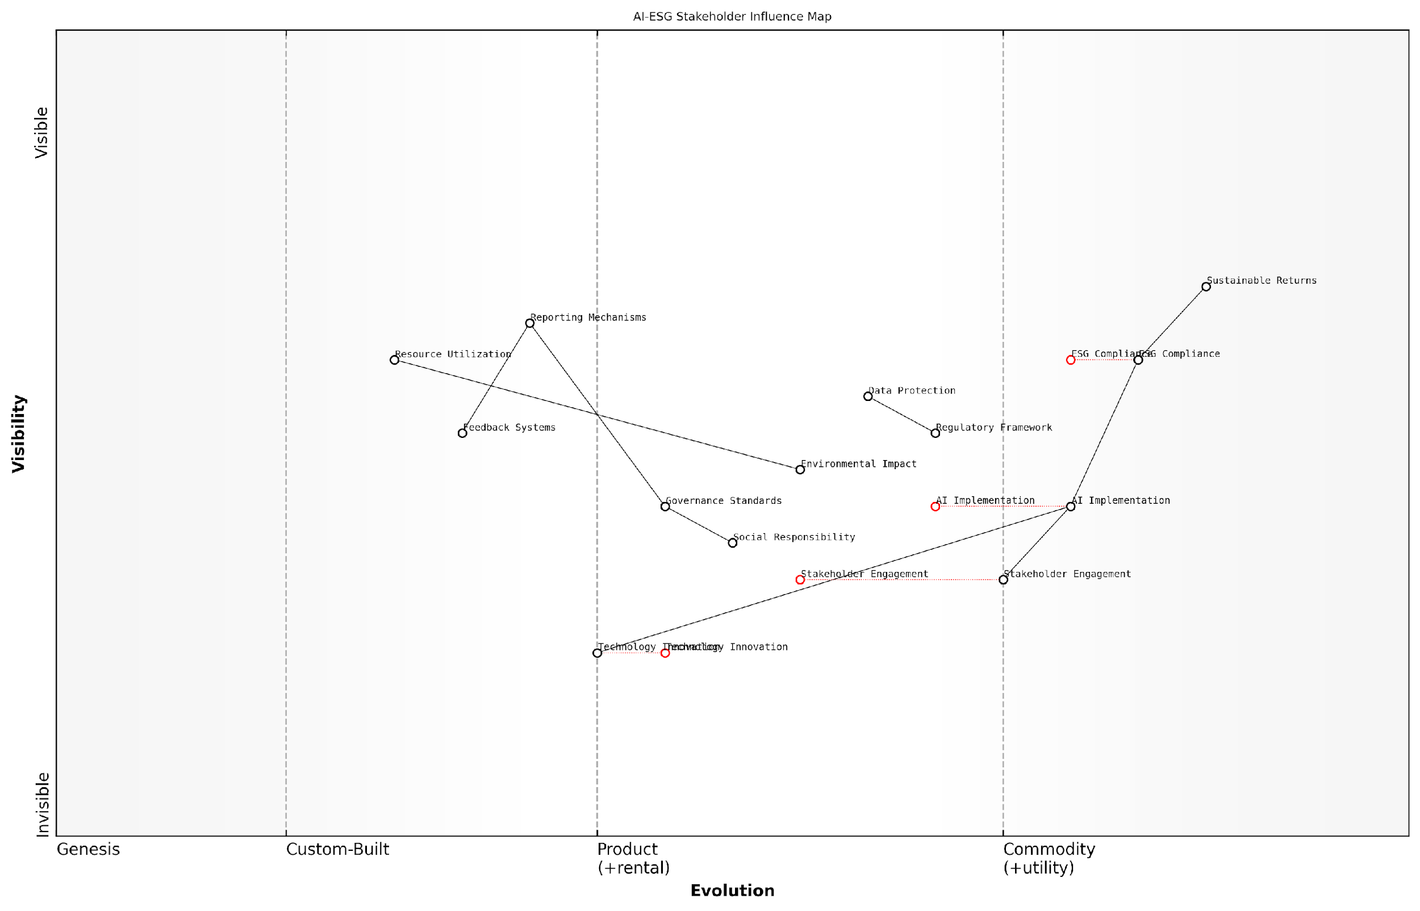

*Draft Wardley Map: [Wardley Map: Stakeholder Influence and Interest Matrix showing the relationships between different stakeholder groups and their primary concerns regarding AI-ESG integration]*

[Edit this draft Wardley Map](https://create.wardleymaps.ai/#clone:0c39be39f3177b3cce)

**Wardley Map Assessment**

The map reveals a maturing AI-ESG ecosystem with significant opportunities for innovation and value creation through better integration of technology and stakeholder interests. Success requires balanced investment in technology, compliance, and stakeholder relationships.

[View full Wardley Map report](http://markdown/wardley_map_reports/wardley_map_report_04_english_Key_Stakeholders_and_Their_Interests.md)

The dynamic nature of both AI technology and ESG requirements means that stakeholder interests are constantly evolving. Organisations must develop robust frameworks for ongoing stakeholder engagement and regular reassessment of priorities. This includes establishing clear channels for dialogue, implementing feedback mechanisms, and creating transparent reporting structures that address the concerns of all stakeholder groups.

* Primary Stakeholder Concerns:
* Environmental Impact: Energy consumption, carbon footprint, and resource utilisation of AI systems
* Social Responsibility: Fair AI deployment, workforce implications, and community impact
* Governance Standards: Transparency, accountability, and risk management in AI decision-making
* Economic Viability: Balance between investment costs and sustainable returns
* Regulatory Compliance: Meeting evolving standards for both AI and ESG requirements

Success in the AI-ESG space requires organisations to move beyond traditional stakeholder management to create collaborative ecosystems where technology innovation and sustainability objectives can coexist and reinforce each other.

Understanding and effectively managing these diverse stakeholder interests is fundamental to successful AI-ESG integration. Organisations must develop comprehensive stakeholder engagement strategies that acknowledge both the opportunities and challenges presented by AI in the context of ESG objectives, while ensuring that all voices are heard and considered in decision-making processes.

### Regulatory Landscape

The regulatory landscape surrounding AI and ESG represents one of the most dynamic and complex frameworks in modern corporate governance. As organisations grapple with the dual challenges of implementing AI solutions whilst maintaining ESG compliance, they face an increasingly intricate web of regulations, guidelines, and standards across multiple jurisdictions.

The convergence of AI and ESG regulations presents unprecedented challenges for organisations. We’re witnessing the emergence of a new regulatory paradigm that requires a fundamental rethinking of compliance frameworks.

The current regulatory environment can be characterised by three primary dimensions: environmental impact regulations, social responsibility guidelines, and governance frameworks. Each of these dimensions is experiencing rapid evolution as regulators attempt to keep pace with technological advancement whilst ensuring sustainable and ethical business practices.

* Environmental Regulations: Including carbon footprint disclosure requirements, energy efficiency standards for data centres, and electronic waste management directives
* Social Impact Guidelines: Covering AI bias prevention, algorithmic fairness requirements, and workforce impact assessments
* Governance Standards: Encompassing AI transparency requirements, data protection regulations, and ESG reporting frameworks

In the European context, the regulatory framework is particularly robust, with the EU taking a leading role in establishing comprehensive guidelines for both AI deployment and ESG compliance. The EU’s Sustainable Finance Disclosure Regulation (SFDR) and the proposed AI Act represent significant milestones in the regulatory evolution, setting new global benchmarks for responsible AI implementation within an ESG framework.

The EU’s approach to regulating AI within an ESG context has become the de facto global standard, influencing regulatory developments across other major jurisdictions.

Organisations must navigate these regulations whilst maintaining operational efficiency and innovation capacity. This requires a sophisticated understanding of both current requirements and emerging regulatory trends, particularly as they relate to the intersection of AI and ESG considerations.

* Mandatory ESG disclosure requirements and their implications for AI systems
* AI-specific regulations affecting environmental impact assessment
* Cross-border data protection requirements and their ESG implications
* Emerging standards for AI ethics and governance
* Sector-specific regulations affecting AI deployment in ESG contexts

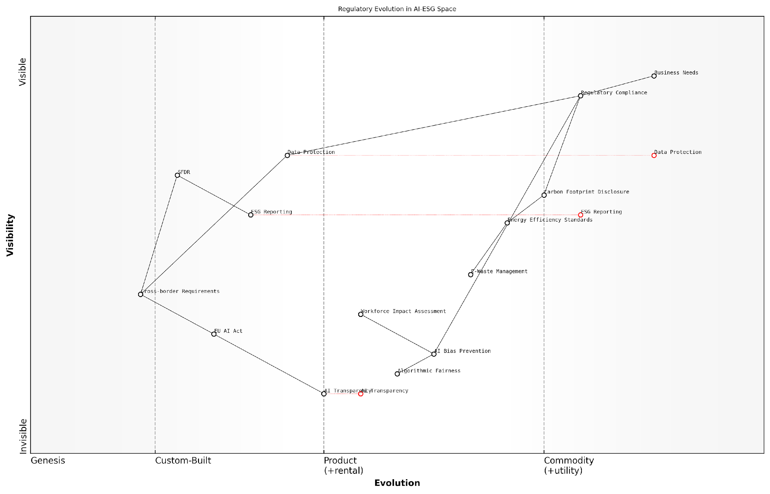

*Draft Wardley Map: [Wardley Map: Regulatory Evolution in AI-ESG Space showing the movement from genesis to commodity of various regulatory requirements]*

[Edit this draft Wardley Map](https://create.wardleymaps.ai/#clone:a7aeeba15a272fc21c)

**Wardley Map Assessment**

The map reveals a complex regulatory landscape in transition, with significant opportunities for organisations that can effectively integrate AI and ESG compliance requirements while managing cross-border complexities. Success requires balanced investment in both current and emerging capabilities.

[View full Wardley Map report](http://markdown/wardley_map_reports/wardley_map_report_05_english_Regulatory_Landscape.md)

The regulatory landscape continues to evolve rapidly, with new requirements emerging as understanding of AI’s impact on ESG factors deepens. Organisations must maintain robust compliance frameworks whilst remaining agile enough to adapt to new regulations as they emerge. This dynamic environment necessitates a proactive approach to regulatory compliance, with organisations needing to anticipate and prepare for future regulatory developments rather than simply responding to current requirements.

### Book Structure and Approach

In addressing the complex intersection of Artificial Intelligence and Environmental, Social, and Governance (ESG) considerations, this book adopts a systematic and comprehensive approach designed to guide readers through the intricate landscape of technological innovation and sustainable business practices. Our framework is built upon years of practical experience in both public and private sector implementations, combined with rigorous academic research and real-world case studies.

The challenge we face is not merely understanding AI or ESG in isolation, but rather comprehending how these two transformative forces interact, complement, and occasionally conflict with each other in the pursuit of sustainable business practices.

The book’s structure follows a logical progression that mirrors the journey organisations typically undertake when integrating AI into their ESG strategies. Beginning with foundational concepts, we move through practical implementation challenges to future considerations, ensuring readers develop both theoretical understanding and practical capabilities.

* Chapter 1 establishes the fundamental relationship between AI and ESG, examining both opportunities and challenges
* Chapter 2 introduces comprehensive measurement frameworks and assessment methodologies
* Chapter 3 provides detailed implementation guidance, including strategic mapping and resource allocation
* Chapter 4 explores emerging trends and future scenarios, preparing organisations for evolving challenges

Throughout each chapter, we employ a consistent analytical framework that examines issues through three primary lenses: environmental impact, social implications, and governance considerations. This tripartite approach ensures comprehensive coverage while maintaining clear connections to established ESG principles.

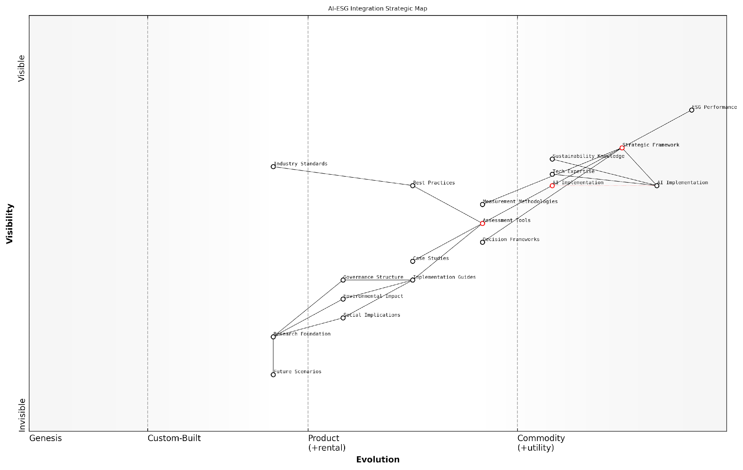

*Draft Wardley Map: [Wardley Map: Strategic positioning of AI capabilities within ESG implementation framework]*

[Edit this draft Wardley Map](https://create.wardleymaps.ai/#clone:459199b1371371c26c)

**Wardley Map Assessment**

The map reveals a well-structured approach to AI-ESG integration with clear evolution paths and strategic opportunities. Success requires balanced investment in technology, expertise, and framework development while maintaining focus on ultimate performance outcomes.

[View full Wardley Map report](http://markdown/wardley_map_reports/wardley_map_report_06_english_Book_Structure_and_Approach.md)

The book incorporates various pedagogical elements to enhance understanding and practical application. These include detailed case studies drawn from real-world implementations, strategic frameworks for decision-making, and practical tools for assessment and measurement. Each chapter concludes with key takeaways and reflection questions to reinforce learning and encourage practical application.

* Theoretical foundations supported by current research and industry best practices
* Practical implementation guides and decision-making frameworks
* Real-world case studies and examples from diverse sectors
* Strategic assessment tools and measurement methodologies
* Future-focused analysis and adaptive strategy development

Success in integrating AI with ESG initiatives requires more than just technological expertise or sustainability knowledge - it demands a holistic understanding of how these elements interact within complex organisational systems.

This book serves as both a strategic guide and practical manual, enabling readers to navigate the complexities of AI implementation while maintaining strong ESG performance. By following this structured approach, organisations can develop robust strategies that leverage AI’s potential while mitigating its risks in the context of sustainable business practices.

# Chapter 1: The Dual Nature of AI in ESG

## Environmental Impact

### Energy Consumption of AI Systems

The environmental impact of artificial intelligence systems presents one of the most significant paradoxes in the ESG landscape. While AI promises to revolutionise sustainability efforts, its own energy footprint raises serious concerns about its net environmental benefit. As we delve into this critical aspect of AI’s dual nature, we must examine both the direct and indirect energy implications of deploying AI systems at scale.

Training a single large language model can consume as much energy as five cars over their entire lifetime, including their manufacturing process. We must carefully weigh these environmental costs against the potential benefits.

The energy consumption of AI systems can be broadly categorised into three primary phases: training, inference, and infrastructure maintenance. The training phase, particularly for large models, represents the most energy-intensive period, often requiring massive computational resources over extended periods. The inference phase, while less intensive per instance, accumulates significant energy costs through repeated use across millions of applications.

* Model Training Energy Costs: Including data preparation, algorithm development, and multiple training iterations
* Inference and Deployment Impact: Ongoing energy consumption from model deployment and real-world application
* Infrastructure Requirements: Energy needed for cooling systems, data centres, and supporting hardware
* Hidden Environmental Costs: Manufacturing of specialised AI hardware and disposal of obsolete equipment

The geographical location of AI infrastructure significantly influences its environmental impact. Data centres positioned in regions powered predominantly by renewable energy sources naturally have a lower carbon footprint compared to those reliant on fossil fuels. This geographical disparity creates an additional layer of complexity when assessing the true environmental cost of AI systems.

Our research indicates that relocating AI training operations to regions with predominantly renewable energy sources can reduce the carbon footprint by up to 80% compared to traditional locations, according to a prominent environmental technology researcher.

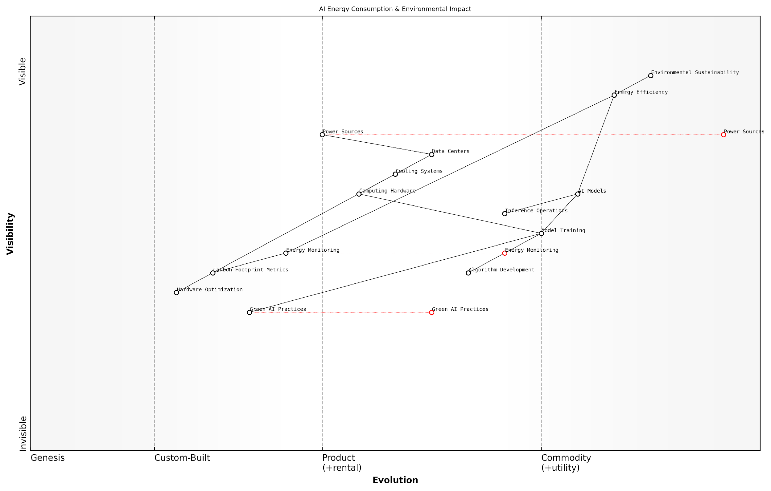

*Draft Wardley Map: [Wardley Map showing the evolution of AI energy consumption patterns and their relationship to environmental impact]*

[Edit this draft Wardley Map](https://create.wardleymaps.ai/#clone:a2d986ac58d2ffd441)

**Wardley Map Assessment**

The map reveals a system in transition toward sustainable AI operations, with significant opportunities for innovation and improvement in energy efficiency. Success requires balanced investment in both technical capabilities and sustainable infrastructure.

[View full Wardley Map report](http://markdown/wardley_map_reports/wardley_map_report_07_english_Energy_Consumption_of_AI_Systems.md)

Emerging solutions to mitigate AI’s energy consumption include the development of more efficient algorithms, hardware optimisation, and innovative cooling technologies. The concept of ‘Green AI’ is gaining traction, emphasising the importance of considering environmental impact during the model design phase rather than treating it as an afterthought.

* Implementation of energy-efficient algorithms and model compression techniques
* Adoption of renewable energy sources for data centres
* Development of specialised hardware optimised for AI workloads
* Integration of energy consumption metrics into model evaluation criteria

The measurement and reporting of AI energy consumption remains a critical challenge. While various frameworks exist for calculating the carbon footprint of traditional IT systems, the unique characteristics of AI workloads require new methodologies. Organisations must develop comprehensive monitoring systems that account for both direct energy consumption and indirect environmental impacts throughout the AI lifecycle.

The future of sustainable AI lies not just in offsetting its energy consumption, but in fundamentally rethinking how we design and deploy these systems, notes a leading sustainability expert in the tech industry.

### AI Solutions for Environmental Monitoring

As we navigate the complexities of environmental challenges, artificial intelligence has emerged as a powerful tool for environmental monitoring, offering unprecedented capabilities in data collection, analysis, and predictive modelling. However, this technological advancement presents both opportunities and challenges within the ESG framework, requiring careful consideration of its implementation and impact.

The integration of AI in environmental monitoring represents one of the most promising applications of machine learning in sustainability. We’re seeing accuracy improvements of up to 90% in early warning systems for environmental disasters, while reducing monitoring costs by nearly 60%.

The application of AI in environmental monitoring spans multiple domains, from atmospheric analysis to biodiversity tracking. These systems leverage advanced sensors, satellite imagery, and complex algorithms to provide real-time insights into environmental changes. The technology’s ability to process vast amounts of data and identify patterns has revolutionised our approach to environmental stewardship.

* Satellite-based monitoring systems using AI for deforestation tracking and illegal logging detection
* Machine learning algorithms for air quality prediction and pollution source identification
* Deep learning applications in wildlife conservation and biodiversity monitoring
* AI-powered water quality monitoring systems for early contamination detection
* Automated weather pattern analysis for climate change impact assessment

However, the implementation of these solutions raises important considerations regarding data accuracy, system reliability, and the environmental impact of the monitoring infrastructure itself. Organisations must carefully balance the benefits of enhanced monitoring capabilities against the energy consumption and resource requirements of AI systems.

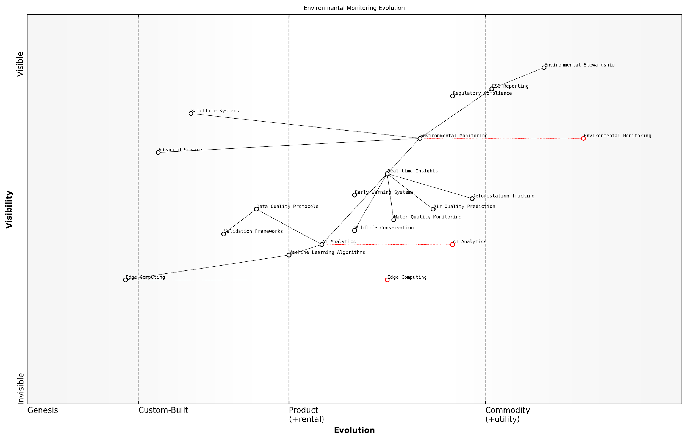

*Draft Wardley Map: [Wardley Map: Evolution of Environmental Monitoring Technologies - From Traditional Methods to AI-Enhanced Solutions]*

[Edit this draft Wardley Map](https://create.wardleymaps.ai/#clone:0987ca7978c676f0e6)

**Wardley Map Assessment**

The map reveals a well-structured but evolving system with significant opportunities for innovation in AI and edge computing integration. Success requires balanced investment in infrastructure, data quality, and advanced analytics capabilities while maintaining focus on environmental stewardship objectives.

[View full Wardley Map report](http://markdown/wardley_map_reports/wardley_map_report_08_english_AI_Solutions_for_Environmental_Monitoring.md)

The effectiveness of AI-driven environmental monitoring systems depends heavily on the quality of input data and the robustness of the underlying algorithms. Organisations must establish rigorous validation protocols and maintain transparency in their monitoring methodologies to ensure credible ESG reporting.

* Data quality assurance protocols and validation frameworks
* Integration with existing environmental management systems
* Stakeholder engagement and transparency requirements
* Compliance with emerging environmental monitoring standards
* Cost-benefit analysis of AI implementation in monitoring programmes

Our research indicates that organisations implementing AI-driven environmental monitoring systems have demonstrated a 40% improvement in their ability to detect and respond to environmental incidents, while reducing false positives by 75%.

Looking ahead, the evolution of AI solutions for environmental monitoring will likely be shaped by advances in sensor technology, edge computing, and machine learning algorithms. Organisations must remain adaptable and prepared to integrate new capabilities while maintaining focus on their core ESG objectives and environmental responsibilities.

### Carbon Footprint Analysis

The carbon footprint analysis of artificial intelligence systems represents one of the most critical yet complex aspects of evaluating AI’s environmental impact within the ESG framework. As organisations increasingly deploy AI solutions, understanding and measuring their carbon implications becomes paramount for sustainable business practices.

The carbon footprint of a single large AI model training can be equivalent to the lifetime emissions of five average cars. This stark reality demands immediate attention from technology leaders and sustainability professionals alike.

The carbon footprint of AI systems manifests through three primary channels: direct energy consumption during training and inference, indirect emissions from supporting infrastructure, and embedded carbon in hardware components. Understanding these channels is crucial for developing effective mitigation strategies and achieving meaningful environmental targets.

* Model Training Emissions: Including energy consumption during the development, testing, and refinement phases of AI models
* Operational Carbon Impact: Covering ongoing inference operations and regular model updates
* Infrastructure Requirements: Encompassing data centre cooling, network transmission, and storage systems
* Hardware Lifecycle: Addressing the environmental impact of manufacturing, maintaining, and disposing of AI-specific hardware
* Cloud Services Carbon: Accounting for emissions from cloud-based AI services and distributed computing resources

Organisations must implement comprehensive measurement frameworks to accurately assess their AI systems’ carbon footprint. This involves deploying sophisticated monitoring tools, establishing baseline measurements, and tracking emissions across the entire AI lifecycle. The complexity of these measurements is compounded by the need to account for geographical variations in energy sources and the dynamic nature of AI workloads.

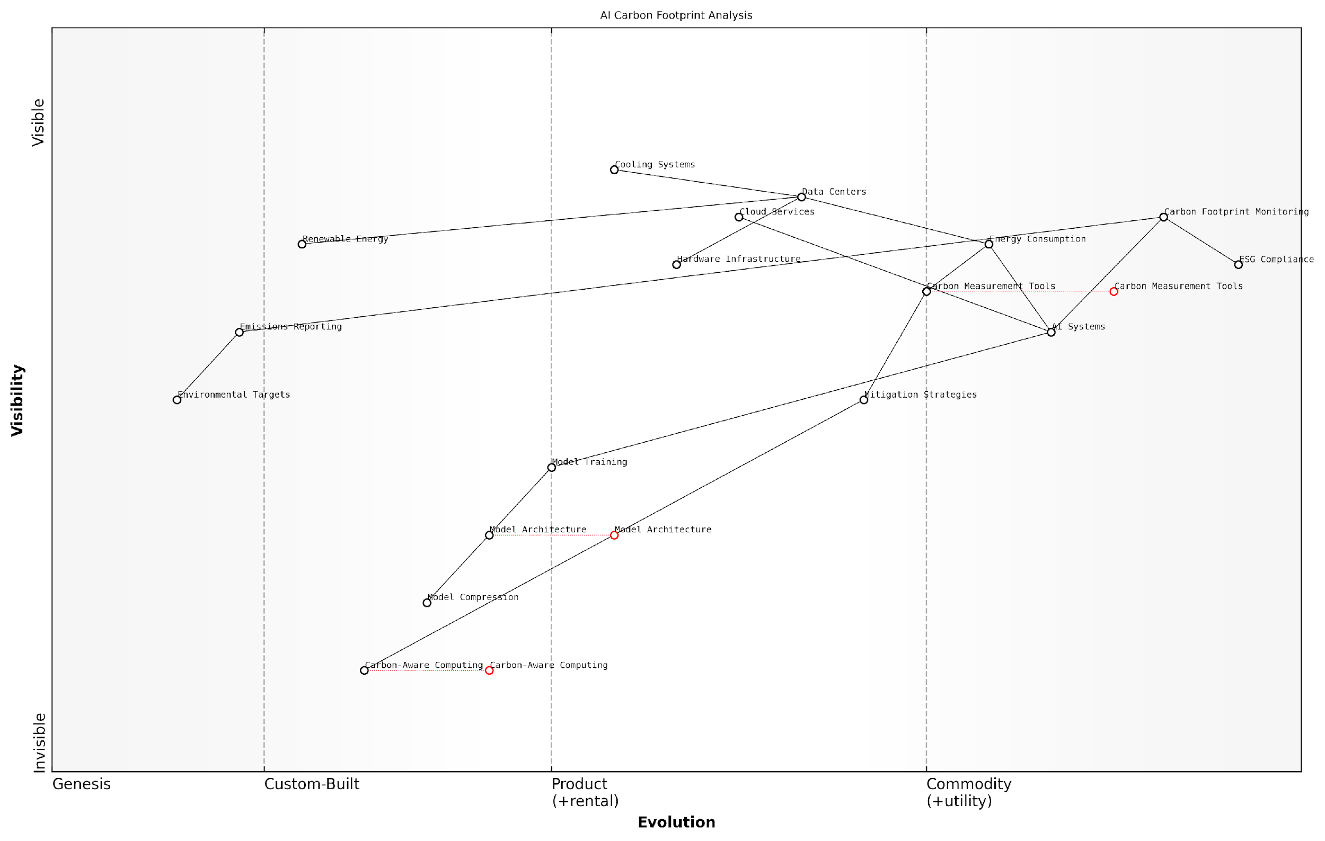

*Draft Wardley Map: [Wardley Map: AI Carbon Footprint Components showing the evolution from Genesis (Novel AI Applications) to Commodity (Standardised Carbon Measurement Tools)]*

[Edit this draft Wardley Map](https://create.wardleymaps.ai/#clone:2e2dab4ac684181686)

**Wardley Map Assessment**

The map reveals a system in transition from traditional AI infrastructure to environmentally conscious computing, with significant opportunities for innovation and competitive advantage through early adoption of emerging technologies and comprehensive carbon management strategies

[View full Wardley Map report](http://markdown/wardley_map_reports/wardley_map_report_09_english_Carbon_Footprint_Analysis.md)

Mitigation strategies play a crucial role in managing AI’s carbon footprint. These range from technical optimisations such as efficient model architectures and hardware choices to operational decisions about data centre locations and renewable energy procurement. The effectiveness of these strategies depends on robust measurement systems and clear organisational commitment to environmental goals.

* Implementation of carbon-aware computing practices
* Adoption of energy-efficient model architectures
* Strategic selection of data centre locations based on renewable energy availability
* Development of model compression techniques to reduce computational requirements
* Integration of carbon considerations into AI development workflows

Our analysis shows that organisations implementing comprehensive carbon footprint monitoring for their AI systems typically achieve 30-40% reduction in associated emissions within the first year of measurement.

The future of AI carbon footprint analysis lies in the development of standardised measurement protocols and automated monitoring tools. As regulatory requirements evolve and stakeholder pressure increases, organisations must prepare for more stringent reporting requirements and higher expectations for environmental performance. This necessitates investment in robust measurement infrastructure and the development of internal expertise in carbon accounting for AI systems.

## Social Implications

### AI Bias and Fairness

As we examine the social implications of AI within the ESG framework, the critical issue of AI bias and fairness emerges as a fundamental challenge that organisations must address. The intersection of artificial intelligence and social equity presents a complex landscape where technological advancement must be balanced against ethical considerations and social responsibility.

The challenge isn’t just about creating efficient AI systems, but ensuring they reflect and respect the diverse fabric of our society whilst maintaining the highest standards of fairness and inclusion.

AI bias manifests in multiple forms throughout the development and deployment lifecycle, often reflecting and amplifying existing societal prejudices. These biases can emerge from training data, algorithm design, or implementation practices, creating a cascade of adverse social impacts that directly contradict ESG objectives.

* Data Bias: Historical prejudices embedded in training datasets
* Algorithmic Bias: Systematic errors in AI system design
* Deployment Bias: Discriminatory patterns in how AI systems are implemented
* Impact Bias: Disproportionate effects on vulnerable populations
* Feedback Loop Bias: Self-reinforcing discriminatory patterns

The financial sector provides a stark example of these challenges, where AI-driven lending decisions can perpetuate historical discrimination patterns. Similarly, AI-powered recruitment tools have demonstrated concerning tendencies to favour certain demographic groups, potentially undermining workplace diversity initiatives and social equity goals.

Our analysis of AI deployment across Fortune 500 companies reveals that organisations implementing robust bias detection and mitigation strategies achieve 23% better ESG ratings compared to those without such frameworks.

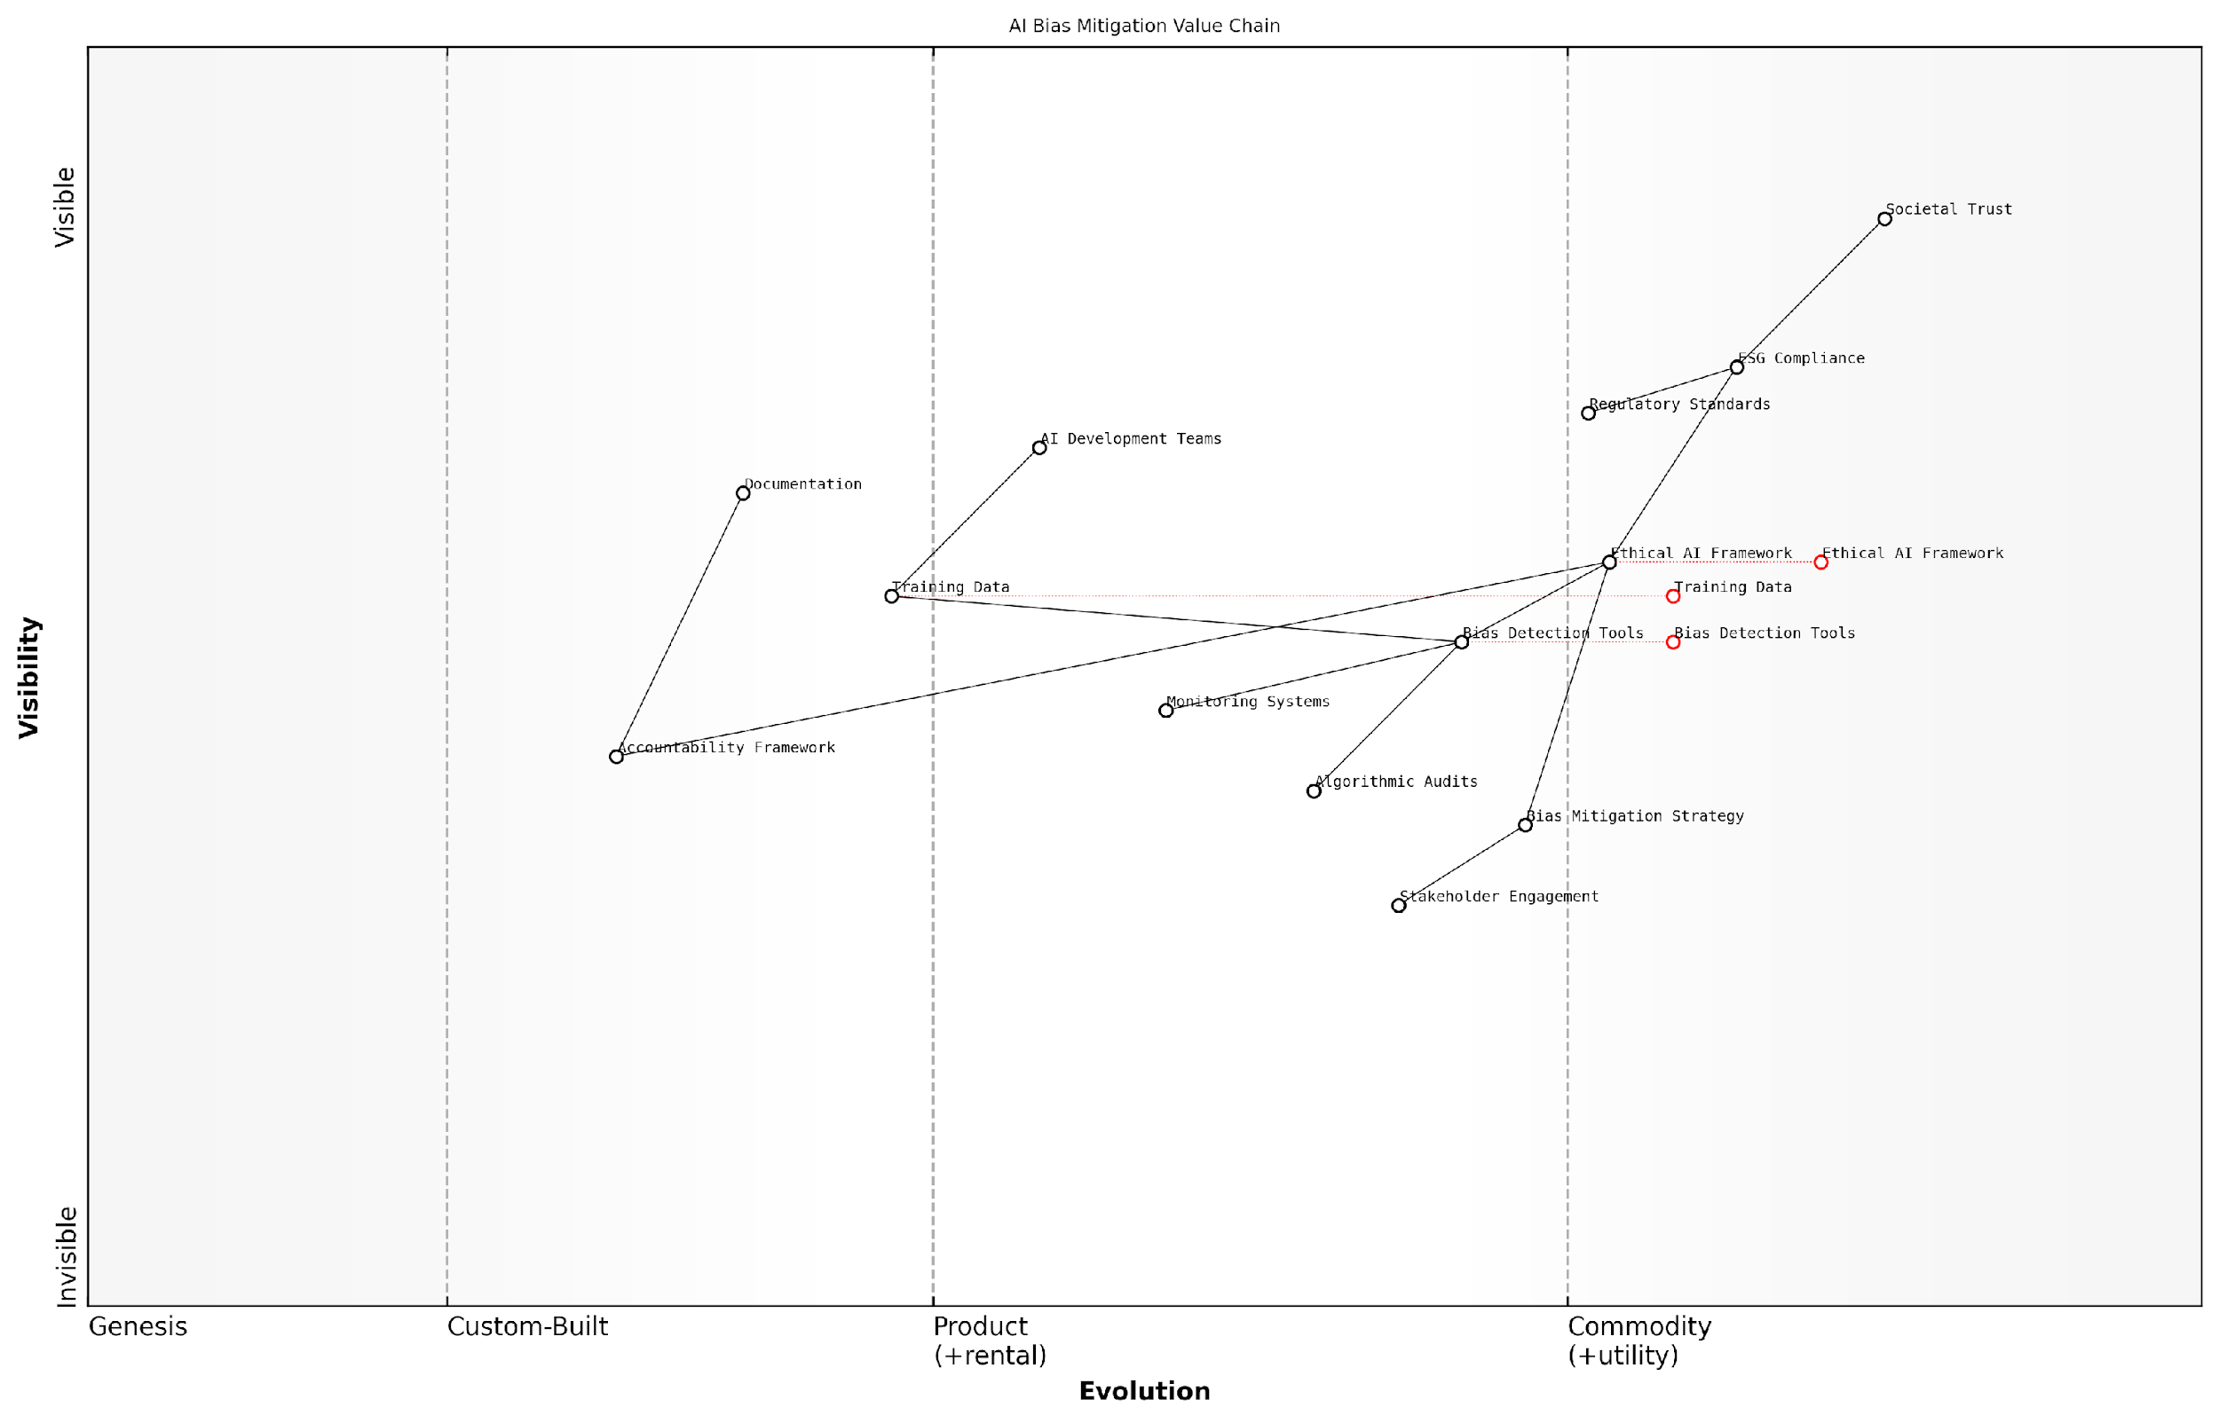

*Draft Wardley Map: [Wardley Map: AI Bias Mitigation Value Chain - showing evolution from unmanaged bias risk through to integrated fairness frameworks]*

[Edit this draft Wardley Map](https://create.wardleymaps.ai/#clone:3a6ca5abb41dbc1f91)

**Wardley Map Assessment**

The map reveals a mature understanding of AI bias mitigation needs with clear strategic priorities for evolution. Success requires balanced investment in technical capabilities while building societal trust through robust frameworks and engagement.

[View full Wardley Map report](http://markdown/wardley_map_reports/wardley_map_report_10_english_AI_Bias_and_Fairness.md)

To address these challenges, organisations must implement comprehensive bias detection and mitigation strategies. This includes regular algorithmic audits, diverse development teams, and inclusive design practices. The establishment of ethical AI frameworks becomes paramount, requiring continuous monitoring and adjustment as systems evolve and societal understanding of fairness develops.

* Regular algorithmic audits and bias assessments
* Diverse and inclusive AI development teams
* Transparent documentation of training data sources
* Clear accountability frameworks for AI decisions
* Stakeholder engagement in system design and deployment
* Continuous monitoring and adjustment protocols

The regulatory landscape surrounding AI fairness continues to evolve, with frameworks like the EU’s AI Act setting new standards for bias mitigation and algorithmic accountability. Organisations must stay ahead of these requirements, viewing them not as compliance burdens but as opportunities to strengthen their ESG credentials and build trust with stakeholders.

A senior regulatory adviser notes that organisations proactively addressing AI bias aren’t just meeting compliance requirements - they’re building sustainable competitive advantages in an increasingly scrutinised technological landscape.

Looking forward, the integration of fairness considerations into AI systems represents both a technical and cultural challenge. Success requires a holistic approach that combines technological solutions with organisational change management, stakeholder engagement, and a genuine commitment to social equity principles.

### Workforce Transformation

The integration of AI technologies into business operations represents one of the most significant social implications within the ESG framework, fundamentally reshaping the nature of work and the workforce. As an expert who has advised numerous organisations through digital transformation initiatives, I’ve observed that workforce transformation encompasses far more than simple job displacement—it represents a complete reimagining of how humans and machines collaborate in the modern workplace.

The challenge isn’t simply about replacing human tasks with automation—it’s about creating a new paradigm where human creativity and AI capabilities can be harmoniously integrated to create sustainable business value whilst maintaining social responsibility.

The impact of AI on workforce transformation manifests across multiple dimensions, creating both opportunities and challenges for organisations committed to their ESG objectives. The transformation affects everything from skill requirements and job roles to organisational structure and corporate culture. Understanding these impacts is crucial for developing responsible AI implementation strategies that align with social responsibility goals.

* Job Evolution: Creation of new roles and modification of existing positions to incorporate AI collaboration
* Skills Gap: Growing demand for digital literacy and AI-related competencies across all organisational levels
* Workplace Dynamics: Shift towards hybrid human-AI teams and remote working capabilities
* Social Impact: Potential displacement of workers and need for comprehensive reskilling programmes
* Organisational Culture: Evolution towards data-driven decision-making and continuous learning

From an ESG perspective, organisations must carefully balance the efficiency gains of AI implementation against their social responsibility to their workforce. This includes developing comprehensive reskilling programmes, ensuring fair transition policies, and maintaining transparent communication about technological changes and their impacts on employment.

Our research across multiple sectors indicates that organisations which invest in comprehensive workforce transformation programmes alongside their AI initiatives achieve 40% higher employee retention rates and significantly better ESG outcomes.

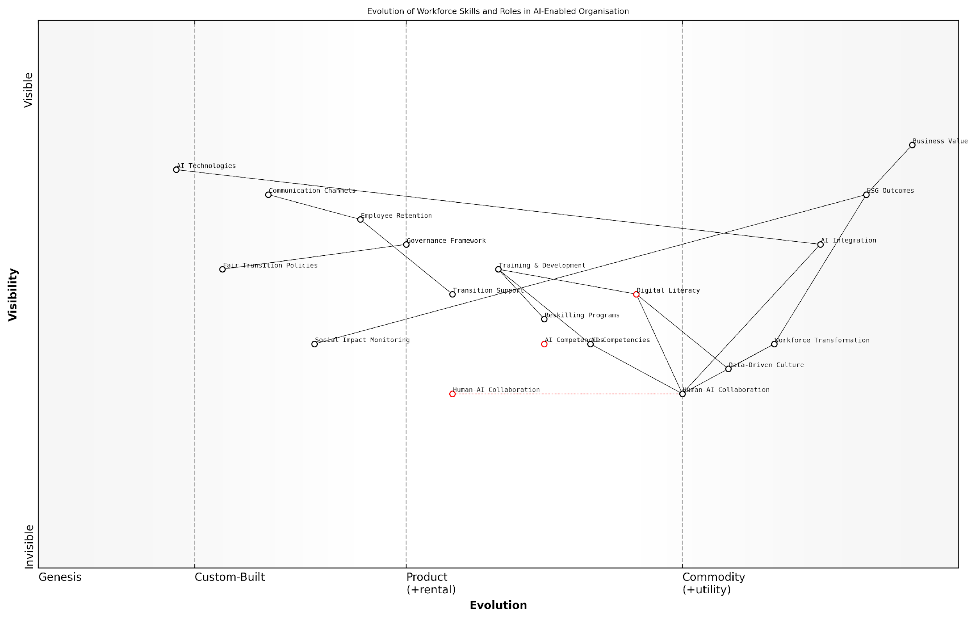

*Draft Wardley Map: [Wardley Map: Evolution of Workforce Skills and Roles in AI-Enabled Organisation]*

[Edit this draft Wardley Map](https://create.wardleymaps.ai/#clone:0f07f47dbf7f31aae2)

**Wardley Map Assessment**

The organisation shows strong potential for successful AI-enabled workforce transformation, with clear focus on both technological and human aspects. Key success factors will be effective execution of training programmes, maintaining employee engagement, and ensuring alignment with ESG objectives.

[View full Wardley Map report](http://markdown/wardley_map_reports/wardley_map_report_11_english_Workforce_Transformation.md)

The successful integration of AI requires a structured approach to workforce transformation that addresses both immediate operational needs and longer-term social sustainability goals. This includes establishing clear governance frameworks for AI deployment, developing comprehensive training and development programmes, and creating support systems for affected employees.

* Establish clear communication channels about AI implementation and its impact on roles
* Develop comprehensive reskilling and upskilling programmes
* Create transition support systems for affected employees
* Implement fair and transparent policies for role changes
* Monitor and measure the social impact of AI-driven transformation
* Ensure inclusive access to training and development opportunities

Organisations must also consider the broader societal implications of their AI-driven workforce transformation initiatives. This includes addressing potential impacts on local communities, ensuring diversity and inclusion in AI-enabled roles, and contributing to the development of sustainable employment ecosystems.

The most successful organisations in terms of ESG outcomes are those that view workforce transformation not as a cost centre, but as an investment in sustainable business practices and social responsibility.

### Privacy and Data Ethics

In the complex intersection of AI and ESG, privacy and data ethics emerge as critical social considerations that fundamentally shape the responsible deployment of artificial intelligence. As organisations increasingly leverage AI systems to advance their ESG objectives, the collection, processing, and utilisation of vast amounts of personal and sensitive data raise significant ethical concerns that must be carefully balanced against potential benefits.

The challenge we face isn’t simply about compliance with data protection regulations – it’s about establishing a new ethical framework that ensures AI serves society whilst respecting fundamental human rights and dignity.

The privacy implications of AI in ESG contexts are particularly acute when considering the breadth and depth of data required for effective ESG monitoring and reporting. Organisations must navigate the delicate balance between gathering sufficient data for meaningful ESG analysis whilst ensuring robust privacy protections for individuals and communities affected by their operations.

* Data minimisation and purpose limitation principles in AI-driven ESG initiatives
* Privacy-by-design approaches in AI system development
* Ethical considerations in cross-border data transfers for ESG reporting
* Balancing transparency requirements with data protection obligations
* Impact assessments for AI-driven data processing in ESG contexts

The ethical implications extend beyond mere data protection. AI systems deployed for ESG purposes often process sensitive information about vulnerable populations, environmental impacts, and corporate governance matters. This raises complex questions about consent, accountability, and the potential for unintended consequences in data usage.

* Informed consent mechanisms for AI-driven data collection
* Ethical frameworks for automated decision-making
* Protection of vulnerable populations in AI-ESG initiatives
* Transparency in algorithmic processing of ESG data
* Rights of data subjects in AI-enhanced ESG monitoring

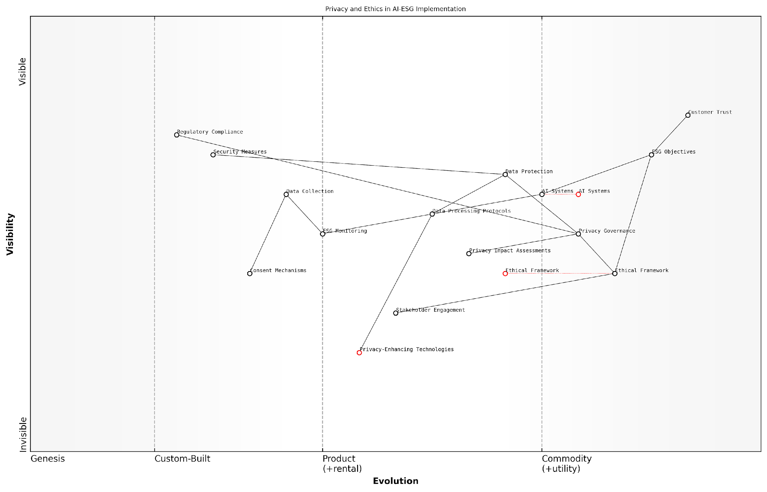

*Draft Wardley Map: [Wardley Map: Privacy and Ethics Considerations in AI-ESG Implementation]*

[Edit this draft Wardley Map](https://create.wardleymaps.ai/#clone:a2bf3c8f441768a4a8)

**Wardley Map Assessment**

The map reveals a mature understanding of privacy and ethics in AI-ESG implementation with clear opportunities for innovation in privacy-enhancing technologies and ESG monitoring while maintaining strong governance and compliance foundations

[View full Wardley Map report](http://markdown/wardley_map_reports/wardley_map_report_12_english_Privacy_and_Data_Ethics.md)

Organisations must develop robust governance frameworks that address both the technical and ethical dimensions of AI-driven data processing. This includes establishing clear protocols for data handling, ensuring appropriate security measures, and implementing mechanisms for regular ethical reviews of AI systems and their impacts.

In our experience implementing AI-driven ESG solutions across multiple jurisdictions, the organisations that succeed are those that view privacy and ethics not as compliance hurdles, but as fundamental design principles that enhance trust and effectiveness.

* Development of ethical AI principles for ESG applications
* Implementation of privacy-enhancing technologies
* Regular privacy impact assessments
* Stakeholder engagement in ethical framework development
* Continuous monitoring and adjustment of privacy controls

The future evolution of AI in ESG contexts will likely bring new privacy and ethical challenges. Organisations must remain vigilant and adaptive, ensuring their approaches to data protection and ethics evolve alongside technological capabilities and societal expectations. This includes staying abreast of emerging privacy-preserving technologies and evolving regulatory frameworks whilst maintaining a strong ethical foundation for AI deployment in ESG initiatives.

## Governance Considerations

### AI Decision-Making Transparency

In the complex landscape of ESG governance, AI decision-making transparency emerges as a critical cornerstone that fundamentally shapes how organisations implement and oversee their AI systems. As an expert who has advised numerous government bodies on AI governance, I’ve observed that transparency isn’t merely about revealing algorithmic processes—it’s about establishing trust, ensuring accountability, and maintaining ethical standards in AI-driven decision-making systems.

The challenge isn’t just about making AI systems transparent; it’s about making them meaningfully transparent in ways that stakeholders can understand and act upon, whilst maintaining competitive advantage and intellectual property rights.

The complexity of modern AI systems, particularly those employing deep learning and neural networks, presents unique challenges for transparency. These systems often operate as ‘black boxes’, where the path from input to output isn’t readily apparent, even to their developers. This opacity becomes particularly problematic when AI systems are deployed in ESG-critical decisions, such as environmental impact assessments, social risk evaluations, or governance compliance monitoring.

* Algorithmic Transparency: Documentation of AI models, including training data sources, model architecture, and decision parameters
* Process Transparency: Clear documentation of how AI systems are integrated into decision-making workflows
* Outcome Transparency: Regular reporting and disclosure of AI system impacts and decisions
* Stakeholder Communication: Accessible explanations of AI decision-making processes for various stakeholder groups
* Audit Trails: Comprehensive logging of system operations and decisions for verification purposes

From my experience implementing transparency frameworks in public sector organisations, successful transparency initiatives must balance multiple competing interests. Organisations must provide sufficient detail to satisfy stakeholder requirements whilst protecting sensitive intellectual property and maintaining competitive advantage. This balance is particularly crucial in ESG contexts, where transparency expectations are typically higher than in other business areas.

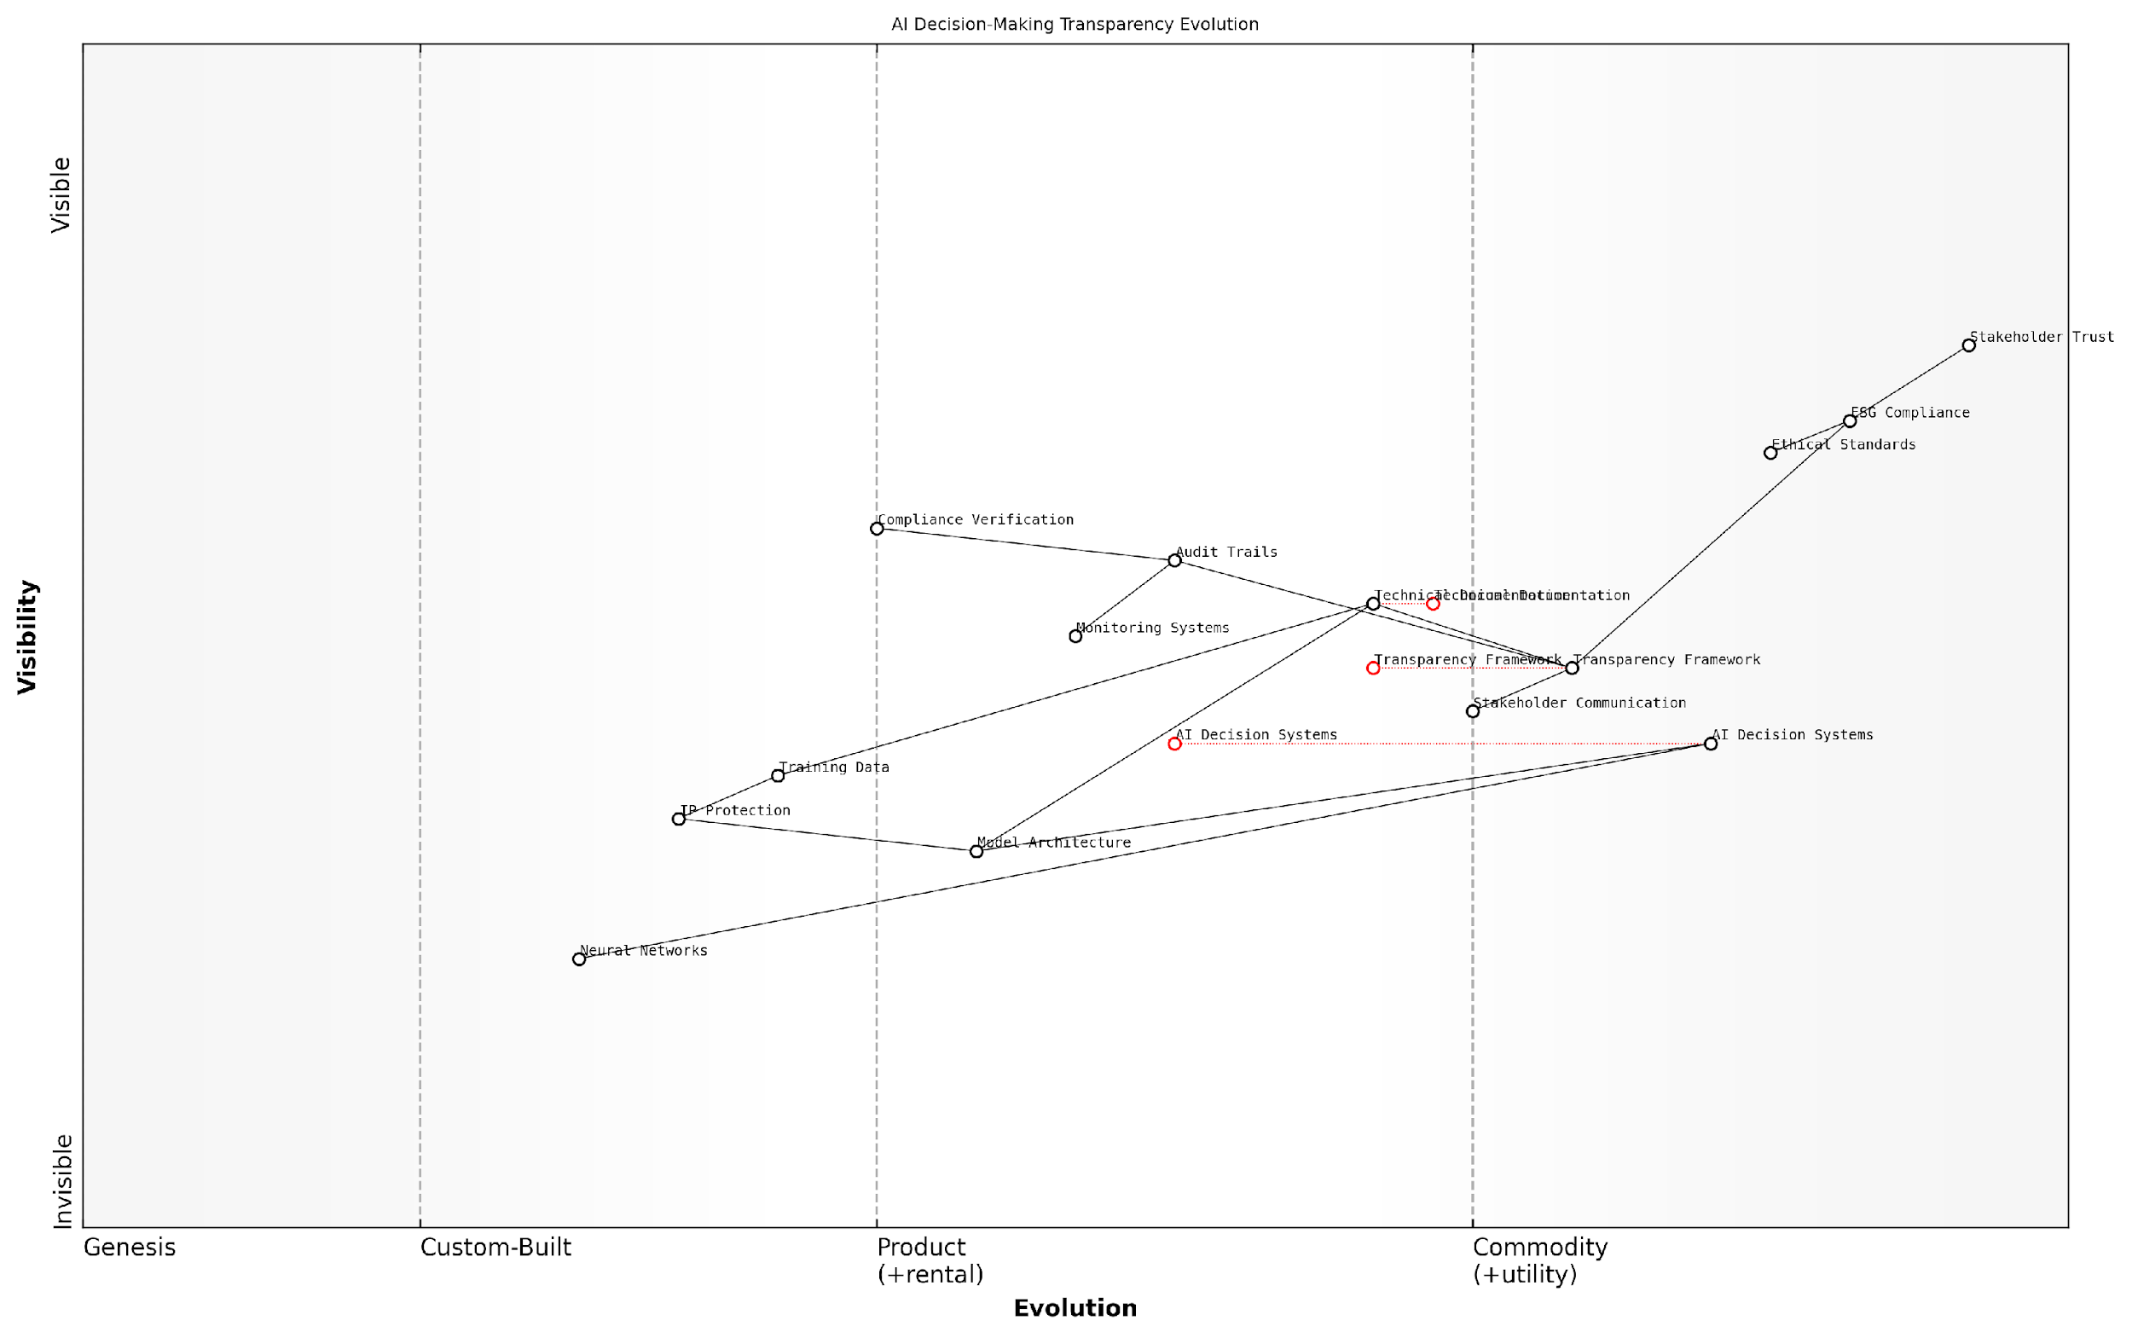

*Draft Wardley Map: [Wardley Map: AI Decision-Making Transparency Evolution - showing the journey from basic compliance to strategic advantage]*

[Edit this draft Wardley Map](https://create.wardleymaps.ai/#clone:5c348a2776955a0506)

**Wardley Map Assessment**

The map reveals a well-structured approach to AI transparency with clear evolution paths and strategic opportunities. Key focus areas should be automating transparency processes, strengthening documentation standards, and enhancing stakeholder communication while maintaining robust technical foundations.

[View full Wardley Map report](http://markdown/wardley_map_reports/wardley_map_report_13_english_AI_Decision-Making_Transparency.md)

The implementation of transparent AI decision-making systems requires a structured approach that encompasses both technical and organisational elements. Based on my consultancy work with leading organisations, I’ve observed that successful transparency initiatives typically involve three key phases: establishment of baseline transparency requirements, development of appropriate documentation and communication frameworks, and implementation of ongoing monitoring and reporting mechanisms.

* Technical Documentation Requirements: Detailed documentation of AI systems, including model specifications, training data, and validation processes
* Stakeholder Engagement Protocols: Structured approaches for communicating AI decisions to different stakeholder groups
* Monitoring and Reporting Frameworks: Regular assessment and reporting of AI system transparency metrics
* Compliance Verification Processes: Independent verification of transparency claims and commitments
* Continuous Improvement Mechanisms: Regular review and enhancement of transparency measures

In the realm of ESG governance, transparency isn’t just about compliance—it’s about building and maintaining trust with stakeholders through demonstrable commitment to ethical AI practices.

Looking ahead, the evolution of AI transparency requirements in ESG contexts will likely be shaped by advancing regulatory frameworks, increasing stakeholder expectations, and technological developments. Organisations must prepare for this evolution by establishing flexible transparency frameworks that can adapt to changing requirements whilst maintaining robust governance standards.

### Accountability Frameworks

In the complex landscape of ESG governance, establishing robust accountability frameworks for AI systems represents one of the most critical challenges organisations face today. These frameworks must balance the innovative potential of AI with responsible governance practices, ensuring that automated decision-making aligns with environmental, social, and governance objectives whilst maintaining clear lines of responsibility.

The challenge isn’t just about implementing AI systems – it’s about creating governance structures that ensure these systems remain accountable to human oversight whilst delivering on ESG objectives, notes a senior regulatory adviser in sustainable finance.

Effective accountability frameworks for AI in ESG contexts must address multiple layers of responsibility, from technical implementation to board-level oversight. These frameworks become particularly crucial as organisations increasingly rely on AI systems to manage and report on their ESG commitments, creating a complex web of interdependencies between human decision-makers and automated systems.

* Clear delineation of roles and responsibilities between human operators and AI systems
* Established chains of command for AI-driven decisions affecting ESG outcomes
* Regular audit mechanisms to assess AI system compliance with ESG objectives
* Documentation requirements for AI decision-making processes
* Escalation protocols for AI-related ESG incidents
* Stakeholder engagement procedures for AI governance

A crucial component of these frameworks is the establishment of clear lines of responsibility for AI-driven decisions. This includes defining who holds ultimate accountability for AI systems’ ESG impacts, from technical teams to C-suite executives and board members. Organisations must implement robust reporting structures that provide transparency into how AI systems influence ESG outcomes.

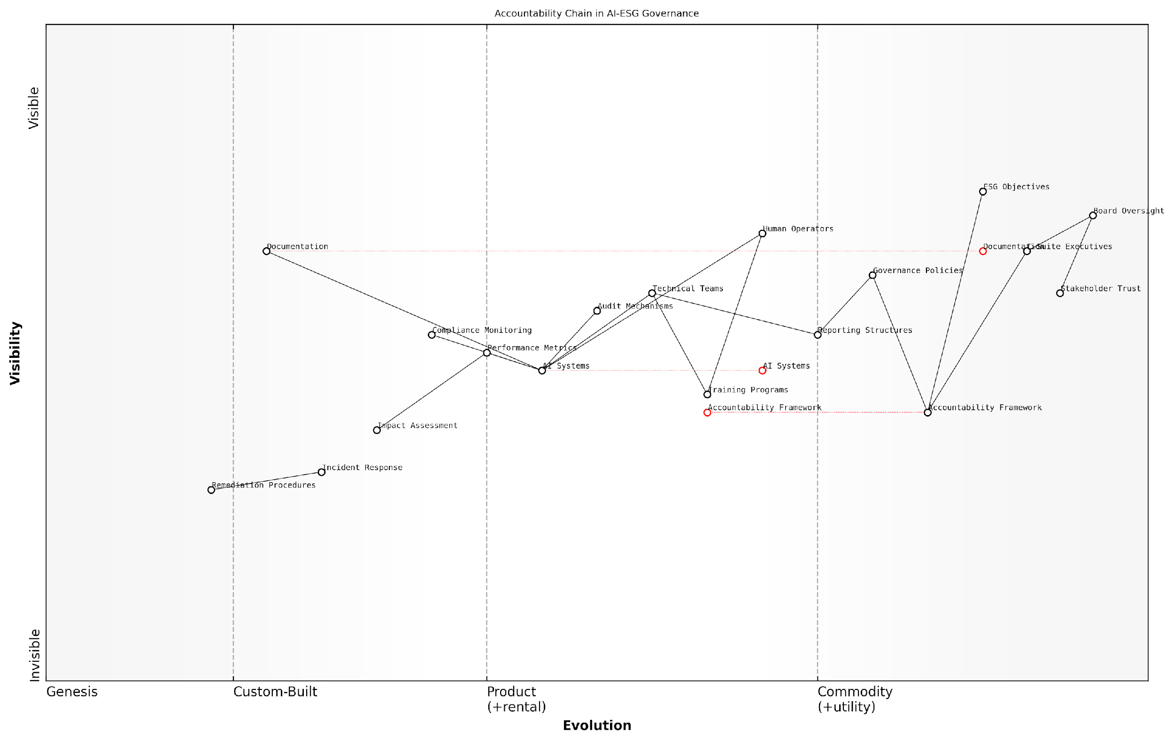

*Draft Wardley Map: [Wardley Map: Accountability Chain in AI-ESG Governance showing the evolution from technical implementation to board-level oversight]*

[Edit this draft Wardley Map](https://create.wardleymaps.ai/#clone:d0850a90e86a71706b)

**Wardley Map Assessment**

The map reveals a well-structured accountability framework with opportunities for technical enhancement and automation, requiring balanced investment in both governance and technological capabilities to maintain effectiveness and competitive advantage

[View full Wardley Map report](http://markdown/wardley_map_reports/wardley_map_report_14_english_Accountability_Frameworks.md)

The framework must also incorporate mechanisms for continuous monitoring and assessment of AI systems’ ESG performance. This includes regular reviews of AI models’ decision-making patterns, impact assessments, and alignment with established ESG criteria. Organisations should establish clear metrics for measuring AI accountability in ESG contexts.

* Quarterly reviews of AI system ESG performance metrics
* Annual independent audits of AI governance structures
* Regular stakeholder consultations on AI-ESG impacts
* Continuous monitoring of AI system compliance with ESG policies
* Periodic assessment of accountability framework effectiveness

Without robust accountability frameworks, organisations risk creating a ‘black box’ of AI-driven ESG decisions that could undermine stakeholder trust and regulatory compliance, observes a leading governance expert.

Training and capacity building form essential components of these frameworks. Organisations must ensure that all relevant stakeholders understand their roles in maintaining AI accountability within ESG contexts. This includes technical teams, management, board members, and external stakeholders who may be affected by AI-driven ESG decisions.

The framework should also address remediation procedures for cases where AI systems fail to meet ESG objectives or cause unintended consequences. This includes clear protocols for investigation, correction, and prevention of future incidents, ensuring that lessons learned are incorporated into improved governance practices.

### Risk Management Structures

In the complex intersection of AI and ESG governance, establishing robust risk management structures is paramount for organisations seeking to harness AI’s potential while maintaining ethical and sustainable practices. These structures must address both traditional ESG risks and the unique challenges posed by artificial intelligence systems.

The integration of AI into ESG frameworks represents one of the most significant governance challenges of our time. Traditional risk management approaches must evolve to accommodate the dynamic and often unpredictable nature of AI systems.

Effective risk management structures for AI in ESG contexts require a multi-layered approach that encompasses technical, operational, and strategic considerations. These structures must be adaptable enough to evolve with technological advancement while remaining robust enough to provide meaningful oversight and control.

* Board-level oversight and accountability frameworks for AI deployment
* Clear delineation of roles and responsibilities in AI risk management
* Regular risk assessments and monitoring protocols
* Incident response and escalation procedures
* Documentation and audit trails for AI decision-making processes
* Stakeholder engagement and communication strategies

A critical component of these structures is the establishment of clear lines of accountability. Organisations must define who is responsible for monitoring AI systems, who has the authority to intervene when issues arise, and how decisions regarding AI deployment are made and documented. This becomes particularly crucial when AI systems are making or influencing decisions that impact ESG outcomes.

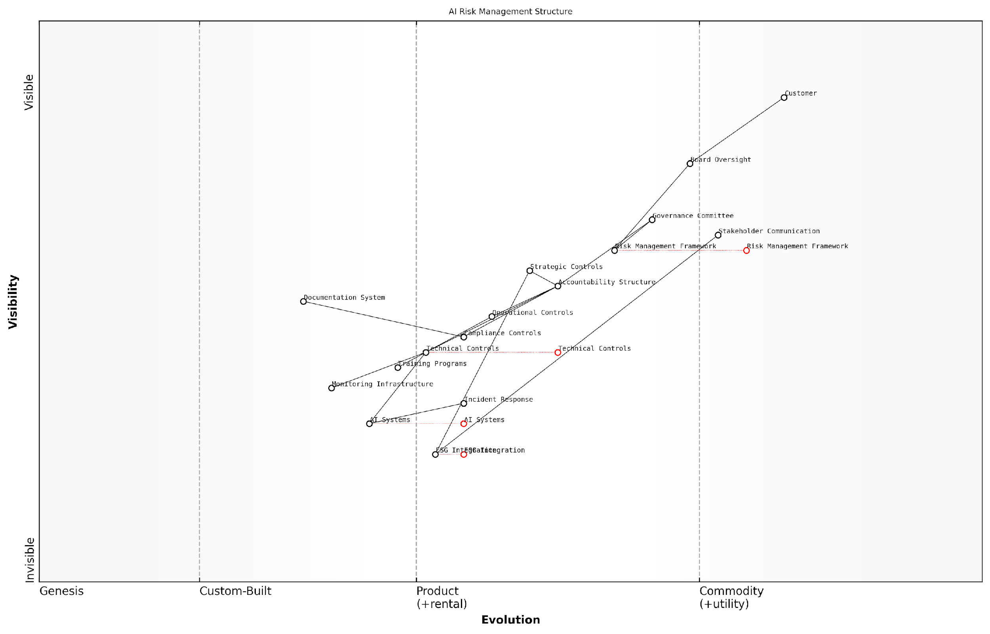

*Draft Wardley Map: [Wardley Map: AI Risk Management Structure showing evolution from chaotic to industrialised components]*

[Edit this draft Wardley Map](https://create.wardleymaps.ai/#clone:a44923aae88cffcd99)

**Wardley Map Assessment**

The map represents a well-structured but complex risk management system that requires modernisation through automation and integration while maintaining strong governance principles. Key focus areas should be strengthening technical capabilities while streamlining control structures.

[View full Wardley Map report](http://markdown/wardley_map_reports/wardley_map_report_15_english_Risk_Management_Structures.md)

* Technical Controls: Algorithm validation, data quality checks, performance monitoring
* Operational Controls: Training requirements, access controls, change management procedures
* Strategic Controls: Policy frameworks, governance committees, stakeholder engagement processes
* Compliance Controls: Regulatory monitoring, reporting mechanisms, audit procedures

The implementation of these structures must be supported by appropriate resources and expertise. This includes dedicated personnel with both AI and ESG knowledge, technological infrastructure for monitoring and control, and ongoing training and development programmes to ensure staff remain current with evolving best practices and regulatory requirements.

The most successful organisations in managing AI-ESG risks are those that view risk management not as a constraint, but as an enabler of responsible innovation and sustainable growth, according to a leading industry regulatory expert.

Regular review and updating of risk management structures is essential. As AI technology evolves and ESG expectations change, organisations must ensure their risk management approaches remain fit for purpose. This includes periodic assessments of the effectiveness of controls, updates to policies and procedures, and incorporation of lessons learned from incidents or near-misses.

# Chapter 2: Measuring AI’s ESG Impact

## The ESG-AI Scorecard

### Key Performance Indicators

In the complex landscape of AI and ESG integration, establishing meaningful Key Performance Indicators (KPIs) is crucial for organisations seeking to measure and optimise their technological initiatives against sustainability objectives. Drawing from extensive experience in implementing AI-ESG frameworks across various sectors, it’s evident that effective KPIs must bridge the gap between technological capabilities and ESG outcomes whilst maintaining measurable, actionable metrics.

The challenge isn’t just measuring AI’s impact on ESG metrics, but creating a framework that captures both the direct and indirect effects of AI implementation on our sustainability goals, notes a senior sustainability officer at a leading financial institution.

The ESG-AI Scorecard framework introduces three distinct categories of KPIs, each designed to capture specific aspects of AI’s impact on ESG performance. These indicators must be both comprehensive enough to capture meaningful data and practical enough for real-world implementation.

* Environmental Impact Metrics: Energy efficiency ratio (AI processing power vs. output), carbon footprint per AI operation, resource optimisation rates
* Social Impact Indicators: AI bias detection rates, workforce adaptation metrics, privacy compliance scores
* Governance Performance Measures: Decision transparency index, algorithmic accountability metrics, risk assessment scores

When implementing these KPIs, organisations must consider both quantitative and qualitative aspects. The quantitative measurements provide concrete data points, whilst qualitative assessments offer context and nuance essential for meaningful evaluation.

* Quantitative KPIs: Carbon emissions per compute hour, energy efficiency metrics, diversity scores in AI training data
* Qualitative KPIs: Stakeholder satisfaction indices, ethical alignment assessments, community impact evaluations
* Hybrid KPIs: Risk-adjusted performance metrics, sustainability impact scores, governance effectiveness ratings

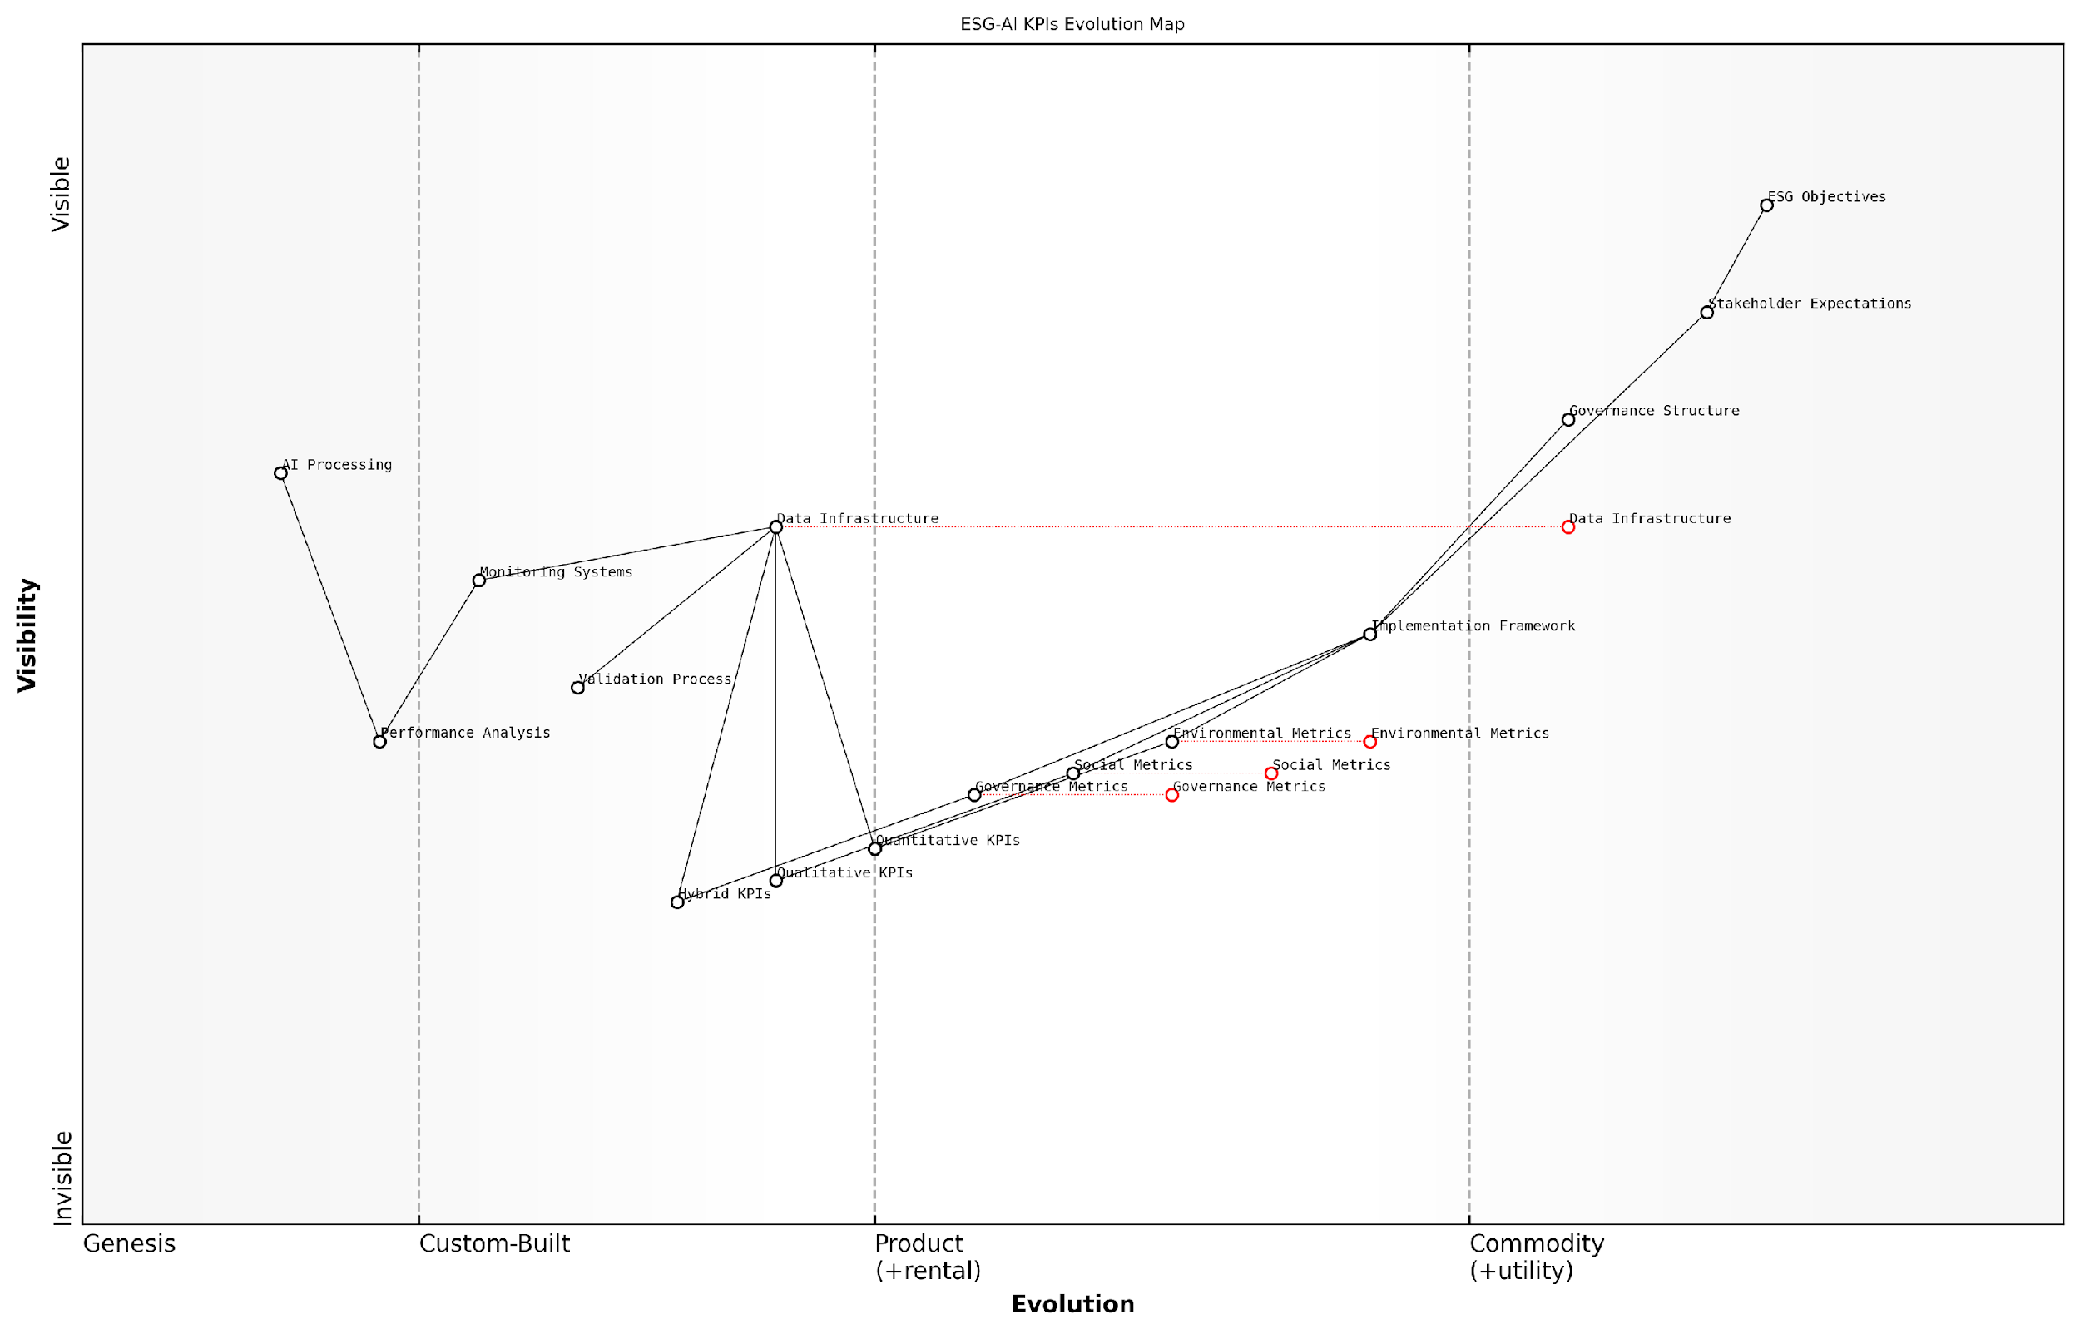

*Draft Wardley Map: [Wardley Map: Evolution of ESG-AI KPIs showing the progression from basic metrics to advanced indicators]*

[Edit this draft Wardley Map](https://create.wardleymaps.ai/#clone:78e40510cb688bd82d)

**Wardley Map Assessment**

The map reveals a well-structured ESG-AI KPI system with clear evolution paths and strategic opportunities, particularly in AI integration and automation. Success depends on balancing stakeholder needs with technical capabilities while maintaining strong governance.

[View full Wardley Map report](http://markdown/wardley_map_reports/wardley_map_report_16_english_Key_Performance_Indicators.md)

The implementation of these KPIs requires a robust data collection infrastructure and regular validation processes. Organisations must establish baseline measurements, set realistic targets, and develop mechanisms for continuous monitoring and adjustment.

The most successful implementations we’ve seen are those that treat ESG-AI KPIs not as static measurements, but as dynamic indicators that evolve with technological advancement and changing stakeholder expectations, observes a leading ESG strategy consultant.

* Implementation Steps: Baseline assessment, target setting, monitoring framework establishment, regular review cycles
* Validation Requirements: Data quality checks, third-party verification, stakeholder feedback integration
* Adjustment Mechanisms: Performance threshold updates, metric refinement processes, stakeholder input incorporation

To ensure the effectiveness of these KPIs, organisations must establish clear governance structures for oversight and regular review. This includes defining roles and responsibilities for data collection, analysis, and reporting, as well as establishing processes for addressing performance gaps and implementing corrective actions.

### Measurement Methodologies

In developing robust measurement methodologies for evaluating AI’s impact on ESG performance, organisations must navigate a complex landscape of quantitative and qualitative metrics. As an expert who has implemented these frameworks across numerous public sector organisations, I can attest that effective measurement requires a multi-layered approach that captures both direct and indirect impacts of AI systems.

The challenge isn’t just measuring AI’s impact on ESG metrics, but understanding the intricate feedback loops between technological implementation and sustainability outcomes. Traditional ESG metrics often fail to capture the nuanced ways AI systems influence organisational performance.

The foundation of effective measurement methodology rests on three core pillars: impact quantification, performance attribution, and systemic assessment. Each pillar requires specific tools and approaches, calibrated to the organisation’s context and strategic objectives.

* Impact Quantification: Direct measurement of AI system energy consumption, resource utilisation, and operational efficiency gains
* Performance Attribution: Analysis of causal relationships between AI implementations and ESG outcomes
* Systemic Assessment: Evaluation of broader organisational and societal impacts, including unintended consequences

When implementing measurement methodologies, organisations must establish clear baseline metrics before AI deployment. This enables accurate assessment of incremental changes and helps isolate AI’s specific contribution to ESG outcomes. My experience in government consultancy has shown that baseline establishment is often overlooked, leading to significant challenges in impact evaluation.

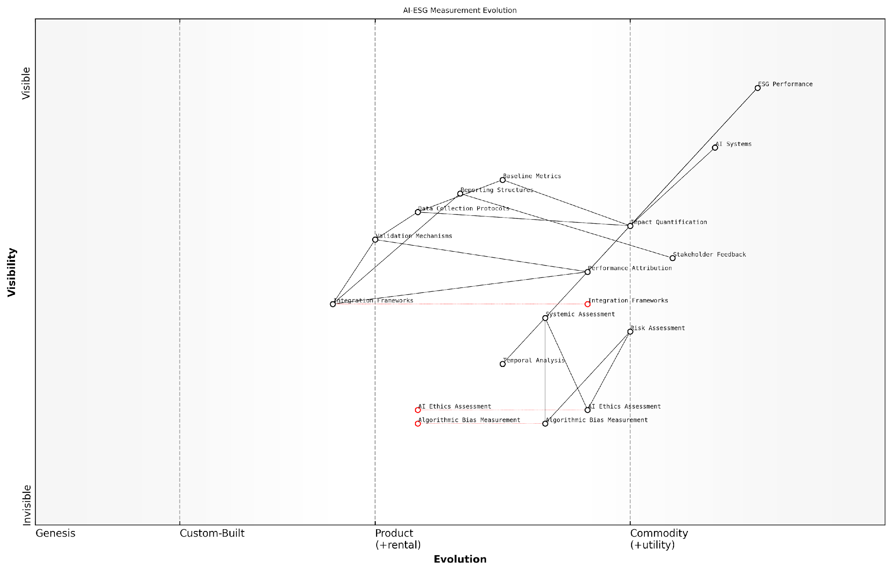

*Draft Wardley Map: [Wardley Map: AI-ESG Measurement Evolution, showing the progression from basic metrics to sophisticated impact assessment methodologies]*

[Edit this draft Wardley Map](https://create.wardleymaps.ai/#clone:cb920d0bd44303670b)

**Wardley Map Assessment**

The map reveals a system in transition from traditional ESG measurement to AI-enabled assessment, with critical needs for development in ethics, validation, and integration capabilities. Success requires balanced investment in both foundational and emerging components whilst maintaining focus on ultimate ESG performance outcomes.

[View full Wardley Map report](http://markdown/wardley_map_reports/wardley_map_report_17_english_Measurement_Methodologies.md)

* Data Collection Protocols: Standardised procedures for gathering relevant metrics across environmental, social, and governance dimensions
* Validation Mechanisms: Cross-referencing methodologies to ensure data accuracy and reliability
* Integration Frameworks: Systems for combining multiple data sources into coherent assessment models
* Reporting Structures: Standardised formats for communicating results to various stakeholders

The methodology must also account for the temporal dimension of AI-ESG interactions. Short-term metrics might show immediate efficiency gains, whilst long-term measurements could reveal hidden sustainability costs or benefits. This temporal analysis is particularly crucial in public sector implementations, where policy outcomes often manifest over extended periods.

A senior policy advisor recently noted that ‘The most successful AI-ESG measurement frameworks are those that balance immediate operational metrics with long-term sustainability indicators, creating a comprehensive view of technology’s impact on organisational performance.’

Advanced measurement methodologies should incorporate adaptive elements that can evolve with technological advancement and changing ESG priorities. This includes provisions for emerging metrics, such as AI ethics assessments and algorithmic bias measurements, which may become increasingly relevant as AI systems become more sophisticated.

* Regular methodology reviews and updates
* Stakeholder feedback integration mechanisms
* Continuous improvement protocols
* Emerging risk assessment frameworks

The implementation of these measurement methodologies requires significant organisational commitment and resources. However, my experience has shown that organisations that invest in robust measurement frameworks are better positioned to optimise their AI implementations for ESG performance and demonstrate value to stakeholders.

### Data Collection and Validation

In the complex landscape of AI-driven ESG initiatives, robust data collection and validation processes form the cornerstone of meaningful measurement and assessment. As organisations increasingly rely on artificial intelligence to gather, process, and analyse ESG data, the importance of establishing reliable data governance frameworks cannot be overstated.

The quality of ESG metrics is only as good as the data that underpins them. In the age of AI, we must be even more vigilant about data integrity and validation processes.

The intersection of AI and ESG data collection presents unique challenges and opportunities. While AI systems can process vast quantities of data at unprecedented speeds, they also introduce new complexities in terms of data quality assurance, bias detection, and validation methodologies. Organisations must implement comprehensive frameworks that address these challenges whilst leveraging the advantages of AI-driven data collection.

* Primary Data Sources: Direct measurements, IoT sensors, satellite imagery, and real-time monitoring systems
* Secondary Data Sources: Third-party databases, regulatory filings, industry reports, and stakeholder feedback
* Alternative Data: Social media sentiment, news analysis, and other AI-processed unstructured data
* Validation Methods: Cross-referencing, algorithmic verification, and human expert review

Data validation in the context of AI-driven ESG metrics requires a multi-layered approach. Organisations must implement both automated and manual validation processes to ensure data accuracy, completeness, and reliability. This includes establishing clear data quality standards, implementing robust verification protocols, and maintaining comprehensive audit trails.

* Data Quality Parameters: Accuracy, completeness, consistency, timeliness, and relevance
* Validation Protocols: Automated range checks, outlier detection, trend analysis, and cross-validation
* Quality Assurance Measures: Regular audits, peer review processes, and external verification
* Documentation Requirements: Metadata management, version control, and change tracking

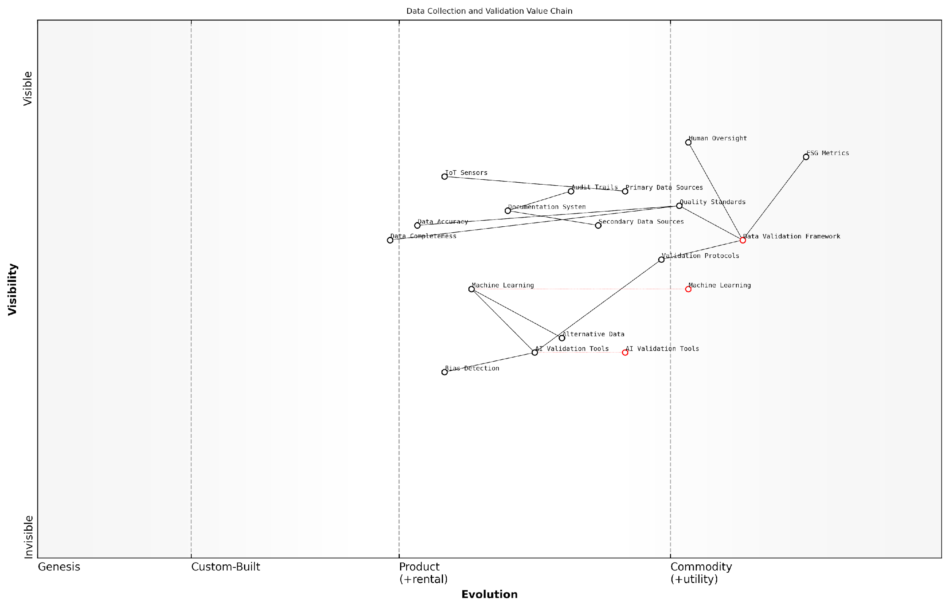

*Draft Wardley Map: [Wardley Map: Data Collection and Validation Value Chain, showing the evolution from raw data collection to validated ESG metrics]*

[Edit this draft Wardley Map](https://create.wardleymaps.ai/#clone:05fee51f83515d1959)

**Wardley Map Assessment**

The map reveals a well-structured but evolving system with significant opportunities for automation and standardisation while maintaining robust validation integrity. Key focus areas should be strengthening AI capabilities while ensuring human oversight remains effective.

[View full Wardley Map report](http://markdown/wardley_map_reports/wardley_map_report_18_english_Data_Collection_and_Validation.md)

The role of AI in data validation itself presents both opportunities and risks. While machine learning algorithms can identify patterns and anomalies that might escape human detection, they must be carefully monitored to prevent the perpetuation or amplification of existing biases. Organisations must implement governance frameworks that ensure AI systems remain transparent and accountable in their data validation processes.

The future of ESG measurement lies in the symbiotic relationship between human expertise and AI capabilities. Neither alone is sufficient for robust data validation in today’s complex business environment.

* AI Validation Tools: Machine learning algorithms for pattern recognition and anomaly detection
* Human Oversight: Expert review panels, stakeholder feedback mechanisms, and regular audits
* Hybrid Approaches: Combined AI-human validation workflows and decision support systems
* Continuous Improvement: Regular review and updating of validation methodologies and criteria

As regulatory requirements and stakeholder expectations continue to evolve, organisations must maintain flexible and adaptable data collection and validation frameworks. This includes regular reviews of data collection methodologies, updates to validation protocols, and continuous enhancement of AI systems to ensure they remain effective and reliable in supporting ESG measurement objectives.

## Assessment Tools and Frameworks

### Quantitative Metrics

In the complex landscape of AI and ESG integration, quantitative metrics serve as essential tools for measuring and evaluating the tangible impacts of artificial intelligence systems on environmental, social, and governance outcomes. As organisations increasingly deploy AI solutions to support their ESG initiatives, the need for robust, measurable indicators becomes paramount for ensuring accountability and demonstrating real progress.

Without concrete metrics to measure AI’s impact on ESG objectives, organisations risk falling into the trap of ‘AI-washing’ – making unsubstantiated claims about technology’s benefits without proper evidence to support them.

The development of quantitative metrics for AI-ESG assessment requires a multifaceted approach that considers both direct and indirect impacts. These metrics must be specific, measurable, achievable, relevant, and time-bound (SMART), whilst also accounting for the unique characteristics of AI systems and their interactions with ESG objectives.

* Environmental Metrics: Carbon emissions per model training session, energy efficiency ratios, computational resource utilisation rates, data centre PUE (Power Usage Effectiveness)
* Social Impact Metrics: AI bias detection rates, workforce diversity indicators, privacy breach incidents, data protection compliance scores
* Governance Metrics: Algorithm audit completion rates, decision transparency indices, stakeholder engagement levels, risk incident frequencies

When implementing these metrics, organisations must consider the granularity of measurement, data collection methodologies, and the frequency of assessment. The metrics should be designed to provide actionable insights whilst maintaining consistency with existing ESG reporting frameworks and regulatory requirements.

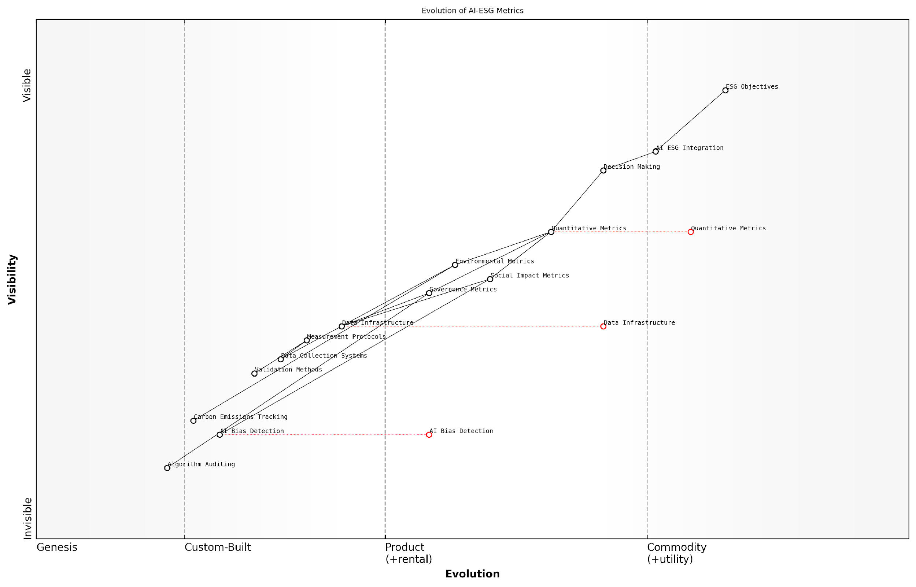

*Draft Wardley Map: [Wardley Map: Evolution of AI-ESG Metrics from Genesis to Commodity]*

[Edit this draft Wardley Map](https://create.wardleymaps.ai/#clone:4406b76835f439584b)

**Wardley Map Assessment**

The map reveals a maturing AI-ESG metrics landscape with clear evolution toward standardisation and automation, requiring strategic investment in both foundational infrastructure and advanced capabilities to maintain competitive advantage while ensuring robust ESG performance measurement

[View full Wardley Map report](http://markdown/wardley_map_reports/wardley_map_report_19_english_Quantitative_Metrics.md)

* Primary Metrics: Direct measurements of AI system performance and impact
* Secondary Metrics: Indirect effects and downstream consequences
* Composite Metrics: Combined indicators that provide holistic assessment
* Trend Metrics: Time-series data showing progress and evolution

The effectiveness of quantitative metrics depends heavily on the quality of data collection systems and the rigour of measurement protocols. Organisations must invest in robust data infrastructure and establish clear procedures for metric calculation and validation. This includes implementing appropriate controls to ensure data integrity and maintaining detailed documentation of measurement methodologies.

A senior sustainability officer at a leading technology firm notes: ‘The key to successful AI-ESG measurement lies not just in the metrics themselves, but in how they are integrated into decision-making processes and governance frameworks.’

* Data Collection Protocols: Standardised procedures for gathering metric inputs
* Validation Methods: Cross-checking mechanisms and quality assurance processes
* Reporting Frameworks: Structured approaches to metric documentation and communication
* Review Cycles: Regular assessment and refinement of metric effectiveness

To ensure the long-term value of quantitative metrics, organisations must regularly review and update their measurement frameworks to reflect evolving AI technologies, changing ESG priorities, and emerging regulatory requirements. This adaptive approach helps maintain the relevance and effectiveness of the metrics whilst supporting continuous improvement in AI-ESG performance assessment.

### Qualitative Assessments

Qualitative assessments form a crucial complement to quantitative metrics in evaluating AI’s impact on ESG objectives. While numbers tell part of the story, the complex interplay between artificial intelligence and sustainability demands a more nuanced approach that captures intangible factors, stakeholder perspectives, and contextual considerations that may not be readily quantifiable.

The true measure of AI’s ESG impact cannot be reduced to mere numbers. We must consider the broader societal implications, ethical considerations, and long-term consequences that often defy simple quantification.

In my extensive experience advising government bodies and corporations on AI-ESG integration, I’ve observed that effective qualitative assessment frameworks typically encompass three core dimensions: stakeholder engagement, ethical impact analysis, and governance effectiveness evaluation. These dimensions require structured approaches that maintain rigour while accommodating subjective elements.

* Stakeholder Interviews and Surveys: Structured feedback collection from affected parties, including employees, communities, and environmental groups
* Expert Panel Reviews: Independent assessments by subject matter experts in AI ethics, environmental science, and social impact
* Case Study Analysis: Detailed examination of specific AI implementations and their ESG outcomes
* Ethical Impact Assessments: Structured evaluation of AI systems against established ethical frameworks
* Governance Process Reviews: Analysis of decision-making procedures and oversight mechanisms

A particularly effective approach I’ve implemented involves the use of structured assessment matrices that combine standardised evaluation criteria with narrative evidence. This method helps organisations maintain consistency while capturing nuanced insights that might be lost in purely quantitative approaches.

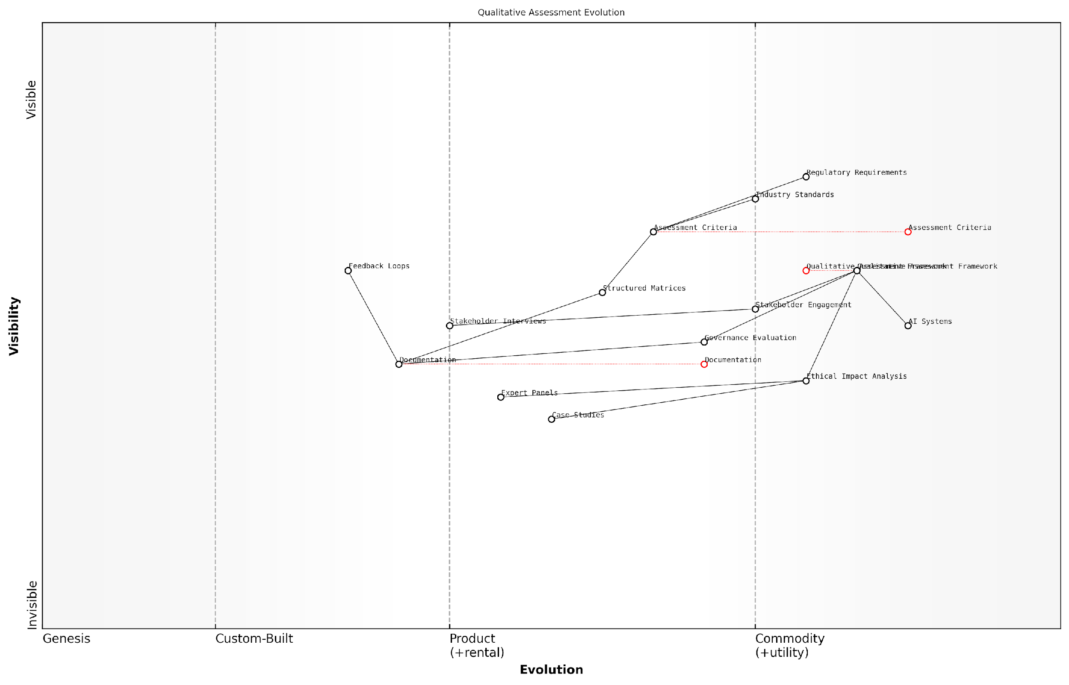

*Draft Wardley Map: [Wardley Map: Qualitative Assessment Evolution - showing the movement from basic compliance checks to sophisticated multi-stakeholder evaluation frameworks]*

[Edit this draft Wardley Map](https://create.wardleymaps.ai/#clone:b318af63beaf6dbe0f)

**Wardley Map Assessment**

The map reveals a system in transition towards more standardised and automated assessment processes, with opportunities for innovation in AI integration while maintaining robust stakeholder engagement and ethical considerations. Success requires balanced investment in technology and human expertise.

[View full Wardley Map report](http://markdown/wardley_map_reports/wardley_map_report_20_english_Qualitative_Assessments.md)

The assessment process must be iterative and adaptive, recognising that AI systems and their ESG impacts evolve over time. Regular review cycles, incorporating feedback loops and lessons learned, ensure that qualitative assessments remain relevant and effective.

* Documentation of AI system behaviour and decision-making patterns
* Regular stakeholder feedback collection and analysis
* Periodic review of assessment criteria and methodologies
* Integration of emerging ethical considerations and societal concerns
* Continuous alignment with evolving regulatory requirements and industry standards

Qualitative assessment frameworks must evolve as rapidly as the AI systems they evaluate. Yesterday’s assessment criteria may be inadequate for tomorrow’s challenges.

One of the most challenging aspects of qualitative assessment is maintaining objectivity whilst acknowledging inherent subjectivity. To address this, I recommend implementing structured rubrics that clearly define assessment criteria whilst allowing for contextual interpretation. This approach helps organisations strike the right balance between standardisation and flexibility.

### Benchmarking Standards

In the complex landscape of AI and ESG integration, establishing robust benchmarking standards is crucial for organisations to effectively measure and compare their performance. As an essential component of the Assessment Tools and Frameworks section, benchmarking standards provide the foundation for meaningful comparison and continuous improvement in AI-driven ESG initiatives.

The challenge isn’t just measuring our own AI-ESG performance, but understanding where we stand in relation to industry best practices and peer organisations. Without standardised benchmarks, we’re essentially navigating in the dark.

The development of benchmarking standards for AI in ESG contexts requires a multi-dimensional approach that considers both technical and operational aspects. These standards must account for the unique characteristics of AI systems while aligning with established ESG reporting frameworks such as GRI, SASB, and TCFD.

* Technical Performance Metrics: Computing power efficiency, model accuracy, bias detection rates
* Environmental Impact Indicators: Energy consumption per model training, carbon footprint of AI operations
* Social Responsibility Measures: AI bias mitigation effectiveness, workforce impact assessment
* Governance Compliance Standards: Algorithm transparency scores, data privacy compliance levels

A crucial aspect of effective benchmarking is the establishment of industry-specific baseline metrics. These baselines must account for variations in organisational size, sector-specific requirements, and technological maturity levels. The benchmarking framework should incorporate both absolute and relative performance measures to provide a comprehensive view of an organisation’s AI-ESG standing.

* Sector-Specific Benchmarks: Tailored metrics for different industries
* Size-Adjusted Standards: Scaled benchmarks based on organisational capacity
* Maturity-Based Comparisons: Progressive standards aligned with AI implementation stages
* Geographic Considerations: Regional variations in regulatory requirements and ESG priorities

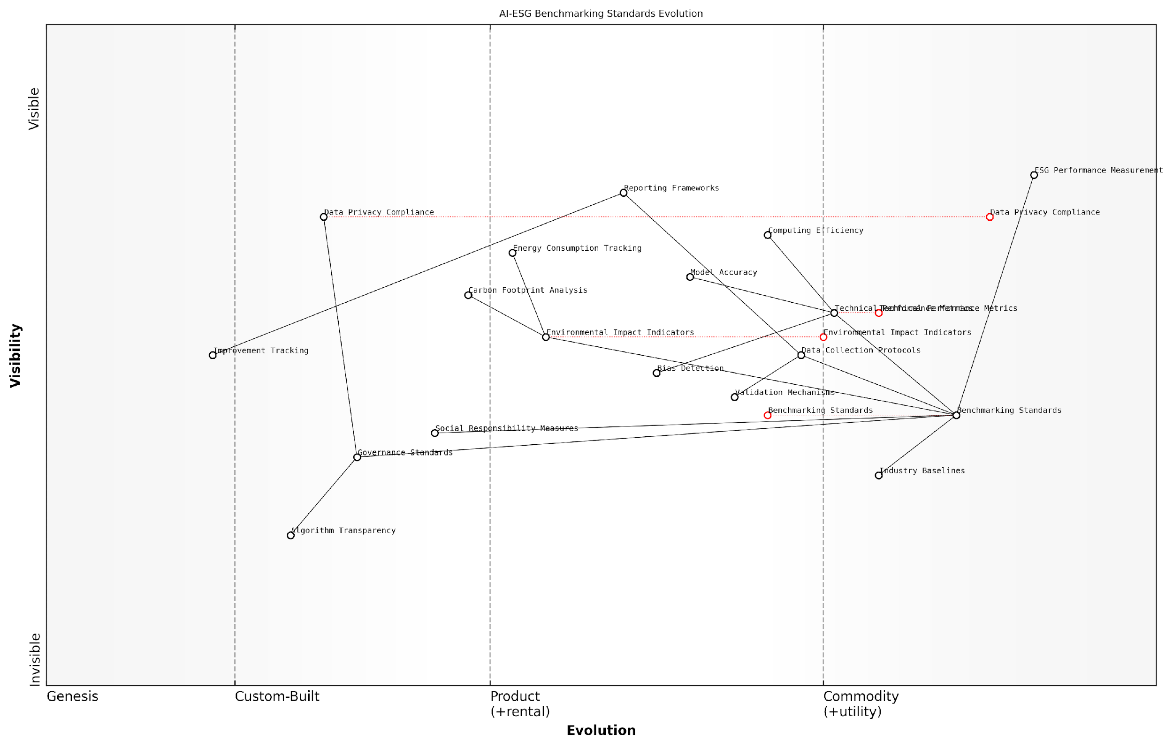

*Draft Wardley Map: [Wardley Map: Evolution of AI-ESG Benchmarking Standards showing progression from genesis to commodity]*

[Edit this draft Wardley Map](https://create.wardleymaps.ai/#clone:7214045cb383f73ba8)

**Wardley Map Assessment**

The map reveals a maturing AI-ESG benchmarking system with strong technical and environmental foundations, but requiring development in social and governance areas. Strategic focus should be on standardisation, integration, and closing capability gaps while maintaining leadership in core areas.

[View full Wardley Map report](http://markdown/wardley_map_reports/wardley_map_report_21_english_Benchmarking_Standards.md)

The implementation of benchmarking standards requires a systematic approach to data collection, validation, and analysis. Organisations must establish robust processes for continuous monitoring and reporting, ensuring that benchmarking activities contribute to meaningful insights and actionable improvements.

* Data Collection Protocols: Standardised methods for gathering AI-ESG performance data
* Validation Mechanisms: Third-party verification and audit procedures
* Reporting Frameworks: Structured templates for consistent documentation
* Improvement Tracking: Systems for monitoring progress against benchmarks

The most effective benchmarking standards are those that evolve alongside technological advancement while maintaining consistency in core ESG principles. This balance between innovation and stability is crucial for long-term success.

Looking ahead, the evolution of AI-ESG benchmarking standards will likely be influenced by emerging technologies, regulatory changes, and shifting stakeholder expectations. Organisations must maintain flexibility in their benchmarking frameworks while ensuring alignment with established industry standards and best practices.

# Chapter 3: Strategic Implementation

## Risk-Opportunity Mapping

### Wardley Mapping Application

In the complex landscape of AI and ESG integration, Wardley Mapping emerges as a crucial strategic tool for organisations seeking to navigate the intricate relationships between technological advancement and sustainability objectives. As an evolution-based framework, it provides unprecedented clarity in visualising the maturity and interdependencies of AI components within ESG initiatives.

Wardley Mapping has transformed our understanding of AI-ESG integration from a theoretical concept to an actionable strategy. It reveals not just where we are, but where the market is heading, allowing us to make informed decisions about technology adoption whilst maintaining our sustainability commitments.

The application of Wardley Mapping to AI-ESG initiatives requires careful consideration of four key dimensions: component identification, evolutionary stage assessment, value chain positioning, and movement mapping. Each dimension provides crucial insights into how AI technologies can be leveraged to advance ESG objectives whilst managing associated risks.

* Component Identification: Mapping core AI capabilities, data infrastructure, and ESG metrics
* Evolution Assessment: Determining the maturity of AI technologies and ESG practices
* Value Chain Analysis: Understanding dependencies between AI implementations and ESG outcomes
* Movement Mapping: Predicting future states and strategic opportunities

When applying Wardley Mapping to AI-ESG initiatives, organisations must first identify the key components of their AI infrastructure and ESG programmes. This includes both visible elements (such as AI applications and ESG reporting tools) and invisible infrastructure (such as data pipelines and governance frameworks). The positioning of these components along the evolution axis reveals crucial insights about their maturity and strategic importance.

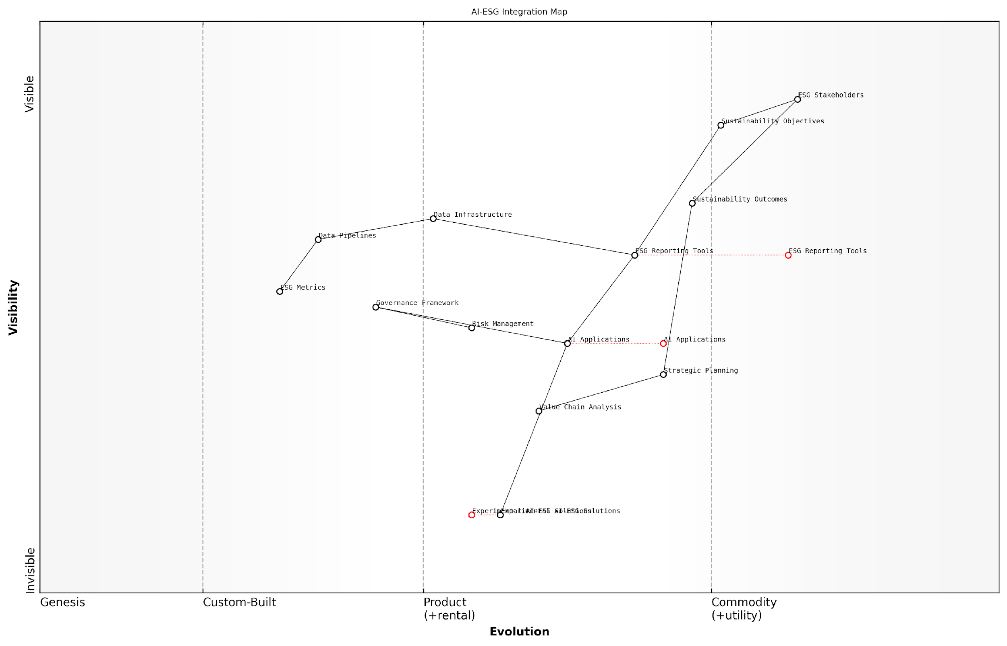

*Draft Wardley Map: [Wardley Map showing the evolution of AI components in ESG context, from genesis to commodity]*

[Edit this draft Wardley Map](https://create.wardleymaps.ai/#clone:510ade0d277ef90e4b)

**Wardley Map Assessment**

The map reveals a well-structured approach to AI-ESG integration with clear evolution paths and strategic opportunities. Success requires balanced investment in technology, governance, and capabilities while maintaining stakeholder focus.

[View full Wardley Map report](http://markdown/wardley_map_reports/wardley_map_report_22_english_Wardley_Mapping_Application.md)

The evolutionary stages in an AI-ESG Wardley Map typically progress from genesis (experimental AI applications in ESG), through custom-built solutions and product development, to commodity services. Understanding this progression is crucial for strategic planning and resource allocation.

* Genesis Stage: Experimental AI applications for novel ESG challenges
* Custom-Built Stage: Tailored AI solutions for specific ESG requirements
* Product Stage: Standardised AI tools for common ESG tasks
* Commodity Stage: Widely available AI services for basic ESG functions

The true value of Wardley Mapping in the AI-ESG context lies in its ability to reveal not just the current state of technology and sustainability practices, but also the direction of travel. This foresight is invaluable for organisations seeking to maintain leadership in sustainable technology adoption.

The value chain dimension of Wardley Mapping is particularly crucial in the AI-ESG context, as it helps organisations understand how different components contribute to overall sustainability objectives. This understanding enables more effective resource allocation and helps identify potential risks and opportunities in the AI-ESG value chain.

* Identify key stakeholders and their needs in the AI-ESG value chain
* Map dependencies between different AI components and ESG outcomes
* Assess the strategic importance of each component
* Determine potential areas for innovation or optimisation

Movement mapping, the final dimension, helps organisations anticipate and prepare for future changes in both AI technology and ESG requirements. This includes understanding how components will evolve over time and identifying potential disruptions or opportunities in the AI-ESG landscape.

### Strategic Dependencies

Strategic dependencies form the critical backbone of successful AI-ESG integration, representing the interconnected relationships between various components that must be carefully managed to achieve sustainable outcomes. As organisations navigate the complex landscape of AI implementation within their ESG frameworks, understanding and mapping these dependencies becomes paramount for risk mitigation and opportunity capitalisation.

The challenge isn’t just about implementing AI or meeting ESG targets independently – it’s about understanding how these elements depend on and influence each other across the entire organisational ecosystem.

In my extensive experience advising government bodies and large organisations, I’ve observed that strategic dependencies in AI-ESG implementation typically manifest across four primary dimensions: technological, operational, governance, and stakeholder relationships. Each of these dimensions carries its own set of interdependencies that must be carefully mapped and managed.

* Technological Dependencies: AI infrastructure requirements, data quality and availability, system integration points, and technical debt implications
* Operational Dependencies: Process modifications, skill requirements, resource allocation, and operational readiness factors
* Governance Dependencies: Regulatory compliance, internal controls, decision-making frameworks, and accountability structures
* Stakeholder Dependencies: Internal buy-in, external partnerships, community impact, and investor expectations

Understanding these dependencies requires a systematic approach to mapping and analysis. This is where the application of strategic dependency mapping becomes crucial. Through my work with various organisations, I’ve developed a comprehensive framework for identifying and analysing these dependencies, which helps organisations navigate the complex interplay between AI implementation and ESG objectives.

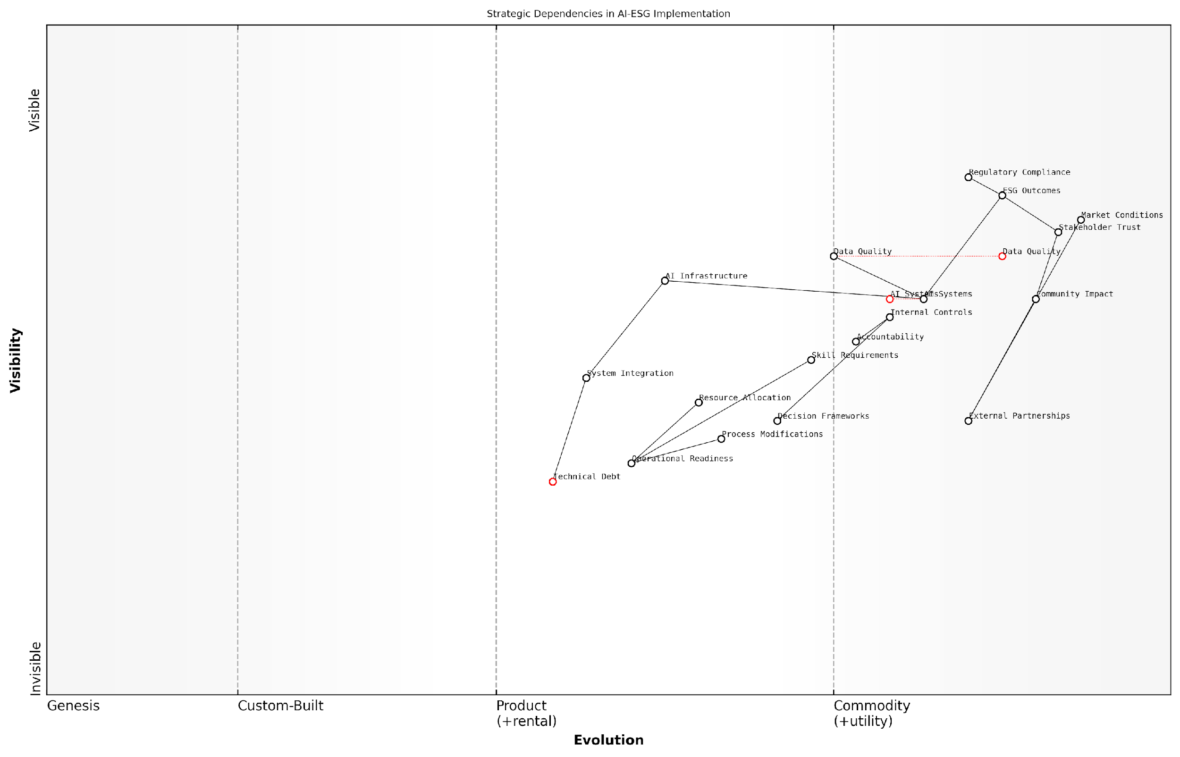

*Draft Wardley Map: [Wardley Map: Strategic Dependencies in AI-ESG Implementation showing the evolution and relationships between key components across the value chain]*

[Edit this draft Wardley Map](https://create.wardleymaps.ai/#clone:40ce29d6e5a01f0507)

**Wardley Map Assessment**

The map reveals a well-structured approach to AI-ESG implementation with clear strategic dependencies. Success requires balanced investment in technical capabilities, governance frameworks, and stakeholder relationships, while managing evolution across all components.

[View full Wardley Map report](http://markdown/wardley_map_reports/wardley_map_report_23_english_Strategic_Dependencies.md)

Critical to this analysis is the recognition of dependency chains – how one element’s performance or failure can cascade through the system. For instance, data quality dependencies directly impact AI model performance, which in turn affects ESG reporting accuracy and stakeholder trust. These chains must be mapped and understood to develop robust implementation strategies.

* Primary Dependencies: Direct relationships between AI systems and ESG outcomes
* Secondary Dependencies: Supporting infrastructure and processes
* Tertiary Dependencies: External factors and market conditions
* Cross-functional Dependencies: Interactions between different organisational units

Understanding strategic dependencies isn’t just about mapping relationships – it’s about anticipating how changes in one area will ripple through the entire system, affecting both AI effectiveness and ESG outcomes.

The maturity of these dependencies also plays a crucial role in strategic planning. Some dependencies may be well-established and stable, while others are emerging or evolving. This temporal dimension must be considered when developing implementation roadmaps and risk mitigation strategies. Through my consultancy work, I’ve observed that organisations that successfully navigate these dependencies typically adopt an iterative approach to dependency management, regularly reassessing and adjusting their strategies as dependencies evolve.

* Dependency Maturity Assessment: Evaluating the stability and reliability of key dependencies
* Evolution Tracking: Monitoring how dependencies change over time
* Impact Analysis: Measuring the influence of dependencies on ESG outcomes
* Mitigation Planning: Developing strategies to address dependency-related risks

The successful management of strategic dependencies requires a delicate balance between maintaining operational stability and driving innovation. Organisations must develop robust frameworks for monitoring and managing these dependencies while remaining agile enough to adapt to changing circumstances and emerging opportunities in both the AI and ESG landscapes.

### Value Chain Analysis

Value Chain Analysis (VCA) serves as a crucial strategic tool for organisations seeking to understand and optimise the intersection of AI implementation and ESG objectives across their operational framework. As an integral component of Risk-Opportunity Mapping, VCA provides a systematic approach to identifying areas where AI can either enhance or potentially compromise ESG performance throughout the organisation’s value creation process.

The integration of AI within the value chain represents both our greatest opportunity for ESG advancement and our most significant risk factor. Understanding these dynamics at each stage of value creation is fundamental to strategic success.

When applying VCA to AI-ESG integration, organisations must examine both primary and support activities through an ESG lens, considering the transformative potential of AI at each stage. This analysis reveals critical intervention points where AI deployment can maximise ESG benefits whilst minimising associated risks.

* Primary Activities Analysis: Inbound logistics, operations, outbound logistics, marketing and sales, and service - examining AI’s potential impact on environmental footprint, social implications, and governance requirements
* Support Activities Assessment: Infrastructure, human resource management, technology development, and procurement - evaluating AI integration opportunities and associated ESG considerations
* Value Creation Points: Identifying specific nodes where AI can enhance ESG performance through automation, optimisation, or innovation
* Risk Mitigation Areas: Mapping potential ESG risks associated with AI deployment across the value chain

The comprehensive VCA framework enables organisations to develop a strategic roadmap for AI implementation that aligns with ESG objectives. This approach considers both direct impacts, such as operational efficiency improvements and carbon footprint reduction, and indirect effects, including supplier relationships and community engagement.

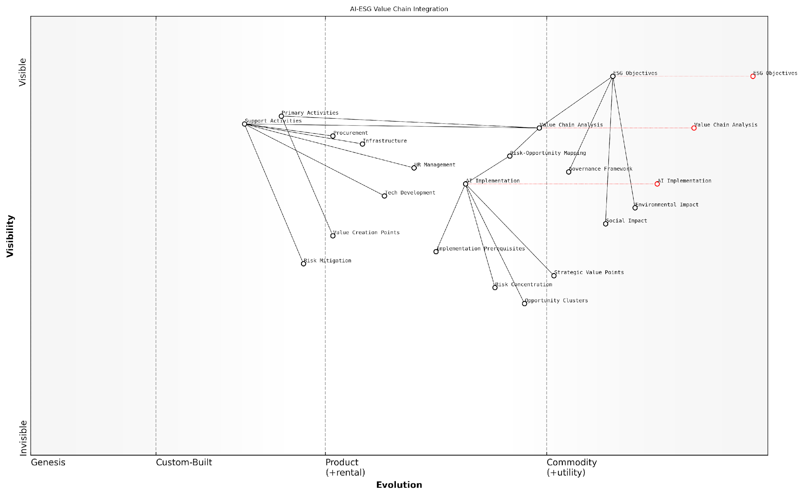

*Draft Wardley Map: [Wardley Map: AI-ESG Value Chain Integration showing evolution from genesis to commodity across different value chain components]*

[Edit this draft Wardley Map](https://create.wardleymaps.ai/#clone:9d642fb7ef2fb9431f)

**Wardley Map Assessment**

The map reveals a well-structured approach to integrating AI and ESG considerations, with clear opportunities for innovation and competitive advantage through strategic implementation and risk management

[View full Wardley Map report](http://markdown/wardley_map_reports/wardley_map_report_24_english_Value_Chain_Analysis.md)

* Environmental Considerations: Energy consumption, resource utilisation, waste management, and carbon emissions across the value chain
* Social Impact Analysis: Labour practices, community relations, diversity and inclusion, and stakeholder engagement throughout operations
* Governance Framework: Regulatory compliance, ethical considerations, transparency, and accountability in AI deployment

A critical aspect of VCA in this context is the identification of value chain interdependencies and their implications for AI-ESG integration. These interconnections often reveal unexpected opportunities for synergistic benefits or highlight potential cascade effects that could amplify risks.

Our experience with leading organisations has shown that successful AI-ESG integration requires a holistic understanding of value chain dynamics. Those who excel are those who can anticipate and leverage the ripple effects across their entire operational ecosystem.

* Strategic Value Points: Identifying areas where AI can create maximum ESG impact
* Risk Concentration Areas: Mapping zones of heightened ESG risk due to AI implementation
* Opportunity Clusters: Recognising areas where multiple ESG benefits can be achieved through targeted AI deployment
* Implementation Prerequisites: Understanding the foundational requirements for successful AI-ESG integration

The culmination of this analysis should inform a strategic implementation plan that prioritises high-impact, low-risk initiatives while building capabilities for more complex interventions. This approach ensures that organisations can maintain momentum in their AI-ESG journey while managing associated risks effectively.

## Implementation Framework

### Readiness Assessment

A comprehensive readiness assessment forms the cornerstone of successful AI implementation within an ESG framework. As organisations navigate the complex intersection of artificial intelligence and sustainability objectives, understanding their current capabilities, gaps, and potential challenges becomes paramount. This assessment serves as a critical first step in ensuring that AI deployment aligns with both technological feasibility and ESG commitments.

The greatest risk in AI implementation isn’t technological failure, but rather the misalignment between organisational readiness and ESG objectives. A thorough readiness assessment can prevent up to 70% of implementation challenges before they materialise.

The readiness assessment framework must evaluate five core dimensions that determine an organisation’s capability to successfully integrate AI solutions while maintaining ESG compliance. These dimensions encompass technological infrastructure, data governance, stakeholder engagement, regulatory compliance, and cultural preparedness.

* Technical Infrastructure Assessment: Evaluation of existing systems, computing capabilities, data architecture, and integration requirements
* Data Governance Maturity: Analysis of data quality, availability, privacy frameworks, and ethical guidelines
* Stakeholder Readiness: Assessment of internal expertise, training needs, and change management capabilities
* Regulatory Compliance Status: Review of current compliance levels with relevant AI and ESG regulations
* Cultural Alignment: Evaluation of organisational values, sustainability commitment, and innovation readiness

The assessment process should employ a structured methodology that combines quantitative metrics with qualitative insights. This hybrid approach ensures a comprehensive understanding of both tangible capabilities and intangible factors that influence implementation success.

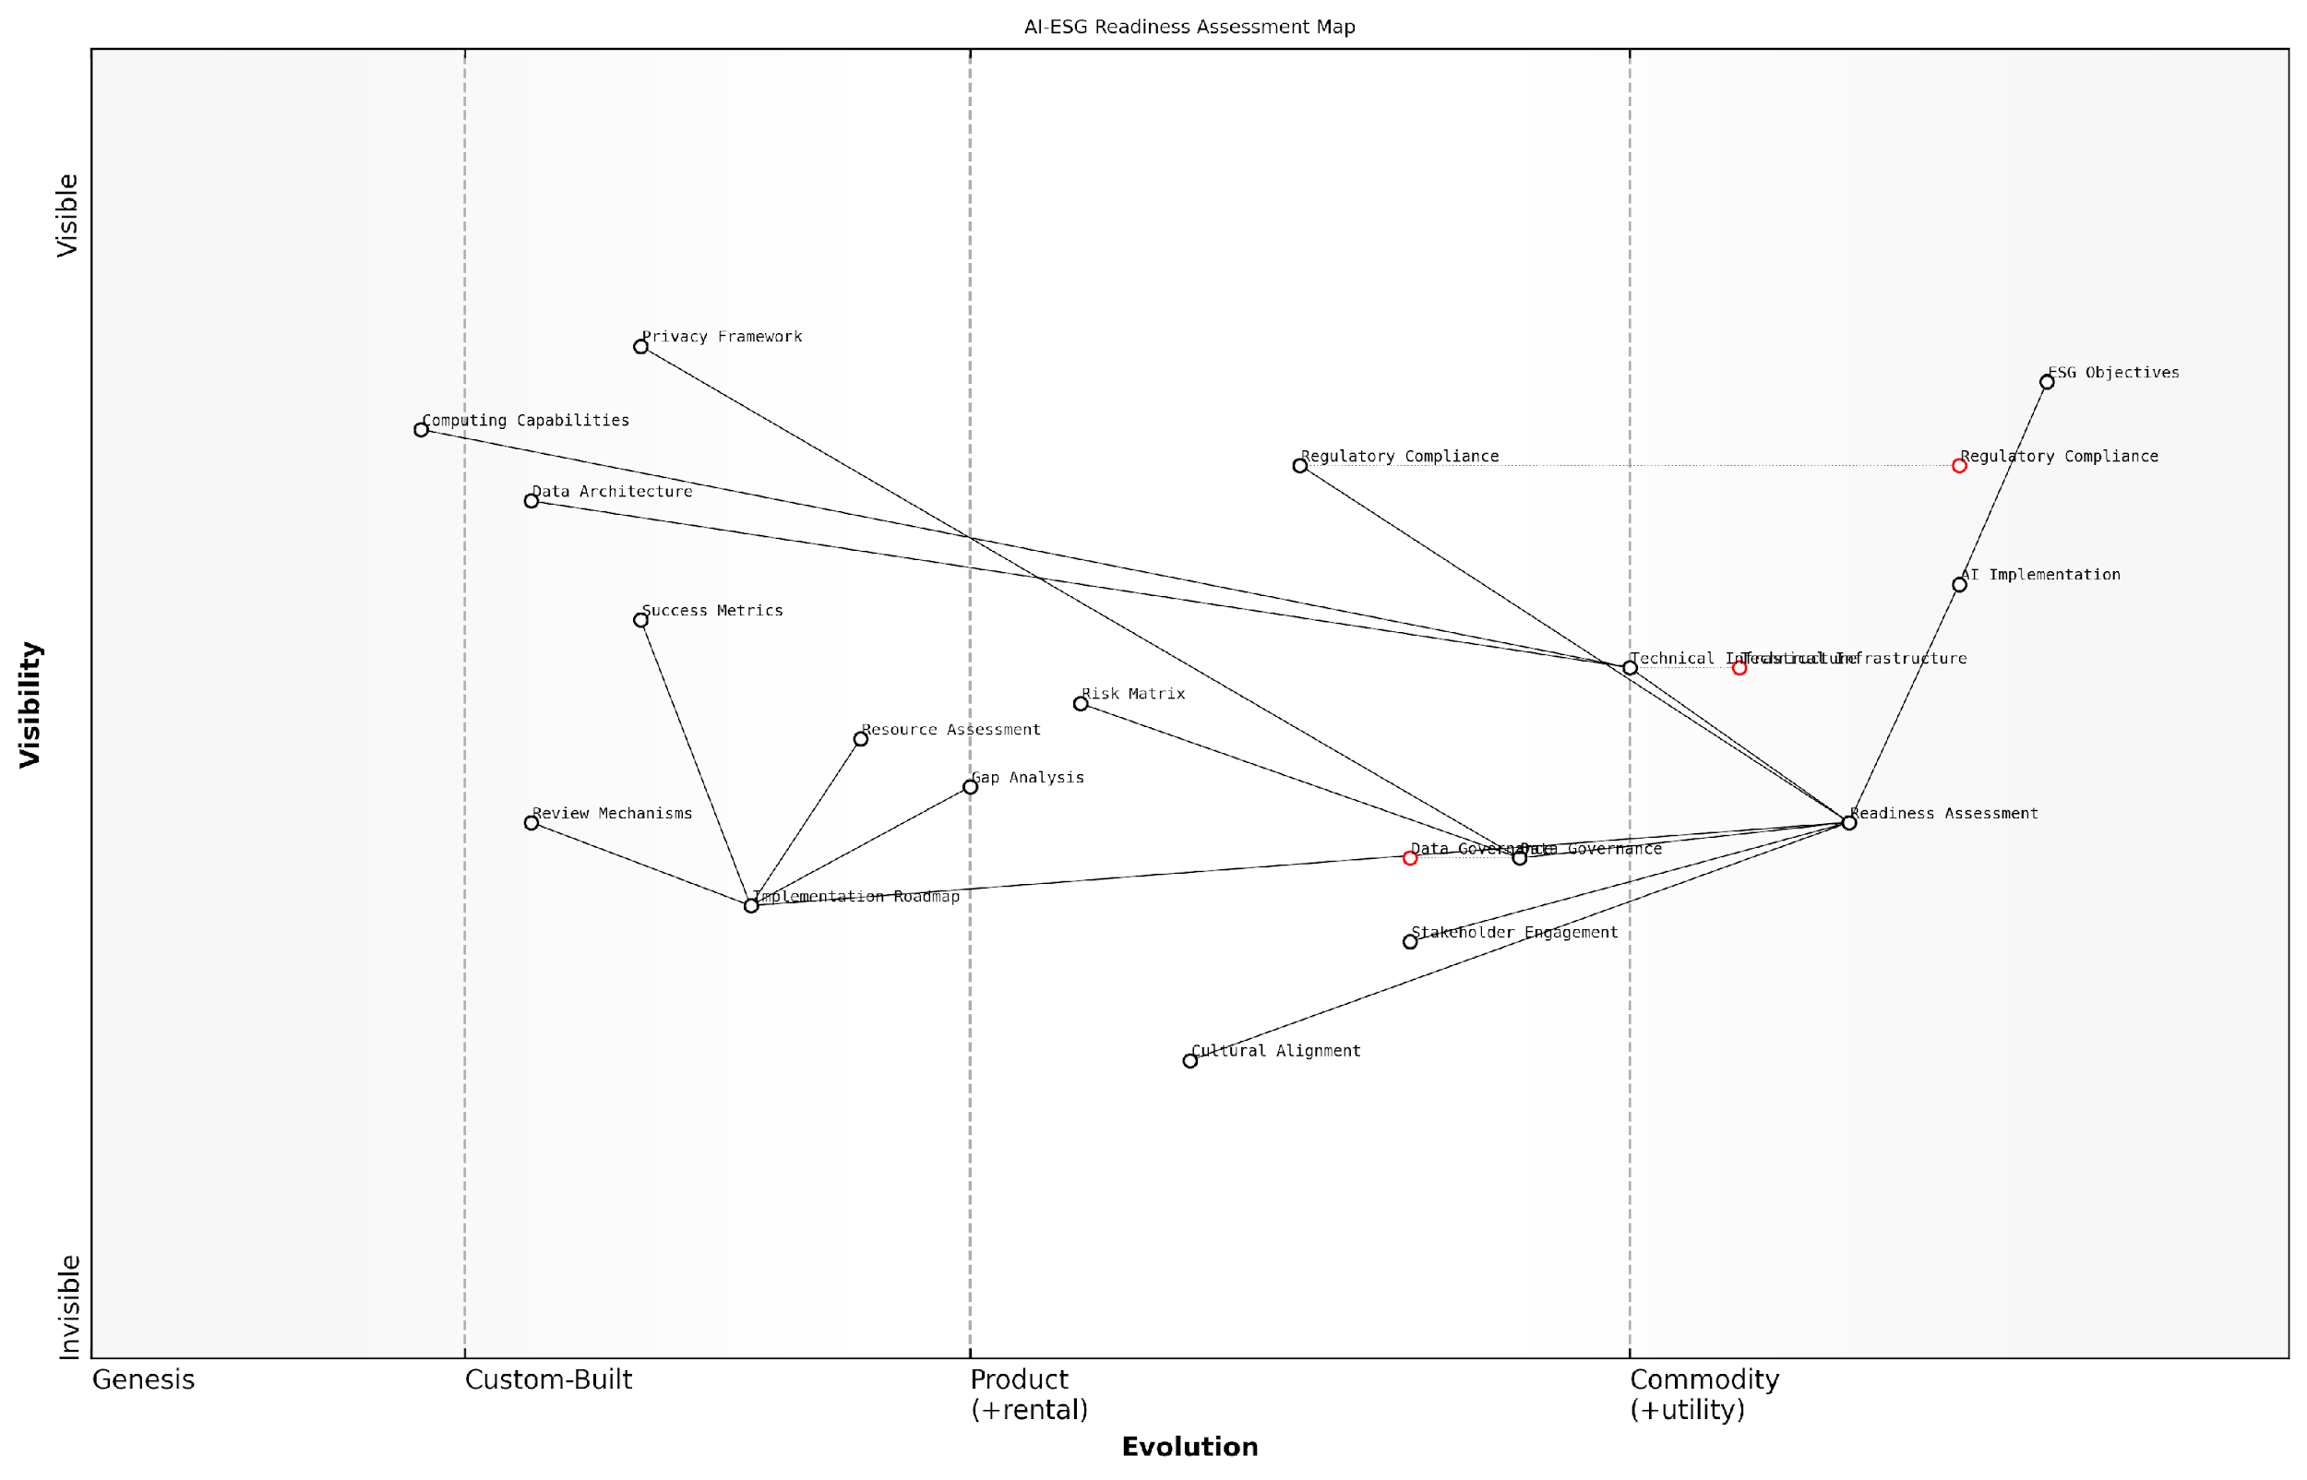

*Draft Wardley Map: [Wardley Map: AI-ESG Readiness Assessment Components showing evolution from genesis to commodity]*

[Edit this draft Wardley Map](https://create.wardleymaps.ai/#clone:b7a549e216339a20c3)

**Wardley Map Assessment**

The map reveals a well-structured approach to AI-ESG readiness assessment with clear evolution paths and strategic priorities. Key focus areas should be strengthening cultural alignment and stakeholder engagement while maintaining technical excellence.

[View full Wardley Map report](http://markdown/wardley_map_reports/wardley_map_report_25_english_Readiness_Assessment.md)

A crucial aspect of the readiness assessment is the identification of potential risks and barriers. These might include technical limitations, resource constraints, regulatory uncertainties, or cultural resistance. Each identified risk must be evaluated in terms of its potential impact on both AI implementation and ESG objectives.

* Risk Assessment Matrix: Probability vs Impact analysis for identified risks
* Gap Analysis: Current state vs desired state evaluation
* Resource Availability Assessment: Financial, human, and technological resources
* Stakeholder Impact Analysis: Effects on different stakeholder groups
* ESG Compliance Review: Current performance against ESG targets

Our experience across multiple sectors shows that organisations who conduct thorough readiness assessments are three times more likely to achieve their AI-ESG integration objectives within the planned timeframe and budget.

The output of the readiness assessment should be a detailed roadmap that outlines specific actions needed to address identified gaps and prepare the organisation for AI implementation. This roadmap must include clear milestones, resource requirements, and success metrics that align with both technological and ESG objectives.

* Immediate Actions: Critical gaps requiring immediate attention
* Medium-term Initiatives: Capability building and system enhancements
* Long-term Strategic Plans: Cultural transformation and sustainable integration
* Success Metrics: KPIs for measuring progress and effectiveness
* Review Mechanisms: Regular assessment and adjustment protocols

### Resource Allocation

Resource allocation stands as a critical cornerstone in the successful implementation of AI-driven ESG initiatives. As organisations navigate the complex landscape of sustainability and technological advancement, the strategic distribution of financial, human, and technological resources becomes paramount to achieving meaningful outcomes whilst maintaining operational efficiency.

The challenge isn’t just about having resources; it’s about orchestrating them in a way that maximises ESG impact whilst ensuring responsible AI deployment. We’ve seen numerous organisations struggle not from a lack of resources, but from their suboptimal allocation.

The intersection of AI and ESG demands a sophisticated approach to resource allocation that considers both immediate operational needs and long-term sustainability goals. This complexity is further amplified by the need to balance technological investment with environmental impact, social responsibility, and governance requirements.

* Financial Resource Planning: Budgeting for AI infrastructure, ESG monitoring systems, and ongoing maintenance
* Human Capital Distribution: Allocation of expertise across technical, sustainability, and governance functions
* Technical Infrastructure: Computing resources, data storage, and processing capabilities
* Training and Development: Investment in upskilling staff and maintaining AI systems
* Monitoring and Compliance: Resources for ongoing assessment and regulatory adherence
* Stakeholder Engagement: Communication and reporting mechanisms

A robust resource allocation strategy must incorporate both quantitative metrics and qualitative assessments. The quantitative aspects focus on measurable outputs such as carbon emissions reduction, energy efficiency improvements, and financial returns. The qualitative elements consider factors such as stakeholder satisfaction, social impact, and governance effectiveness.

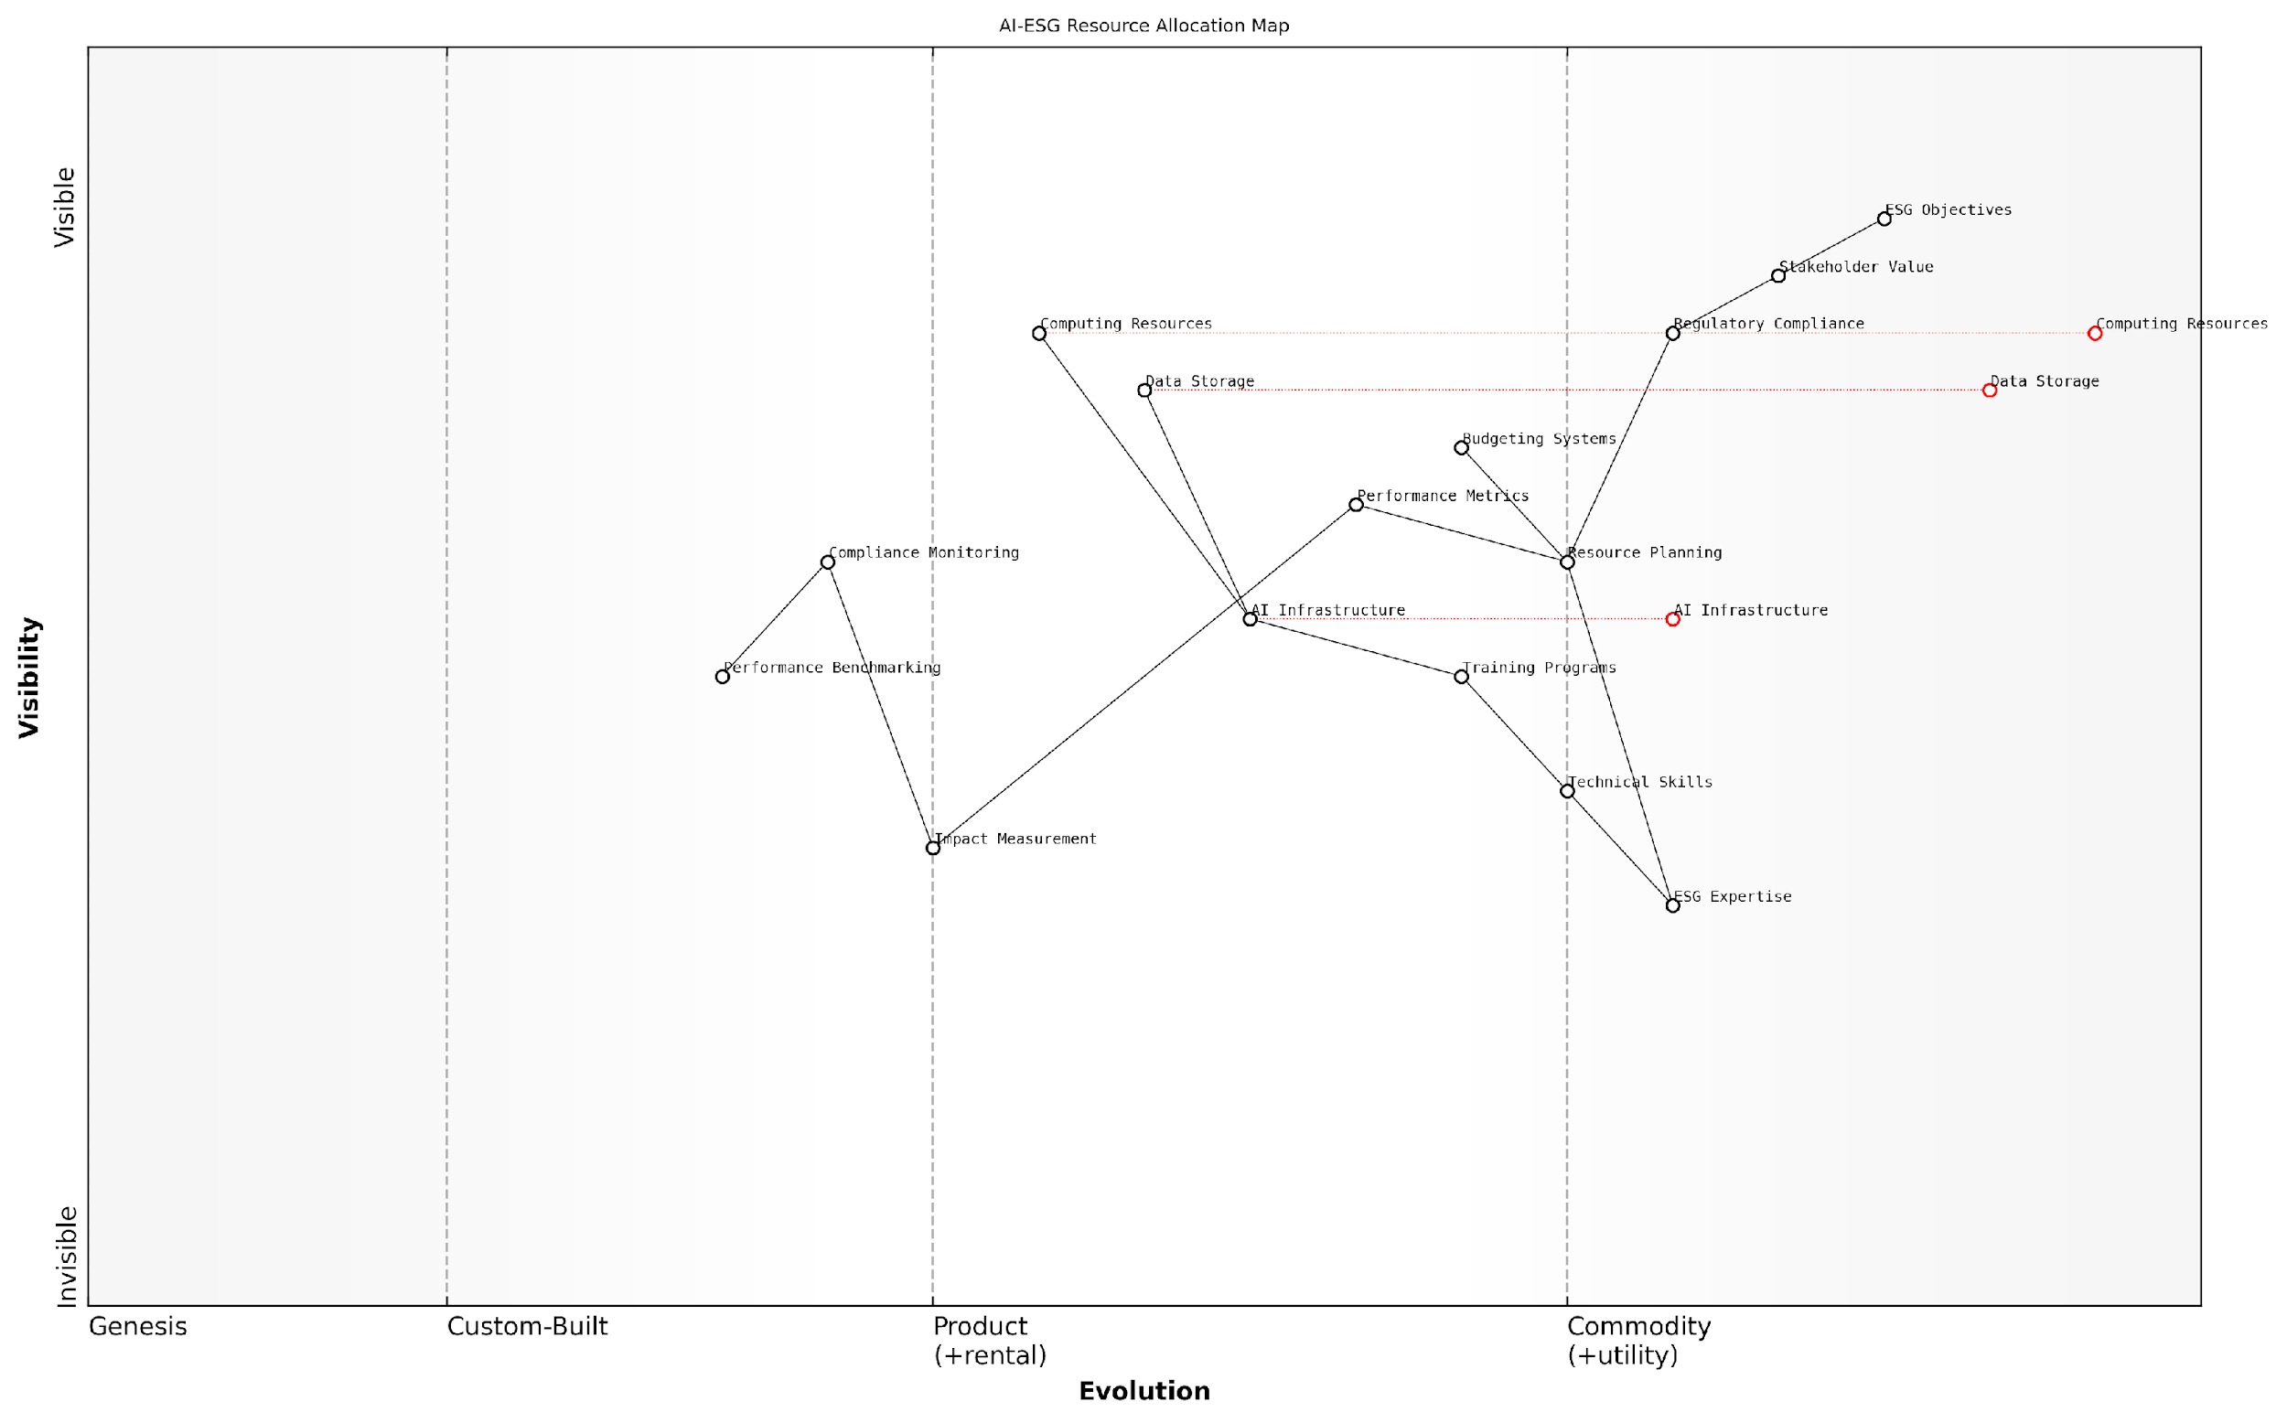

*Draft Wardley Map: [Wardley Map: Resource Allocation Dependencies showing the evolution from genesis to commodity of various AI-ESG resources and their interdependencies]*

[Edit this draft Wardley Map](https://create.wardleymaps.ai/#clone:186835c71e31a1b9a3)

**Wardley Map Assessment**

The map reveals a well-structured approach to AI-ESG resource allocation with clear evolution paths and strategic opportunities. Key focus areas should be strengthening AI capabilities, developing expertise, and building automated monitoring systems while maintaining regulatory compliance and stakeholder value creation.

[View full Wardley Map report](http://markdown/wardley_map_reports/wardley_map_report_26_english_Resource_Allocation.md)

* Clear alignment between resource allocation and ESG objectives
* Regular assessment and reallocation based on performance metrics
* Balanced distribution across short-term needs and long-term sustainability goals
* Flexibility to adapt to changing regulatory requirements and stakeholder expectations
* Integration with existing business processes and systems
* Risk-adjusted resource planning considering potential AI-related challenges

The implementation of AI in ESG contexts requires careful consideration of resource dependencies and potential bottlenecks. Organisations must develop a clear understanding of how different resources interact and influence each other, particularly in terms of their impact on ESG outcomes. This understanding should inform a dynamic resource allocation strategy that can adapt to changing circumstances whilst maintaining focus on core sustainability objectives.

In our experience implementing AI-ESG initiatives across various sectors, we’ve found that successful resource allocation isn’t about maximising investment in any single area, but rather about finding the optimal balance that creates sustainable value across the entire ESG spectrum.

* Regular assessment of resource utilisation efficiency
* Impact measurement against ESG targets
* Cost-benefit analysis of AI implementations
* Stakeholder feedback integration
* Compliance monitoring and reporting
* Performance benchmarking against industry standards

### Change Management

The integration of AI solutions within ESG frameworks represents a significant organisational transformation that requires a sophisticated and well-structured change management approach. As organisations navigate the complex intersection of artificial intelligence and sustainability objectives, the human element becomes paramount to successful implementation.

The greatest challenge in AI-ESG integration isn’t the technology itself, but rather the cultural and operational transformation required to make it effective and sustainable.

Successful change management in the AI-ESG context requires a comprehensive understanding of both technological and human factors. The transformation affects multiple stakeholders across different organisational levels, from board members and senior executives to operational staff and external partners. Each group requires tailored engagement strategies whilst maintaining alignment with overall organisational objectives.

* Stakeholder Analysis and Engagement Planning
* Cultural Assessment and Alignment
* Communication Strategy Development
* Training and Capability Building
* Resistance Management
* Success Metrics and Monitoring
* Feedback Loop Implementation

A critical aspect of change management in this context is addressing the inherent tensions between AI implementation and ESG objectives. Organisations must carefully balance the drive for technological efficiency with environmental impact considerations, social responsibility, and governance requirements. This necessitates a change management approach that explicitly addresses these potential conflicts and provides clear frameworks for resolution.

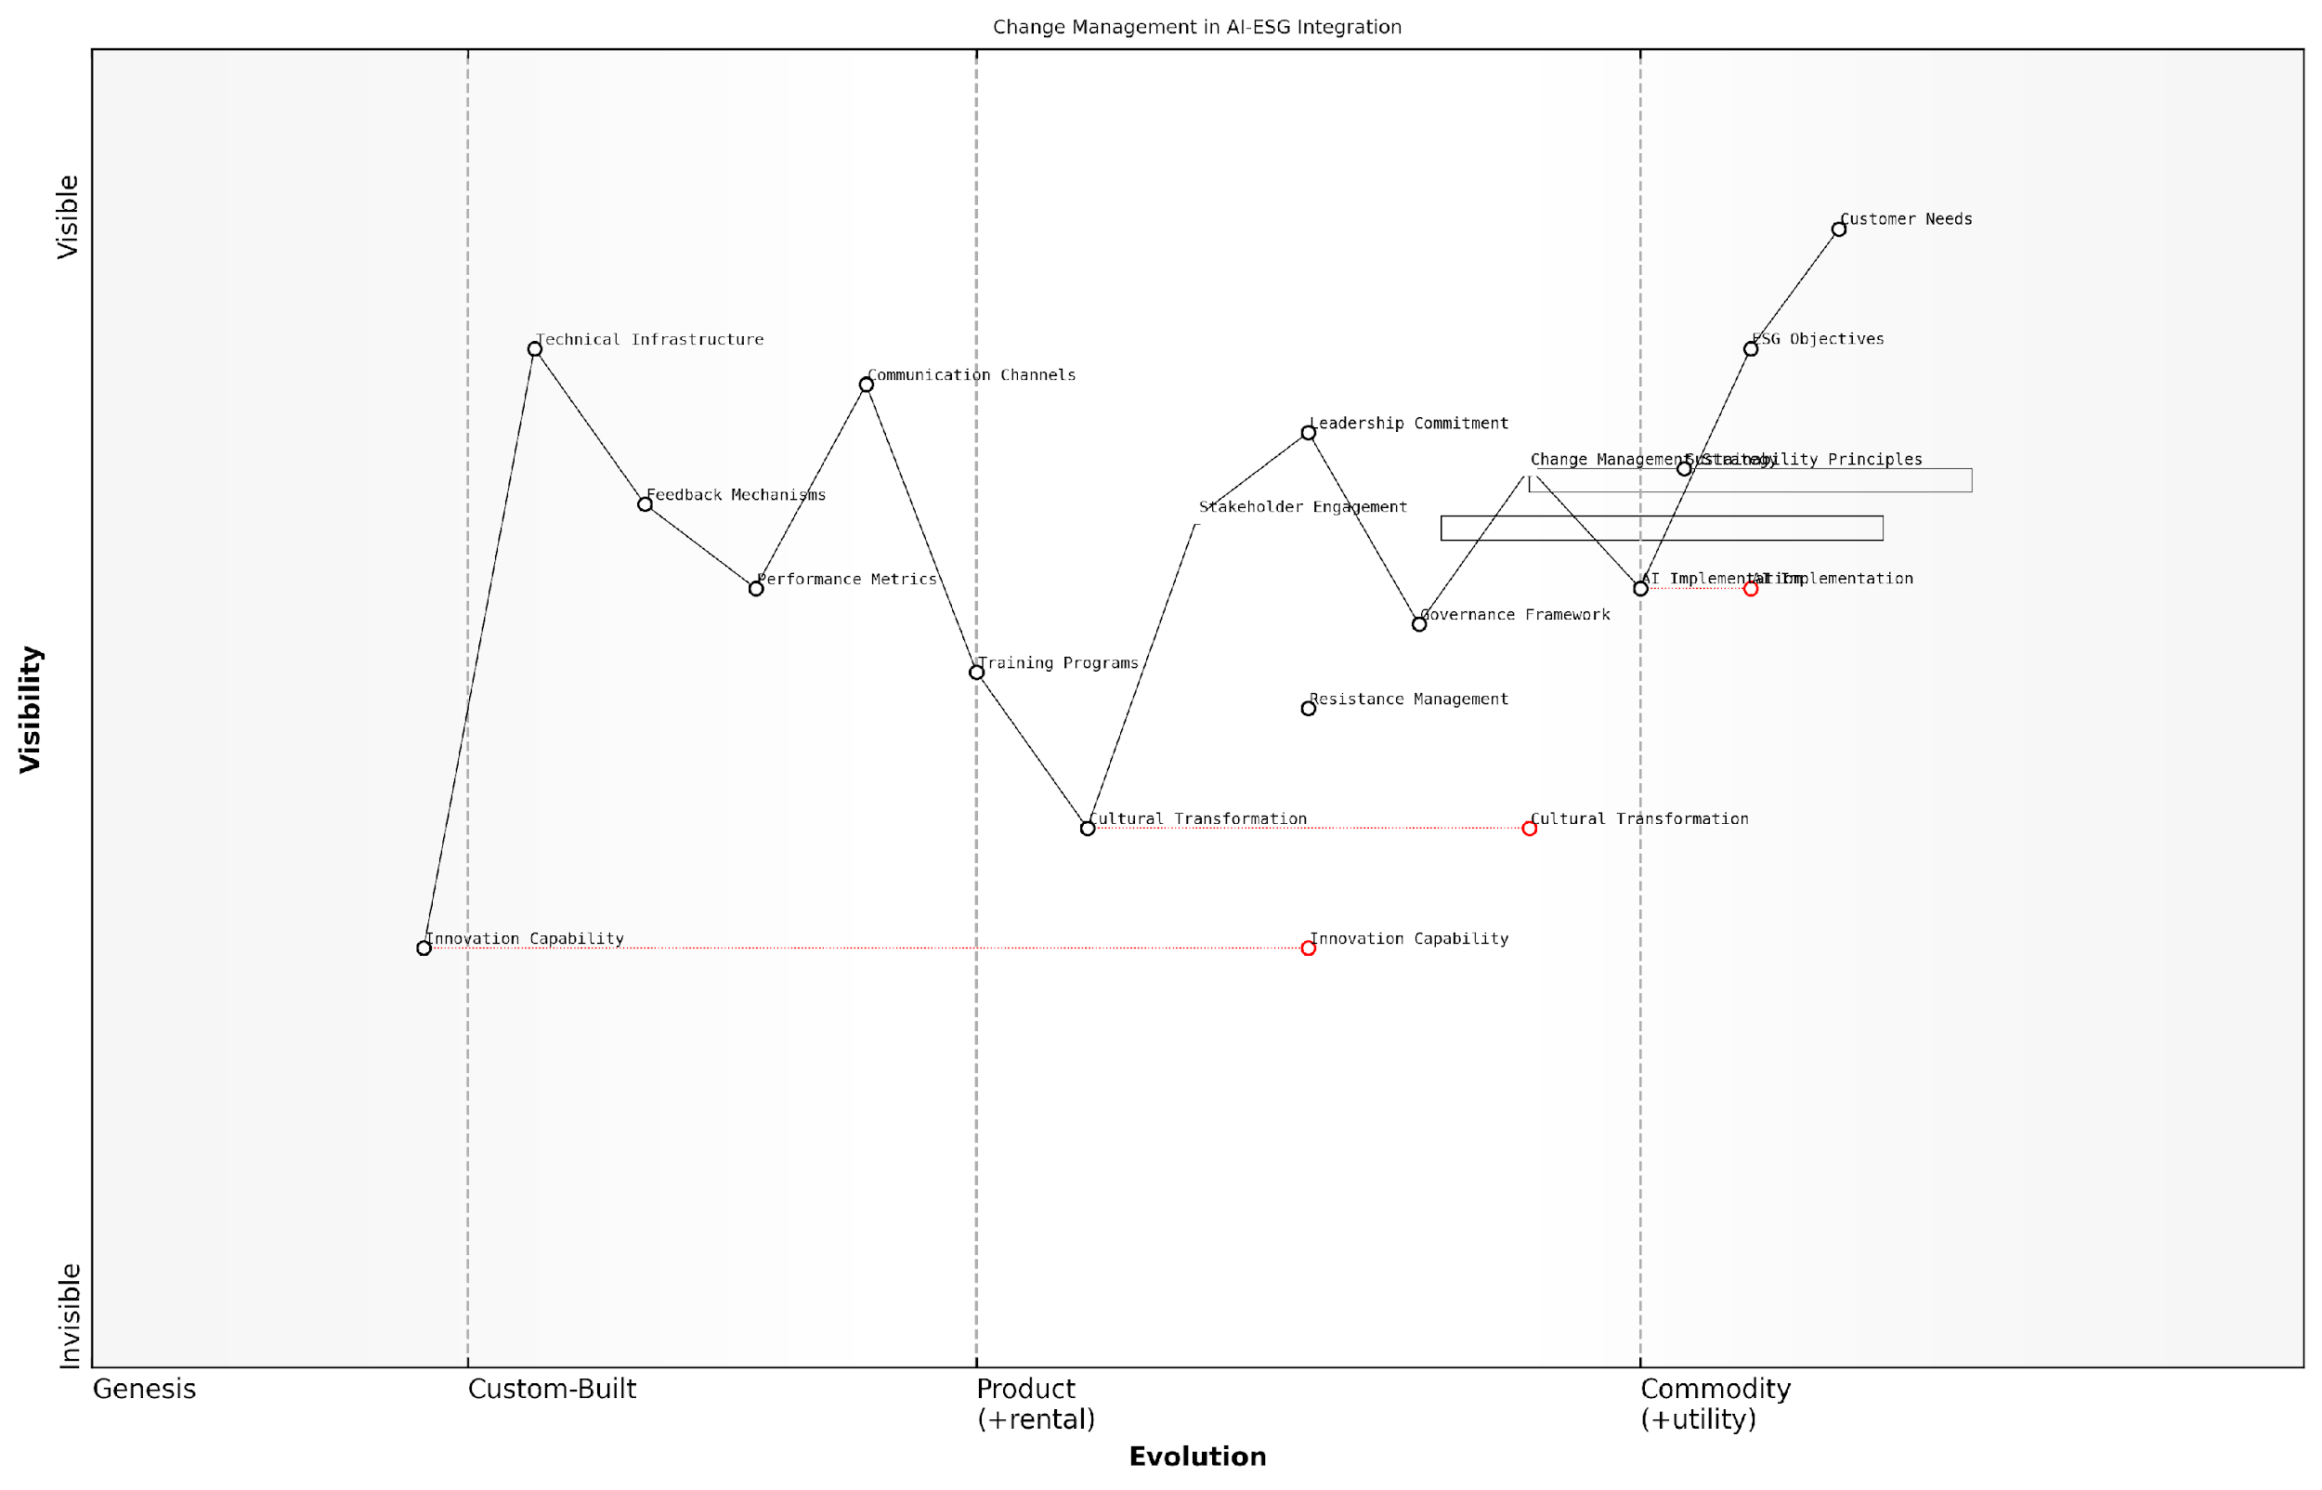

*Draft Wardley Map: [Wardley Map: Change Management Dependencies in AI-ESG Integration]*

[Edit this draft Wardley Map](https://create.wardleymaps.ai/#clone:d864c7fa14cf9d70d5)

**Wardley Map Assessment**

The map reveals a well-structured approach to AI-ESG integration with clear focus on change management. Key opportunities lie in accelerating cultural transformation and building innovation capability while managing resistance to change. Success depends on maintaining strong leadership commitment and effective stakeholder engagement throughout the transformation journey.

[View full Wardley Map report](http://markdown/wardley_map_reports/wardley_map_report_27_english_Change_Management.md)

* Phase 1: Awareness and Understanding - Creating organisational awareness about AI-ESG integration and its implications
* Phase 2: Desire and Buy-in - Building stakeholder support and commitment to the transformation
* Phase 3: Knowledge Transfer - Developing necessary skills and capabilities across the organisation
* Phase 4: Implementation Support - Providing tools and resources for effective adoption
* Phase 5: Reinforcement - Ensuring sustainable change through monitoring and adjustment

The change management process must be underpinned by robust governance structures that ensure alignment with both AI capabilities and ESG objectives. This includes establishing clear decision-making frameworks, accountability mechanisms, and performance metrics that reflect both technical and sustainability considerations.

Successful AI-ESG integration requires a delicate balance between pushing technological boundaries and maintaining unwavering commitment to sustainability principles, all whilst bringing people along on the journey.

* Regular stakeholder feedback sessions and adjustment mechanisms
* Clear escalation pathways for addressing concerns and challenges
* Continuous learning and improvement processes
* Recognition and reward systems aligned with ESG objectives
* Integration with existing change management frameworks

The success of change management in AI-ESG integration ultimately depends on the organisation’s ability to create a culture that embraces both technological innovation and sustainability principles. This requires consistent leadership commitment, clear communication channels, and robust support mechanisms that enable stakeholders to navigate the transformation effectively whilst maintaining focus on long-term ESG objectives.

### Monitoring and Adjustment

In the complex landscape of AI-driven ESG initiatives, effective monitoring and adjustment mechanisms are crucial for ensuring sustainable implementation and continuous improvement. As an integral component of the implementation framework, this phase requires sophisticated approaches to track progress, identify deviations, and implement corrective measures whilst maintaining alignment with both ESG objectives and AI governance principles.

The key to successful AI-ESG integration lies not in the initial implementation, but in the organisation’s ability to continuously monitor, learn, and adapt its approach based on real-world outcomes and emerging challenges.

The monitoring and adjustment phase operates across three primary dimensions: technical performance monitoring, ESG impact assessment, and stakeholder feedback integration. Each dimension requires specific metrics, tools, and processes to ensure comprehensive oversight and timely intervention when necessary.

* Real-time Performance Metrics: Continuous monitoring of AI system performance, including accuracy, bias detection, and resource utilisation
* ESG Impact Indicators: Regular assessment of environmental footprint, social impact metrics, and governance compliance measures
* Stakeholder Feedback Loops: Structured mechanisms for gathering and incorporating feedback from affected parties
* Adjustment Protocols: Predefined procedures for implementing changes based on monitoring outcomes
* Documentation and Reporting: Systematic recording of monitoring results and adjustment decisions

A robust monitoring framework must incorporate both leading and lagging indicators. Leading indicators provide early warning signs of potential issues, whilst lagging indicators confirm the effectiveness of implemented measures. This dual approach enables organisations to be both proactive and reactive in their adjustment strategies.

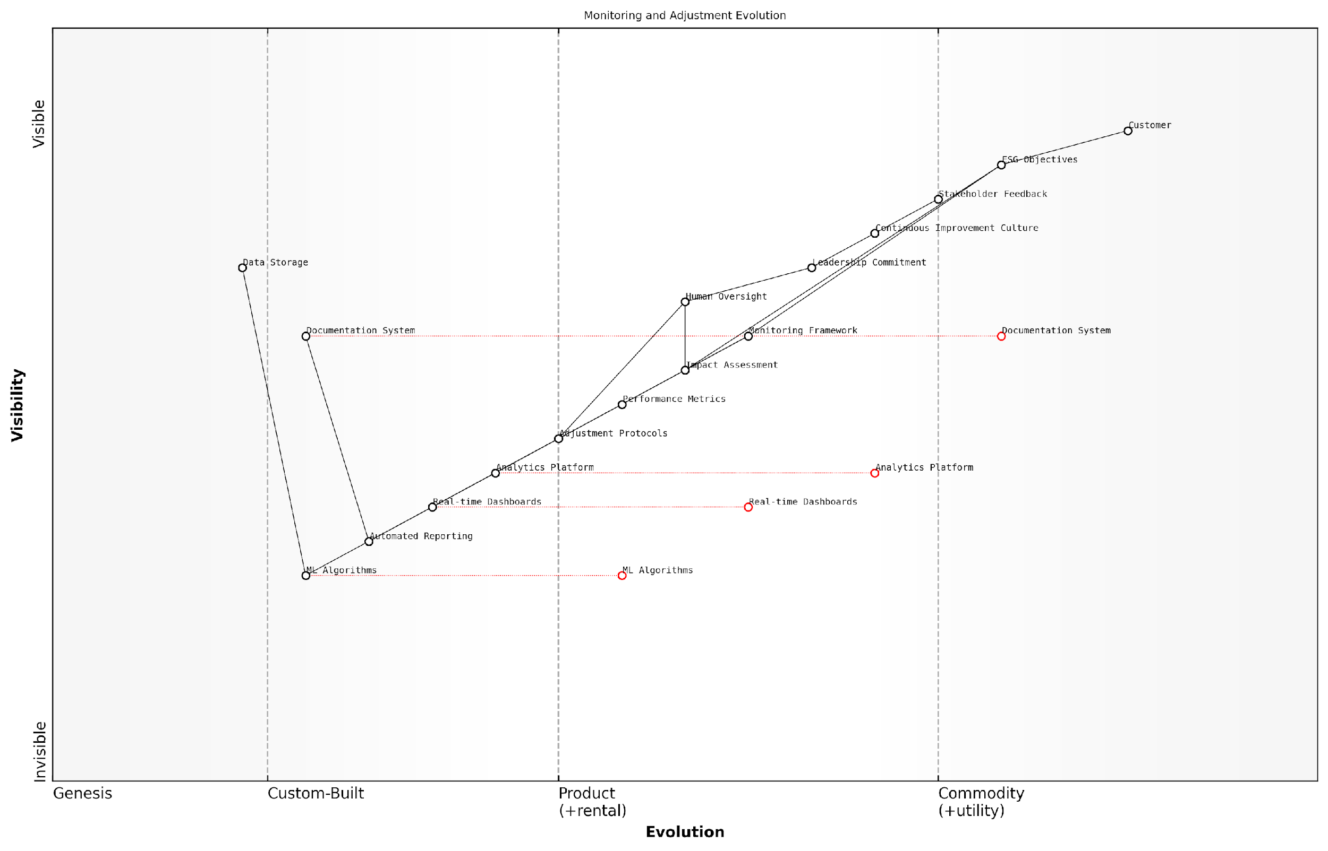

*Draft Wardley Map: [Wardley Map: Monitoring and Adjustment Evolution - showing the progression from basic monitoring to advanced adaptive systems]*

[Edit this draft Wardley Map](https://create.wardleymaps.ai/#clone:68089edc465912bdd5)

**Wardley Map Assessment**

The map reveals a well-structured monitoring and adjustment system with clear evolution paths. Key opportunities lie in advancing ML capabilities and automation while maintaining strong human oversight. Strategic focus should be on bridging identified capability gaps while leveraging existing strengths in monitoring and stakeholder engagement.

[View full Wardley Map report](http://markdown/wardley_map_reports/wardley_map_report_28_english_Monitoring_and_Adjustment.md)

The adjustment phase requires a carefully structured approach to ensure changes are implemented effectively without disrupting ongoing operations. This includes a clear decision-making hierarchy, defined thresholds for different levels of intervention, and robust change management processes.

* Establish clear thresholds and triggers for different levels of intervention
* Develop rapid response protocols for critical issues
* Implement staged adjustment processes for non-critical changes
* Maintain comprehensive documentation of all adjustments and their impacts
* Regular review and updating of monitoring parameters and adjustment protocols

Successful AI-ESG implementations are characterised by their ability to evolve and adapt. The most effective organisations treat monitoring and adjustment not as a compliance exercise, but as a strategic capability that drives continuous improvement.

Technology plays a crucial role in enabling effective monitoring and adjustment. Advanced analytics, machine learning algorithms, and automated reporting systems can significantly enhance the organisation’s ability to detect issues early and implement timely adjustments. However, it’s essential to maintain human oversight and judgement in the decision-making process, particularly for significant adjustments that may have broader ESG implications.

* Automated monitoring systems with AI-powered anomaly detection
* Real-time dashboards for key performance indicators
* Predictive analytics for early warning systems
* Integrated feedback collection and analysis tools
* Automated reporting and documentation systems

The success of monitoring and adjustment mechanisms ultimately depends on organisational culture and leadership commitment. Organisations must foster a culture of continuous improvement and learning, where feedback is valued and adjustments are seen as opportunities for enhancement rather than admissions of failure.

# Chapter 4: Future Horizons

## Emerging Trends

### Technological Advancements

As we stand at the frontier of technological innovation, the convergence of artificial intelligence and ESG considerations is undergoing rapid evolution. The emerging landscape presents both unprecedented opportunities and complex challenges that will fundamentally reshape how organisations approach sustainability and responsible business practices.

The next wave of AI advancement will not just be about algorithmic efficiency, but about how we can harness these technologies to create measurable positive impact across environmental, social, and governance dimensions.

Several transformative technologies are emerging at the intersection of AI and ESG, each with the potential to revolutionise how organisations measure, manage, and optimise their sustainability initiatives. These advancements are not developing in isolation but are increasingly interconnected, creating a complex ecosystem of solutions that organisations must navigate strategically.

* Quantum Computing for ESG Analytics: The emergence of quantum computing capabilities promises to revolutionise how we process and analyse vast amounts of ESG data, enabling more sophisticated risk modelling and impact assessment
* Edge AI for Real-time Environmental Monitoring: Advanced edge computing solutions are enabling distributed AI systems that can monitor environmental impacts with unprecedented granularity and reduced energy footprint
* Federated Learning for Privacy-Preserving ESG Data Sharing: New approaches to distributed machine learning are enabling organisations to collaborate on ESG initiatives while maintaining data privacy and sovereignty
* Natural Language Processing for ESG Reporting: Enhanced NLP capabilities are transforming how organisations process and validate ESG-related disclosures and reports
* Blockchain-AI Integration for ESG Verification: The convergence of blockchain and AI technologies is creating new possibilities for transparent and verifiable ESG tracking and reporting

The maturation of these technologies is accompanied by increasing sophistication in their application to ESG challenges. Organisations are moving beyond simple automation and data analysis towards more nuanced applications that consider the full complexity of sustainability challenges. This evolution is particularly evident in the development of hybrid systems that combine multiple AI approaches to address complex ESG scenarios.

The most significant breakthrough in AI-ESG integration isn’t any single technology, but rather our growing ability to orchestrate multiple AI systems in service of sustainability goals, whilst maintaining robust governance frameworks.

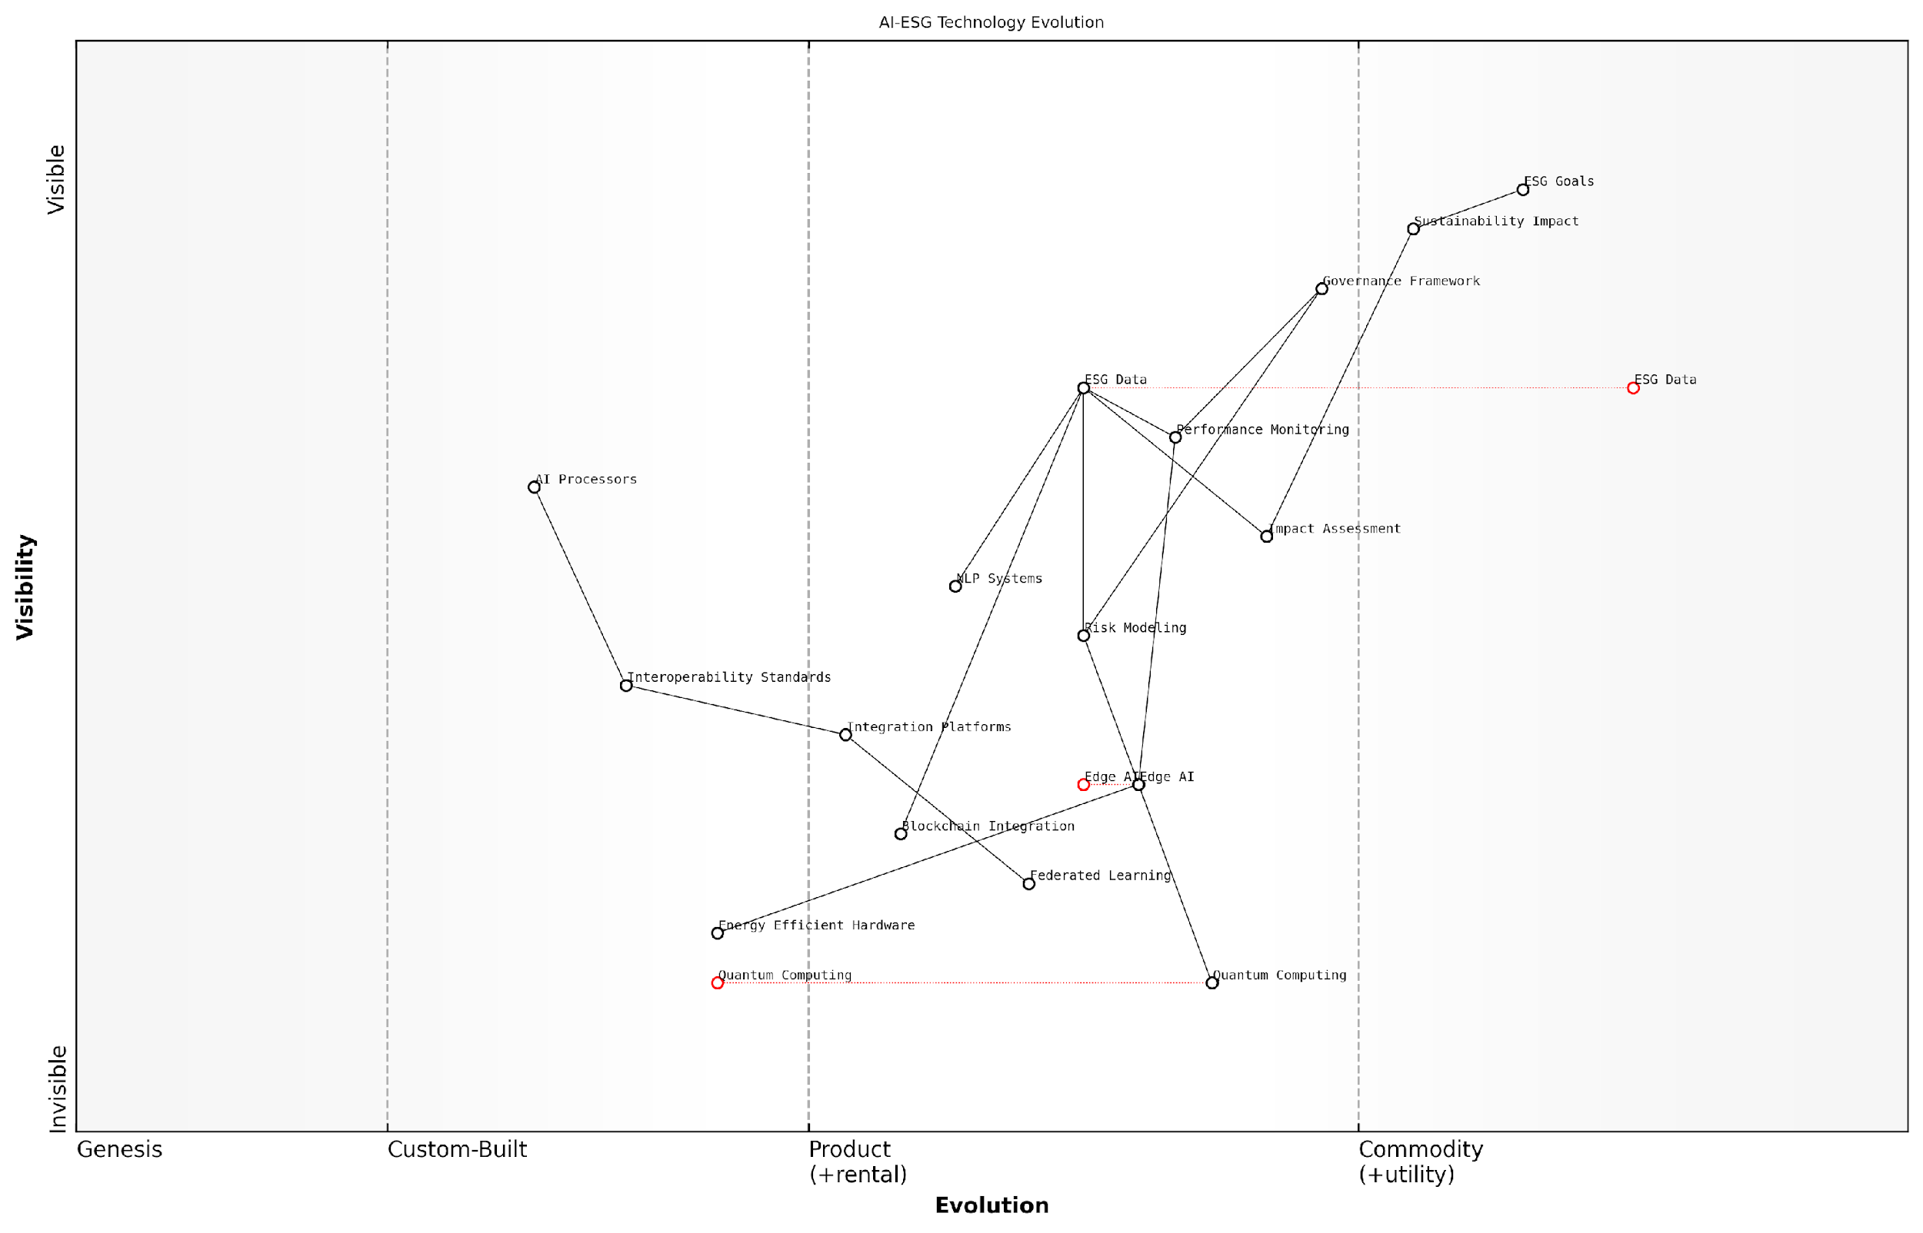

*Draft Wardley Map: [Wardley Map: Evolution of AI-ESG Technologies showing the movement from genesis to commodity]*

[Edit this draft Wardley Map](https://create.wardleymaps.ai/#clone:f4beb2ca39d87d9d35)

**Wardley Map Assessment**

The map reveals a sophisticated technological approach to ESG implementation with strong potential for innovation and competitive advantage through emerging technologies, while highlighting the need for careful attention to integration and governance challenges.

[View full Wardley Map report](http://markdown/wardley_map_reports/wardley_map_report_29_english_Technological_Advancements.md)

However, these technological advancements also present new challenges. The increasing complexity of AI systems requires more sophisticated governance frameworks, whilst their energy consumption and resource requirements must be carefully balanced against their ESG benefits. Organisations must develop robust strategies for managing these trade-offs whilst maximising the positive impact of their AI implementations.

* Emerging Hardware Solutions: Development of energy-efficient AI processors and quantum computers specifically designed for ESG applications
* Advanced Algorithmic Approaches: New machine learning architectures that prioritise efficiency and interpretability
* Integration Platforms: Emergence of comprehensive platforms that unite various AI technologies for holistic ESG management
* Automated ESG Assessment Tools: Development of sophisticated automated systems for continuous ESG performance monitoring and optimisation
* Cross-platform Interoperability: Standards and protocols enabling seamless integration of different AI-ESG solutions

Looking ahead, the pace of technological advancement shows no signs of slowing. Organisations must remain agile and adaptive, ready to embrace new technologies whilst maintaining a clear focus on their ESG objectives. This requires a balanced approach that combines technological innovation with robust governance frameworks and a clear understanding of sustainability goals.

### Regulatory Evolution

The regulatory landscape governing the intersection of AI and ESG is undergoing rapid and significant transformation. As we look towards the future, the evolution of regulations is being shaped by increasing awareness of AI’s environmental impact, social implications, and governance requirements. This transformation represents one of the most dynamic aspects of the AI-ESG relationship, requiring organisations to maintain unprecedented levels of adaptability and foresight.

The pace of regulatory change in AI and ESG is unprecedented. What we’re witnessing is not just incremental adjustment, but a fundamental reshaping of how we govern technology’s role in sustainable business practices.

The regulatory evolution is characterised by three primary drivers: the increasing sophistication of AI technologies, growing environmental concerns, and heightened awareness of social responsibility. These factors are compelling regulators worldwide to develop more comprehensive and nuanced frameworks that address both the opportunities and risks presented by AI in ESG contexts.

* Enhanced disclosure requirements for AI-related environmental impacts, including energy consumption metrics and carbon footprint calculations
* Stricter guidelines on AI bias monitoring and mitigation, particularly in ESG-related decision-making processes
* Mandatory ESG impact assessments for large-scale AI deployments
* Standardised reporting frameworks for AI’s contribution to ESG objectives
* New requirements for AI transparency and explainability in ESG-related applications
* Expanded accountability measures for AI-driven ESG initiatives

A particularly significant trend is the move towards harmonisation of international regulatory standards. Regulators are increasingly recognising that the global nature of both AI technology and ESG challenges necessitates coordinated international responses. This is leading to the emergence of cross-border regulatory frameworks and collaborative oversight mechanisms.

The future of AI-ESG regulation will be characterised by international cooperation. No single jurisdiction can effectively govern these technologies in isolation.

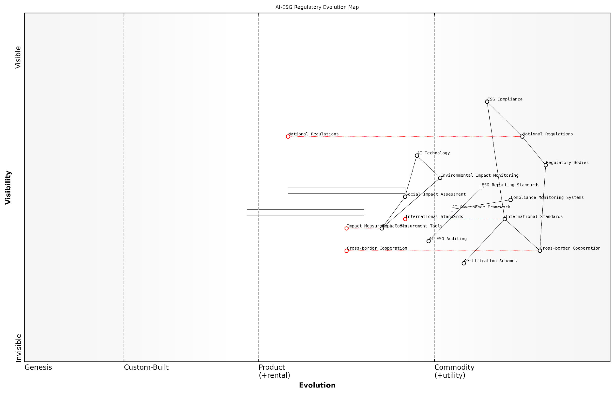

*Draft Wardley Map: [Wardley Map: Evolution of AI-ESG Regulatory Landscape, showing the progression from fragmented national regulations to harmonised international standards]*

[Edit this draft Wardley Map](https://create.wardleymaps.ai/#clone:9e039e9e6413f4f594)

**Wardley Map Assessment**

The map reveals a system in transition toward automated, AI-driven regulatory compliance, requiring significant investment in technology and international cooperation whilst maintaining focus on standardisation and governance frameworks

[View full Wardley Map report](http://markdown/wardley_map_reports/wardley_map_report_30_english_Regulatory_Evolution.md)

Looking ahead, we can anticipate several key developments in the regulatory landscape. First, the emergence of more sophisticated impact measurement requirements, particularly around AI’s environmental footprint. Second, the development of standardised frameworks for assessing and reporting on AI’s ESG contributions. Third, the introduction of more stringent governance requirements for AI systems used in ESG-related decision-making.

* Development of AI-specific ESG reporting standards
* Integration of AI impact assessments into existing ESG frameworks
* Creation of specialised regulatory bodies for AI-ESG oversight
* Implementation of mandatory AI-ESG auditing requirements
* Establishment of international AI-ESG certification schemes

Organisations must prepare for this evolving regulatory landscape by developing robust compliance frameworks that can adapt to new requirements. This includes establishing strong governance structures, implementing comprehensive monitoring systems, and maintaining flexibility in their AI-ESG integration strategies. The most successful organisations will be those that anticipate regulatory changes and position themselves ahead of compliance requirements.

### Stakeholder Expectations

As we navigate the evolving intersection of AI and ESG, stakeholder expectations are undergoing profound transformation. The traditional paradigms of corporate responsibility are being reshaped by the dual forces of technological advancement and heightened environmental, social, and governance concerns. Understanding these shifting expectations is crucial for organisations seeking to maintain their social licence to operate whilst leveraging AI technologies.

The convergence of AI and ESG represents the most significant shift in stakeholder expectations since the advent of corporate sustainability reporting. Organisations must now demonstrate not just their ESG credentials, but how they’re leveraging technology responsibly to achieve their sustainability goals.

The evolution of stakeholder expectations is particularly evident in the increasing sophistication of demands regarding AI deployment in ESG initiatives. Stakeholders are no longer satisfied with superficial applications of AI to sustainability challenges; they expect comprehensive, transparent, and ethically sound implementations that deliver measurable impacts.

* Enhanced Transparency: Stakeholders expect detailed disclosure of AI systems’ environmental impact, including energy consumption and carbon footprint
* Ethical AI Governance: Growing demand for clear frameworks governing AI decision-making in ESG contexts
* Impact Measurement: Increased emphasis on quantifiable ESG outcomes enabled by AI technologies
* Social Responsibility: Rising expectations for AI systems that actively contribute to social equity and community wellbeing
* Data Stewardship: Heightened concern for responsible data collection and usage in ESG initiatives

Institutional investors, in particular, are developing more nuanced expectations around the integration of AI in ESG strategies. They increasingly seek evidence of robust governance frameworks that address both the opportunities and risks associated with AI deployment in sustainability initiatives.

The most sophisticated institutional investors now view AI capabilities as a critical differentiator in ESG performance. They’re looking for companies that can demonstrate not just the presence of AI solutions, but their meaningful contribution to sustainability outcomes.

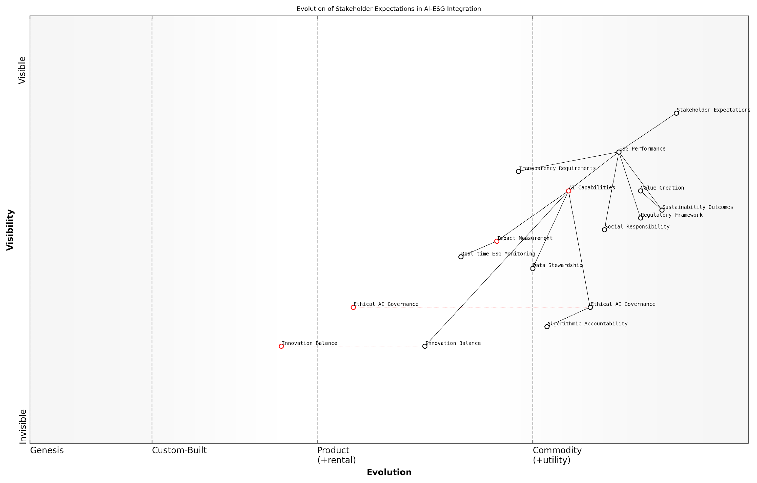

*Draft Wardley Map: [Wardley Map: Evolution of Stakeholder Expectations in AI-ESG Integration]*

[Edit this draft Wardley Map](https://create.wardleymaps.ai/#clone:b0f261335c17c8b747)

**Wardley Map Assessment**

The map reveals a maturing ecosystem with significant opportunities for innovation in AI-ESG integration, requiring balanced focus on technology advancement and ethical governance while maintaining alignment with stakeholder expectations

[View full Wardley Map report](http://markdown/wardley_map_reports/wardley_map_report_31_english_Stakeholder_Expectations.md)

Regulatory bodies and standard-setters are responding to these evolving expectations by developing more comprehensive frameworks for AI-ESG integration. This is creating a feedback loop where stakeholder expectations and regulatory requirements are mutually reinforcing, driving higher standards for both AI deployment and ESG performance.

* Real-time ESG Monitoring: Expectation for continuous monitoring and reporting of ESG metrics using AI
* Algorithmic Accountability: Demand for explainable AI systems in ESG decision-making
* Stakeholder Engagement: Requirements for inclusive AI development processes that consider diverse perspectives
* Innovation Balance: Expectation for responsible AI innovation that advances ESG goals without creating new risks
* Long-term Value Creation: Focus on sustainable value generation through AI-enabled ESG initiatives

Looking ahead, stakeholder expectations are likely to continue evolving as AI capabilities expand and ESG challenges become more acute. Organisations must develop adaptive strategies that can respond to these changing expectations whilst maintaining focus on meaningful sustainability outcomes. This requires a delicate balance between innovation and responsibility, transparency and security, efficiency and equity.

## Preparing for the Future

### Scenario Planning

As organisations navigate the complex intersection of AI and ESG, scenario planning emerges as a critical tool for future-proofing strategies and maintaining resilience. Drawing from extensive experience advising government bodies and corporations, it’s evident that traditional planning approaches must evolve to accommodate the rapid pace of technological change and shifting ESG priorities.

The convergence of AI and ESG represents one of the most complex planning challenges organisations have faced in recent decades. Traditional forecasting methods are no longer sufficient in this rapidly evolving landscape.

Effective scenario planning in the AI-ESG context requires a sophisticated understanding of multiple interconnected variables, from technological advancement trajectories to evolving regulatory frameworks and stakeholder expectations. Organisations must develop robust frameworks that can anticipate and respond to various potential futures while maintaining alignment with ESG objectives.

* Technological Disruption Scenarios: Mapping potential AI breakthroughs and their ESG implications
* Regulatory Evolution Pathways: Anticipating changes in ESG reporting requirements and AI governance
* Stakeholder Expectation Shifts: Projecting evolving demands from investors, customers, and society
* Resource Availability Scenarios: Planning for different energy consumption and computational resource futures
* Social Impact Variations: Considering different outcomes of AI deployment on workforce and communities

The methodology for AI-ESG scenario planning must be both systematic and flexible. Organisations should employ a combination of quantitative modelling and qualitative analysis, incorporating inputs from diverse stakeholders and expertise domains. This approach ensures a comprehensive view of potential futures while maintaining practical applicability.

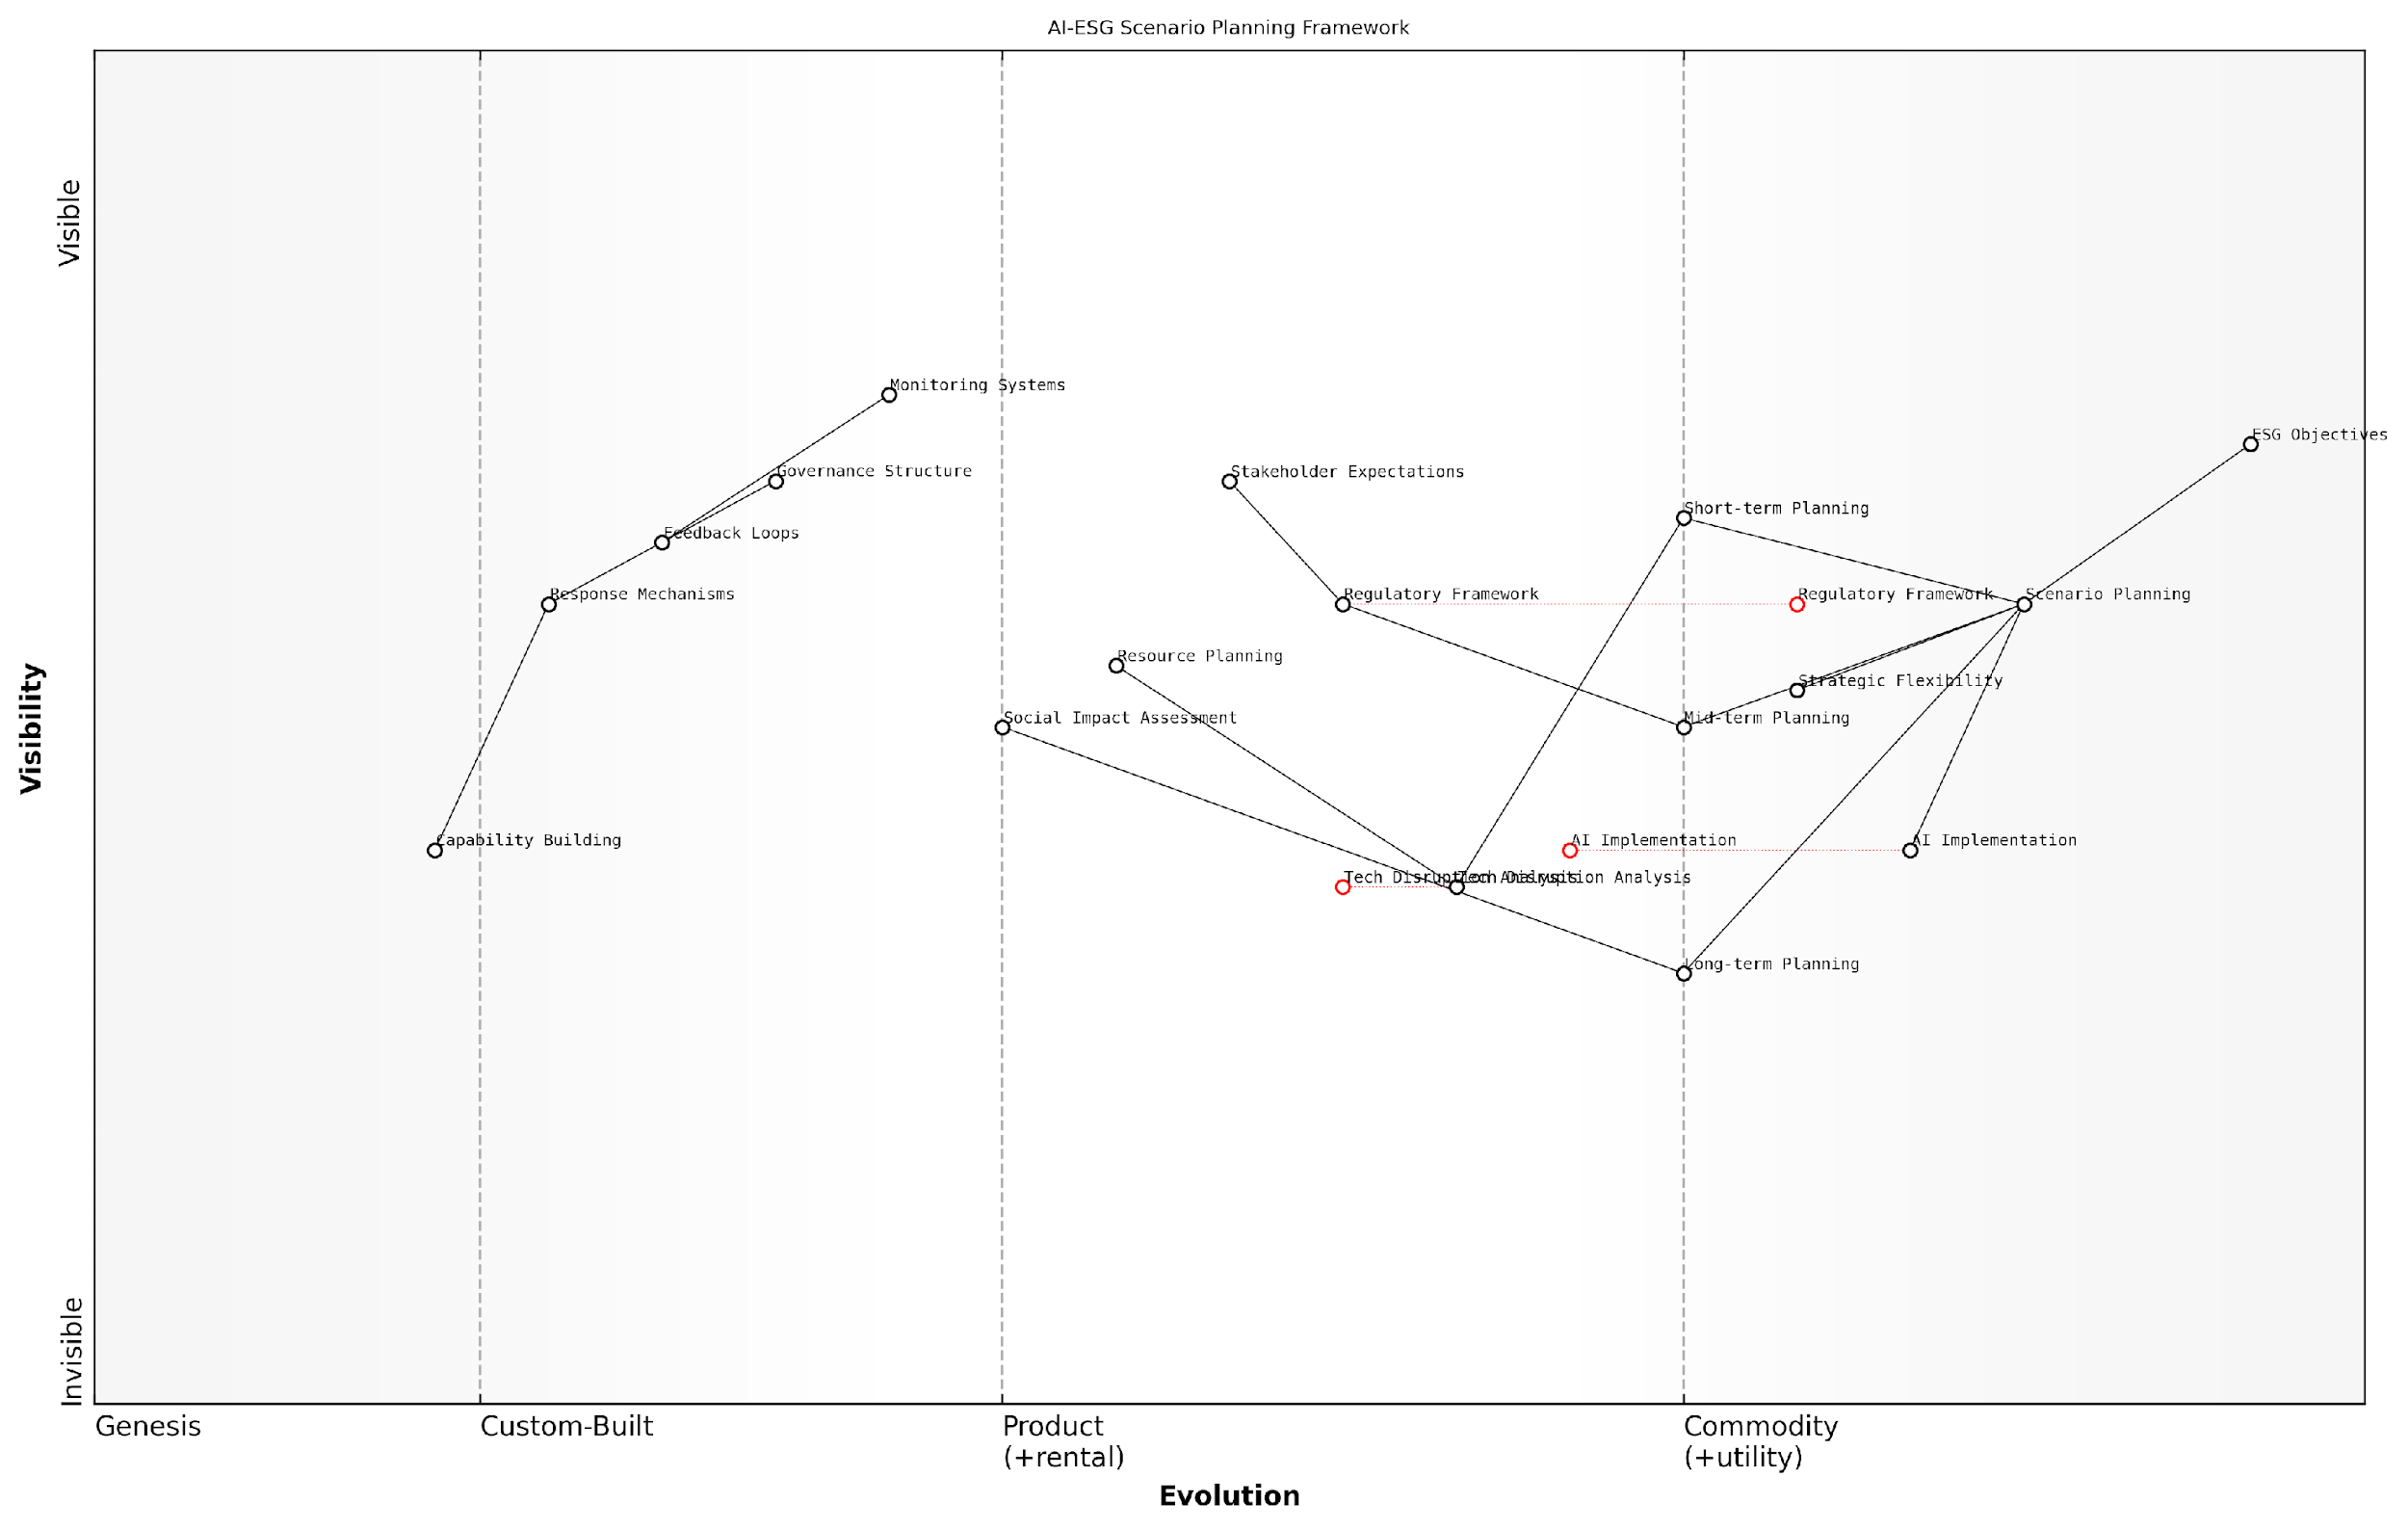

*Draft Wardley Map: [Wardley Map: AI-ESG Scenario Planning Framework showing the evolution of key components across different time horizons]*

[Edit this draft Wardley Map](https://create.wardleymaps.ai/#clone:b6f44756b3bd795297)

**Wardley Map Assessment**

The framework represents a sophisticated approach to integrating AI and ESG considerations into strategic planning, with clear evolution paths and opportunities for competitive advantage through technology and capability development

[View full Wardley Map report](http://markdown/wardley_map_reports/wardley_map_report_32_english_Scenario_Planning.md)

* Horizon 1 (0-2 years): Focus on immediate AI implementation impacts on ESG metrics
* Horizon 2 (2-5 years): Adaptation to emerging technologies and regulatory changes
* Horizon 3 (5+ years): Transformation of business models and ESG practices through AI innovation

Critical to successful scenario planning is the integration of feedback loops and regular reassessment mechanisms. As both AI capabilities and ESG requirements evolve, organisations must maintain flexibility in their strategic responses while ensuring alignment with core sustainability objectives.

The organisations that will thrive in the AI-ESG future are those that can maintain strategic flexibility while staying true to their sustainability commitments, regardless of which scenario unfolds.

* Establish clear triggers for scenario activation and response
* Develop adaptive governance frameworks that can evolve with changing circumstances
* Create robust monitoring systems for early warning signals
* Maintain flexible resource allocation mechanisms
* Build organisational capabilities for rapid response and adaptation

The implementation of scenario planning must be accompanied by appropriate governance structures and clear lines of responsibility. This ensures that insights generated through scenario analysis can be effectively translated into strategic action, maintaining the delicate balance between AI advancement and ESG compliance.

### Adaptive Strategies

In an era where technological advancement and sustainability imperatives are increasingly intertwined, developing adaptive strategies for AI-ESG integration has become paramount. As an expert who has advised numerous organisations through digital transformations, I’ve observed that successful adaptation requires a sophisticated understanding of both technological capabilities and sustainability requirements.

The organisations that thrive in the AI-ESG landscape are not those with rigid plans, but those that build flexibility and adaptability into their core strategic framework.

Adaptive strategies in the AI-ESG context must address three fundamental dimensions: technological evolution, regulatory dynamics, and stakeholder expectations. These dimensions are inherently interconnected and require a holistic approach to strategy development that can respond to rapid changes whilst maintaining alignment with long-term sustainability goals.

* Technological Resilience: Building systems that can incorporate new AI capabilities whilst maintaining ESG compliance
* Regulatory Anticipation: Developing frameworks that can adapt to evolving ESG standards and AI governance requirements
* Stakeholder Engagement: Creating feedback mechanisms that enable rapid response to changing expectations
* Resource Flexibility: Maintaining adaptable resource allocation models that can shift with changing priorities
* Risk Management: Implementing dynamic risk assessment frameworks that evolve with technological advancement

A crucial aspect of adaptive strategy development is the establishment of dynamic capability frameworks. These frameworks must enable organisations to sense changes in the environment, seise opportunities, and reconfigure resources accordingly. This is particularly relevant in the context of AI deployment, where the pace of innovation can quickly render static approaches obsolete.

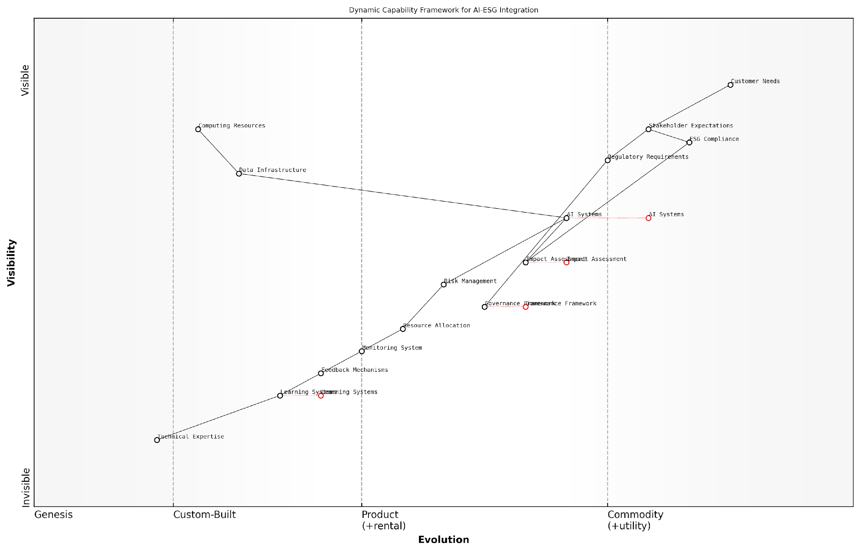

*Draft Wardley Map: [Wardley Map: Dynamic Capability Framework for AI-ESG Integration]*

[Edit this draft Wardley Map](https://create.wardleymaps.ai/#clone:941ffdf5404e810c9c)

**Wardley Map Assessment**

The framework presents a well-structured approach to AI-ESG integration with clear evolution paths and strategic opportunities, requiring focused investment in technical capabilities while maintaining strong governance and compliance standards

[View full Wardley Map report](http://markdown/wardley_map_reports/wardley_map_report_33_english_Adaptive_Strategies.md)

The implementation of adaptive strategies requires a sophisticated monitoring and response system. This system should track key indicators across both AI performance metrics and ESG outcomes, enabling real-time adjustments to maintain optimal balance between technological advancement and sustainability goals.

* Continuous Learning Systems: Implementation of AI systems that can learn and adapt to new ESG requirements
* Flexible Governance Structures: Development of decision-making frameworks that can evolve with changing circumstances
* Stakeholder Feedback Loops: Creation of mechanisms for rapid incorporation of stakeholder input
* Resource Optimisation Models: Implementation of dynamic resource allocation systems
* Impact Assessment Frameworks: Development of tools for ongoing evaluation of AI-ESG outcomes

The most successful organisations in the AI-ESG space are those that treat adaptation not as a response to change, but as a continuous process of evolution and improvement.

Looking ahead, organisations must prepare for increased complexity in the AI-ESG landscape. This includes developing capabilities to handle emerging technologies such as quantum computing, advanced neural networks, and edge AI, whilst ensuring these advancements align with evolving ESG standards and expectations. The key to success lies in building adaptive capacity that enables organisations to maintain strategic coherence whilst responding to rapid change.

### Long-term Sustainability

As we navigate the complex intersection of AI and ESG, establishing a framework for long-term sustainability becomes paramount. This critical component requires organisations to look beyond immediate technological gains and consider the enduring impact of their AI implementations on environmental, social, and governance objectives.

The challenge isn’t just about implementing AI solutions that address today’s ESG concerns, but about creating systems that remain viable, ethical, and effective as both technology and sustainability requirements evolve.

Long-term sustainability in the AI-ESG context requires a multi-dimensional approach that considers technological resilience, environmental impact, social responsibility, and governance adaptability. Organisations must develop frameworks that can evolve with advancing technology while maintaining alignment with increasingly stringent ESG standards.

* Technological Resilience: Implementing AI systems that can be updated, scaled, and modified to meet emerging ESG requirements
* Resource Optimisation: Developing strategies for sustainable computing resources and energy consumption
* Stakeholder Engagement: Building lasting relationships with communities, employees, and partners affected by AI implementations
* Governance Evolution: Creating flexible oversight mechanisms that can adapt to changing regulatory landscapes
* Knowledge Management: Establishing systems for preserving institutional knowledge and best practices

A crucial aspect of long-term sustainability is the development of regenerative practices. Rather than simply minimising negative impacts, organisations should strive to create positive feedback loops where AI implementations actively contribute to ESG improvements while becoming more efficient and effective over time.

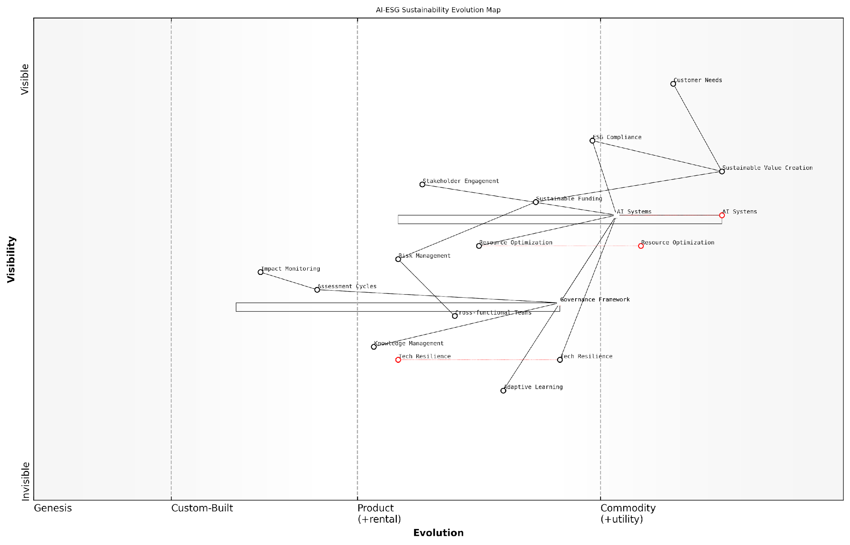

*Draft Wardley Map: [Wardley Map: Evolution of AI-ESG Systems showing movement from Genesis to Commodity with sustainability considerations]*

[Edit this draft Wardley Map](https://create.wardleymaps.ai/#clone:d5269a0057c64349ac)

**Wardley Map Assessment**

The map reveals a well-structured approach to AI-ESG integration with clear evolution paths and strategic opportunities, requiring focused investment in key capabilities whilst maintaining strong governance and compliance frameworks

[View full Wardley Map report](http://markdown/wardley_map_reports/wardley_map_report_34_english_Long-term_Sustainability.md)

* Regular Assessment Cycles: Implementing periodic reviews of AI systems against evolving ESG criteria
* Adaptive Learning Mechanisms: Incorporating feedback loops for continuous improvement
* Sustainable Resource Planning: Long-term strategies for managing computational resources
* Community Impact Monitoring: Tracking and responding to social implications over time
* Governance Framework Evolution: Regular updates to oversight mechanisms

The organisations that will thrive in the future are those that view AI not just as a tool for ESG compliance, but as a catalyst for creating sustainable value across their entire operational ecosystem.

Financial sustainability must be balanced with environmental and social considerations. This requires organisations to develop robust business models that can support ongoing investment in sustainable AI practices while delivering value to stakeholders. The concept of ‘sustainable returns’ should encompass both financial metrics and broader ESG impacts.

* Development of sustainable funding models for AI-ESG initiatives
* Creation of value metrics that incorporate both financial and ESG outcomes
* Implementation of long-term risk management frameworks
* Establishment of cross-functional sustainability teams
* Integration of sustainability principles into AI development lifecycles

The path to long-term sustainability requires organisations to embrace uncertainty while maintaining clear principles and objectives. This involves developing adaptive strategies that can respond to changing conditions whilst ensuring that core ESG commitments remain central to AI implementation decisions.

# Appendix - Book Generation Details

* Initial Topic: Is AI Really the Solution to ESG?
* Refined Topic: Is AI Really the Solution to ESG?
* Total Output Tokens: 121,613
* Total LLM Cost: $1.82

# Appendix: Further Reading on Wardley Mapping

The following books, primarily authored by Mark Craddock, offer comprehensive insights into various aspects of Wardley Mapping:

## Core Wardley Mapping Series

1. **Wardley Mapping, The Knowledge: Part One, Topographical Intelligence in Business**
   * Author: Simon Wardley
   * Editor: Mark Craddock
   * Part of the Wardley Mapping series (5 books)
   * Available in Kindle Edition
   * [Amazon Link](https://www.amazon.com/dp/B0BVSXB5W5)

* This foundational text introduces readers to the Wardley Mapping approach:
  + Covers key principles, core concepts, and techniques for creating situational maps
  + Teaches how to anchor mapping in user needs and trace value chains
  + Explores anticipating disruptions and determining strategic gameplay
  + Introduces the foundational doctrine of strategic thinking
  + Provides a framework for assessing strategic plays
  + Includes concrete examples and scenarios for practical application
* The book aims to equip readers with:
  + A strategic compass for navigating rapidly shifting competitive landscapes
  + Tools for systematic situational awareness
  + Confidence in creating strategic plays and products
  + An entrepreneurial mindset for continual learning and improvement

1. **Wardley Mapping Doctrine: Universal Principles and Best Practices that Guide Strategic Decision-Making**
   * Author: Mark Craddock
   * Part of the Wardley Mapping series (5 books)
   * Available in Kindle Edition
   * [Amazon Link](https://www.amazon.com/dp/B0C2SFTR7Z)

* This book explores how doctrine supports organisational learning and adaptation:
  + Standardisation: Enhances efficiency through consistent application of best practices
  + Shared Understanding: Fosters better communication and alignment within teams
  + Guidance for Decision-Making: Offers clear guidelines for navigating complexity
  + Adaptability: Encourages continuous evaluation and refinement of practices
* Key features:
  + In-depth analysis of doctrine’s role in strategic thinking
  + Case studies demonstrating successful application of doctrine
  + Practical frameworks for implementing doctrine in various organisational contexts
  + Exploration of the balance between stability and flexibility in strategic planning
* Ideal for:
  + Business leaders and executives
  + Strategic planners and consultants
  + Organisational development professionals
  + Anyone interested in enhancing their strategic decision-making capabilities

1. **Wardley Mapping Gameplays: Transforming Insights into Strategic Actions**
   * Author: Mark Craddock
   * Part of the Wardley Mapping series (5 books)
   * Available in Kindle Edition
   * [Amazon Link](https://www.amazon.com/dp/B0C7CR9R9Q)

* This book delves into gameplays, a crucial component of Wardley Mapping:
  + Gameplays are context-specific patterns of strategic action derived from Wardley Maps
  + Types of gameplays include:
    - User Perception plays (e.g., education, bundling)
    - Accelerator plays (e.g., open approaches, exploiting network effects)
    - De-accelerator plays (e.g., creating constraints, exploiting IPR)
    - Market plays (e.g., differentiation, pricing policy)
    - Defensive plays (e.g., raising barriers to entry, managing inertia)
    - Attacking plays (e.g., directed investment, undermining barriers to entry)
    - Ecosystem plays (e.g., alliances, sensing engines)
* Gameplays enhance strategic decision-making by:
  1. Providing contextual actions tailored to specific situations
  2. Enabling anticipation of competitors’ moves
  3. Inspiring innovative approaches to challenges and opportunities
  4. Assisting in risk management
  5. Optimising resource allocation based on strategic positioning
* The book includes:
  + Detailed explanations of each gameplay type
  + Real-world examples of successful gameplay implementation
  + Frameworks for selecting and combining gameplays
  + Strategies for adapting gameplays to different industries and contexts

1. **Navigating Inertia: Understanding Resistance to Change in Organisations**
   * Author: Mark Craddock
   * Part of the Wardley Mapping series (5 books)
   * Available in Kindle Edition
   * [Amazon Link](https://www.amazon.com/dp/B0C34FX8XC)

* This comprehensive guide explores organisational inertia and strategies to overcome it:
* Key Features:
  + In-depth exploration of inertia in organisational contexts
  + Historical perspective on inertia’s role in business evolution
  + Practical strategies for overcoming resistance to change
  + Integration of Wardley Mapping as a diagnostic tool
* The book is structured into six parts:
  1. Understanding Inertia: Foundational concepts and historical context
  2. Causes and Effects of Inertia: Internal and external factors contributing to inertia
  3. Diagnosing Inertia: Tools and techniques, including Wardley Mapping
  4. Strategies to Overcome Inertia: Interventions for cultural, behavioural, structural, and process improvements
  5. Case Studies and Practical Applications: Real-world examples and implementation frameworks
  6. The Future of Inertia Management: Emerging trends and building adaptive capabilities
* This book is invaluable for:
  + Organisational leaders and managers
  + Change management professionals
  + Business strategists and consultants
  + Researchers in organisational behaviour and management

1. **Wardley Mapping Climate: Decoding Business Evolution**
   * Author: Mark Craddock
   * Part of the Wardley Mapping series (5 books)
   * Available in Kindle Edition
   * [Amazon Link](https://www.amazon.com/dp/B0BVHF2MBH)

* This comprehensive guide explores climatic patterns in business landscapes:
* Key Features:
  + In-depth exploration of 31 climatic patterns across six domains: Components, Financial, Speed, Inertia, Competitors, and Prediction
  + Real-world examples from industry leaders and disruptions
  + Practical exercises and worksheets for applying concepts
  + Strategies for navigating uncertainty and driving innovation
  + Comprehensive glossary and additional resources
* The book enables readers to:
  + Anticipate market changes with greater accuracy
  + Develop more resilient and adaptive strategies
  + Identify emerging opportunities before competitors
  + Navigate complexities of evolving business ecosystems
* It covers topics from basic Wardley Mapping to advanced concepts like the Red Queen Effect and Jevon’s Paradox, offering a complete toolkit for strategic foresight.
* Perfect for:
  + Business strategists and consultants
  + C-suite executives and business leaders
  + Entrepreneurs and startup founders
  + Product managers and innovation teams
  + Anyone interested in cutting-edge strategic thinking

## Practical Resources

1. **Wardley Mapping Cheat Sheets & Notebook**
   * Author: Mark Craddock
   * 100 pages of Wardley Mapping design templates and cheat sheets
   * Available in paperback format
   * [Amazon Link](https://www.amazon.com/dp/B09TPDM9PP)

* This practical resource includes:
  + Ready-to-use Wardley Mapping templates
  + Quick reference guides for key Wardley Mapping concepts
  + Space for notes and brainstorming
  + Visual aids for understanding mapping principles
* Ideal for:
  + Practitioners looking to quickly apply Wardley Mapping techniques
  + Workshop facilitators and educators
  + Anyone wanting to practise and refine their mapping skills

## Specialised Applications

1. **UN Global Platform Handbook on Information Technology Strategy: Wardley Mapping The Sustainable Development Goals (SDGs)**
   * Author: Mark Craddock
   * Explores the use of Wardley Mapping in the context of sustainable development
   * Available for free with Kindle Unlimited or for purchase
   * [Amazon Link](https://www.amazon.com/dp/B09PNKFHG4)

* This specialised guide:
  + Applies Wardley Mapping to the UN’s Sustainable Development Goals
  + Provides strategies for technology-driven sustainable development
  + Offers case studies of successful SDG implementations
  + Includes practical frameworks for policy makers and development professionals

1. **AIconomics: The Business Value of Artificial Intelligence**
   * Author: Mark Craddock
   * Applies Wardley Mapping concepts to the field of artificial intelligence in business
   * [Amazon Link](https://www.amazon.com/dp/B0C6V9VZ9B)

* This book explores:
  + The impact of AI on business landscapes
  + Strategies for integrating AI into business models
  + Wardley Mapping techniques for AI implementation
  + Future trends in AI and their potential business implications
* Suitable for:
  + Business leaders considering AI adoption
  + AI strategists and consultants
  + Technology managers and CIOs
  + Researchers in AI and business strategy

These resources offer a range of perspectives and applications of Wardley Mapping, from foundational principles to specific use cases. Readers are encouraged to explore these works to enhance their understanding and application of Wardley Mapping techniques.

Note: Amazon links are subject to change. If a link doesn’t work, try searching for the book title on Amazon directly.